Local Action Plan Template

Territorial Mission
The Salvation Army exists to share the love of Jesus Christ, meet human needs and be a transforming
influence in the communities of our world.

Territorial Vision
We are an innovative partner, mobilized to share hope wherever there is hardship, building communities
that are just and know the love of Jesus.

Territorial Values
Hope, Service, Dignity, Stewardship

Territorial Strategic Pillars
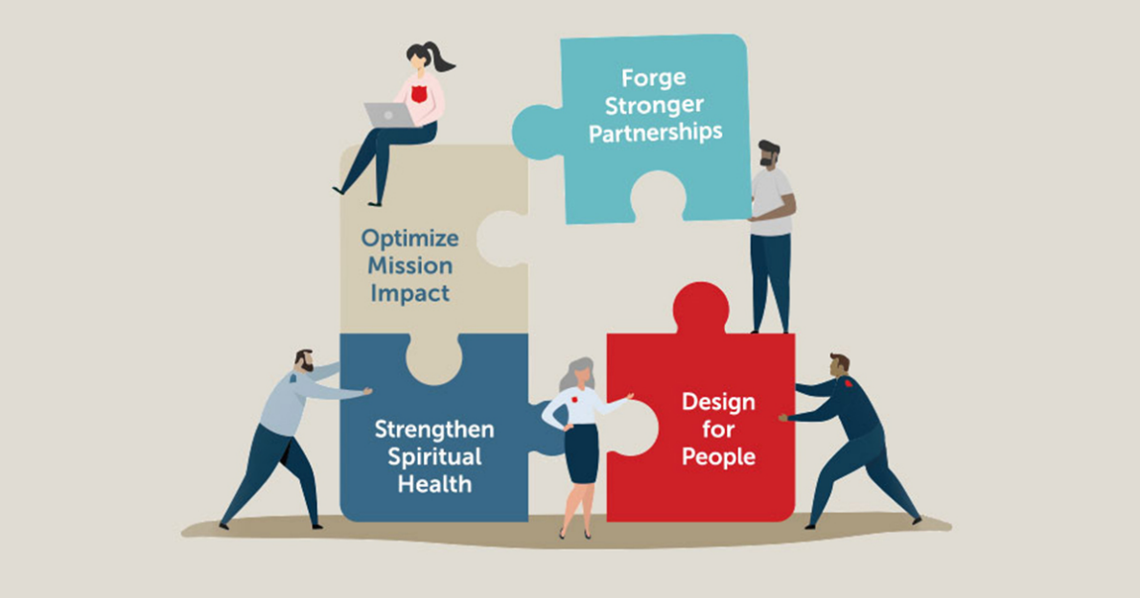
Local Action Plan Template

Ministry Unit:

Local Commitment Statement:
Leader:
Period:
Section 1 – Review last year
- Please complete the table below for your last year’s objectives:

Objective / Project | Status1 | Comment
1Status: To be started; In progress; Partially achieved; Achieved; Abandoned

- What have been some of the highlights for your ministry area over the last year?

- What are the biggest challenges your ministry area is facing currently?

- What dreams do you have for your ministry area this year?

Section 2 – Clarify your purpose
- In light of the overall Corps local commitment statement, what do you see as the purpose of your ministry area?

- Who are the people your ministry touches? What do they look like demographically?

Section 3 – Identify your Projects / Objectives for the Year
- What are the things you would like to achieve over the next year? Enter these in the first column below.
Tip: For each potential achievement, ask yourself ‘why do you want to achieve that?’; and keeping asking ‘why?’ on each of your answers until the final answer is ‘because that’s what we’re about’. Then take the last one your ministry is responsible for. For example, I want to run social events. Why? To provide a place for people to bring their friends to. Why? So that the friends will come to our Sunday service. Why? So they will come to follow Jesus. Your objective might be to help people bring their friends to our Sunday service.
- Now think about how you will know you have been successful by quantifying your goal and deciding how you might measure this. For example, survey the corps and have 90% of the respondents state their relationship with God has grown over the year; have five new families attend our Sunday service brought by friends. Enter this in the second column.
- Now brainstorm any ideas you have on how you intend to achieve this (just ideas – you will expand these in the next step).

What would you like to achieve? | How will you know you have been successful? | Ideas for how you will achieve this.

- Now take these ideas and develop your plan for the year (on the following page).

Section 4 – Your Plan for the Year Project/Objective 1: <project name> Description and measure of success:

To achieve this objective, what do you plan to do this year?

No | Task | Who? | Effort? | When?
1
2
3
4

Project/Objective 2: <project name>
Description and measure of success:
To achieve this objective, what do you plan to do this year?

No | Task | Who? | Effort? | When?
1
2
3
4

Project/Objective 3: <project name>
Description and measure of success:
To achieve this objective, what do you plan to do this year?

No | Task | Who? | Effort? | When?
1
2
3
4

Other Tasks

No | Task | Who? | Effort? | When?
1
2
3

Your Requirements for the Year
To help you achieve your action plan, what assistance do you need?

Support Area | Your Requirements
Budget:
Training:
Support:
Other:

