Annual Corps
MISSION IMPACT REVIEW
FORMS

TABLE OF CONTENTS

Turn on Microsoft Word Navigation, under View, to use the interactive menu.
Why An Annual Review? |  | 2
Review Cycle, Supporting Documents |  | 3
Review Check List |  | 4
Corps Membership: Additions and Removals |  | 5
Women’s Ministries Integrated Membership Roll |  | 8
Review Sign-off |  | 9
Appendix A – How to Create the Require Reports (SAMIS, LINK2Feed) |  | 10

ON LINE SUBMISSION

- Prepare forms (pages 6-9) and store them on your computer as one document.
- Prepare the SAMIS Corps Review report and the Link2Feed report and have them ready to upload through the online form (instructions pg 10)
- Complete the On-Line Form

Other info: www.saMissionResource.ca/annual-reviews

“Engage in STRATEGIC THINKING regularly throughout the year.”

WHY AN ANNUAL REVIEW?

STATISTICAL ACCOUNTABILITY
The statistical element of the review enables discussion with the Corps Council/Mission Board around attendance and rolls, and helps to ensure that rolls and statistics are up-to-date and properly entered into SAMIS. During the visit by DHQ personnel, key elements of that discussion can be shared and final approval given for membership decisions and roll updates made by the Pastoral Care Council. The review also provides corps leadership with information necessary to set and follow a strategic plan.

GOAL SETTING
Part of the year long process involves input from local program leaders and committees, regularly reviewing GOALS, and setting new goals for the coming year. Once a year, ideally before the fall season beings, the Strategic Thinking Worksheets provide an opportunity for each program leader/committee to set updated goals for the coming year. (Find a copy here: www.saMissionResource.ca/annual-reviews )

HOW YOUR INFORMATION IS SHARED,
AND IMPACTS TERRITORIAL DECISION MAKING

- The annual review process is viewed as a vital tool to receive input from every corps ministry unit regarding their health and growth.

- The Location information in SAMIS is fed into the online locator, so the public can find every unit on the Google interactive map through www.salvationarmy.ca/locator

- The review results are summarized at THQ and are provided to divisional and territorial personnel to highlight successes and identify areas needing assistance at the end of the review period.

- Statistics entered into SAMIS are used by DHQ/THQ to assess ministry unit, and to file reports to IHQ.

CYCLE OF ANNUAL REVIEW AND GOAL SETTING FOR UPCOMING YEAR
 | January | - Complete all ROLL updates in SAMIS, to reflect all expected additions, transfers and removals (provided verbal/written permission has been given by your AC). This will ensure that minimal updates will be required after the DHQ visit.  -Ensure that all program statistics have been entered into SAMIS, and all Link2Feed data is complete for the prior year.
 | February | -Meet with the leadership team to discuss the review documents.  - Discuss and identify GOALS that will be included with the review  SAMIS closing date and deadline to enter SAMIS data is February 28.
 | March - May | The Leadership Team meets with the DHQ personnel to present the review documents and roll changes. Divisional personnel sign off on official books and Rolls.  -Review GOALS for the year with your leadership team regularly at Corps Council/Mission Board meetings.  - Consider using a Congregational Health Assessment tool to evaluate the health of the corps. See suggested tools: www.saMissionResource.ca/corps-health-tools
 | June - August | Redistribute the Strategic Thinking Worksheets to respective group leaders for check-in and assessment of achievements from last years’ goals and to set new goals for the coming year. Engage in goal setting discussion to set the goals for the coming mission year (Sept -Aug).
 | September – December | - Finalize all attendance information in SAMIS.  - The Pastoral Care Council should meet to finalize any ROLL changes and ensure that the roll numbers in SAMIS have been updated in the December month.  - Distribute/Collect the Strategic Thinking Worksheets and other helpful tools listed above to engage your leaders in the goal-setting process.  - Ensure that each leadership team and group engage in strategic thinking and submits their worksheet for Corps Council/Mission Board discussion  - Finalize GOALS that will be submitted on the review document to DHQ/THQ.
* For information on the Corps Council/Mission Board and leadership team members, see the Corps Administration Model document, available on our website.
The following documents are provided as appendices to the review and are contained in the .zip file posted in SAMIS, or download here:
www.saMissionResource.ca/annual-reviews

- Corps - Community and Family Services Template (If the CFS is not accredited by Social Services, a completed copy of this document should be completed and filed on site).
- Corps Administration Model (Descriptions of Corps Locals and functioning of the administration Corps Councils/Mission Board).
- AMR Supporting Documents
This document includes the following:
- Operating Policy for Corps Local Officers, Soldiers and Adherents of The Salvation Army
- Creating S.M.A.R.T. Goals
- Identifying the Elevator Message for our Congregation

REVIEW CHECKLIST

 |  |  |  | Date:
Area Commander / DHQ Representative:
Item | Noted | Comment

ROLLS
Senior Soldiers Roll
Junior Soldiers Roll
Recruits Roll
Adherents Roll
Friends Roll
OTHER ROLLS/REGISTERS
Local Officers/Leader’s Register
Seekers Register (SR & YP)
Marriage Register
Burial Register
Pastoral Care Council Members
CCM Membership Register
Band – Songster – Music Registers
Candidates Fellowship Register
WM Integrated Membership Roll/Register
YP REGISTERS
Sunday School Attendance Register
Ready To Serve
Cradle Roll/Register
Dedication Register
DOCUMENTATION
Leader/Volunteer/Employee Police Checks (SR & YP)
Armatus Abuse Training Records (SR & YP)
Articles of War/Covenants
Pastoral Care Council Minute Books (SR & YP)
History book
Community & Family Services Template (non-accredited units)

INSTRUCTIONS FOR ADDITIONS/REMOVALS PAGES

Keep a copy of this page to track membership changes throughout the year. Reference the Official Membership Rolls - Guidelines for information on adding and removing names from the rolls.
EXAMPLES: Use these examples as guidelines for completing your Additions/Removals page, part of the Annual Corps Review document. Use ‘X’ or identifying letters in the columns, whichever is most useful.
1. Jane Doe has been enrolled as a Sr. Soldier - from the Sr. Recruits roll. An 'X' has been entered under 'ADD - Sr. Soldier', and an 'X’ has been entered under 'REMOVE - Sr. Recruits'. This shows movement between Rolls. a 'REASON' is not required for this entry.
2. John Smith has been transferred from Jr. Soldier. An 'X' under 'REMOVE - Jr. Soldier' indicates this change. And an 'X' has been entered under 'REASON - To Other Church/Corps' with indication of where John went.
3. Mary Brown has been enrolled as a Sr. Soldier - from the Adherents roll. An 'X' has been entered under 'ADD - Sr. Soldier', and an 'X' has been entered under 'REMOVE - Adherents'. This shows movement between Rolls. a 'REASON' is not required for this entry.
4. Tom Thumb has been added to Senior Soldiers, From Other Corps.

E = Enrolled
T = Transferred In
R = Reinstated

R = Roll removed from
T = Transferred from

CORPS MEMBERSHIP: ADDITIONS AND REMOVALS
Enter names ONCE in the table below, indicating movement accordingly

NAME |  | E = Enrolled  T = Transferred In  R = Reinstated  ADD |  |  |  |  | REMOVE  R = Roll removed from  T = Transferred from |  |  |  |  | REASON  Enter √ to indicate reason. |  |  |  |  |  |  |  |  |  | COMMENTS
 |  |  |  |  |  |  |  |  |  |  |  | Add |  |  |  | Remove
 |  | Adherents | Friends | Junior Soldiers | Senior Soldiers | Senior Recruits | Adherents | Friends | Junior Soldiers | Senior Soldiers | Senior Recruits | Reinstated | From Other Corps/Church | New Contact |  | P/G – Deceased |  | Double Entry |  | Verified Non-Attendance | To Other Corps/Church
 |  |  |  |  |  |  |  |  |  |  |  |  |  |  |  |  |  |  | Date
Local Officer |  |  |  |  |  |  | Corps Officer |  |  |  |  |  |  |  |  |  |  |  | DC or designate

CORPS MEMBERSHIP: ADDITIONS AND REMOVALS
Enter names ONCE in the table below, indicating movement accordingly

NAME |  | ADD  A = Roll added to |  |  |  |  | REMOVE  R = Roll removed from  T = Transferred from |  |  |  |  | REASON  Enter √ to indicate reason. |  |  |  |  |  |  |  |  |  | COMMENTS
 |  |  |  |  |  |  |  |  |  |  |  | Add |  |  |  | Remove
 |  | Adherents | Friends | Junior Soldiers | Senior Soldiers | Senior Recruits | Adherents | Friends | Junior Soldiers | Senior Soldiers | Senior Recruits | Reinstated | From Other Corps/Church | New Contact |  | P/G – Deceased |  | Double Entry |  | Verified Non-Attendance | To Other Corps/Church
 |  |  |  |  |  |  |  |  |  |  |  |  |  |  |  |  |  |  | Date
Local Officer |  |  |  |  |  |  | Corps Officer |  |  |  |  |  |  |  |  |  |  |  | DC or designate

WOMEN’S MINISTRIES ADDITIONS/REMOVALS

Enter names to indicate any changes to the WM Integrated Membership Roll
*For instructions visit: Important Definitions About Membership, Attendance, Seekers, Women’s Ministries

NAME |  |  | ADD  A = Roll added to |  |  |  |  |  | REMOVE  R = Roll removed from |  |  |  |  |  |  | REASON  Enter √ to indicate reason |  |  |  |  | COMMENTS
 |  |  | Home League | Junior Miss | Spiritual Growth | Healthy Lifestyles | Fellowship and Outreach | Preschool | Home League | Junior Miss | Spiritual Growth | Healthy Life Styles | Fellowship and Outreach | Preschool |  | Promoted to Glory |  | Transferred to Outer Circle | Transferred to another Corps | Removed for other reasons
 |  |  |  |  |  |  |  |  |  |  |  |  |  |  |  |  | Date
 | Local Officer |  |  |  |  |  |  |  |  | Corps Officer |  |  |  |  |  |  | DC or designate

2021

REVIEW SIGN-OFF

Date completed:
Corps Officer signature(s):
Local Participant signature(s):
DHQ signature(s):
 |  | Divisional Headquarters representative | Date
 |  | Divisional Headquarters representative | Date

Follow these instructions to create the required SAMIS REVIEW REPORT.
Before you begin, ensure that all your statistics and roll changes for the desired year have been completed.
1. Sign in to SAMIS.
2. Choose REPORTS -> CORPS REVIEW
3. Choose the 'Documents' tab.
4. Click ‘Generate Reports’ button in the bottom right.

4. Click on the 'Documents' tab - and right click on each of the two documents, choose 'save target (or link) as'.... and put them on your computer where you can find them.

5. Find the documents on your computer - Open the word document as usual. Right click on the .zip file - and choose 'Unzip to here'. If you need help with the .zip file visit www.winzip.com
6. Click the 'Generate Reports' button in the lower right corner of the 'Documents' tab. This will run the required report from SAMIS. Visit the 'View Reports' tab and right click on the finished 'Corps Review Reports' - save to your computer.

7. Insert the Corps Review Reports from SAMIS after page 7 of the Annual Corps Membership Review & Strategic Plan document before you submit it to your DHQ.

For more help with the Annual Review visit: www.saMinistryResources.ca/annual-reviews

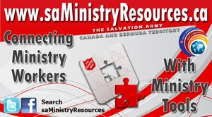

CREATE THE SAMIS REVIEW REPORT

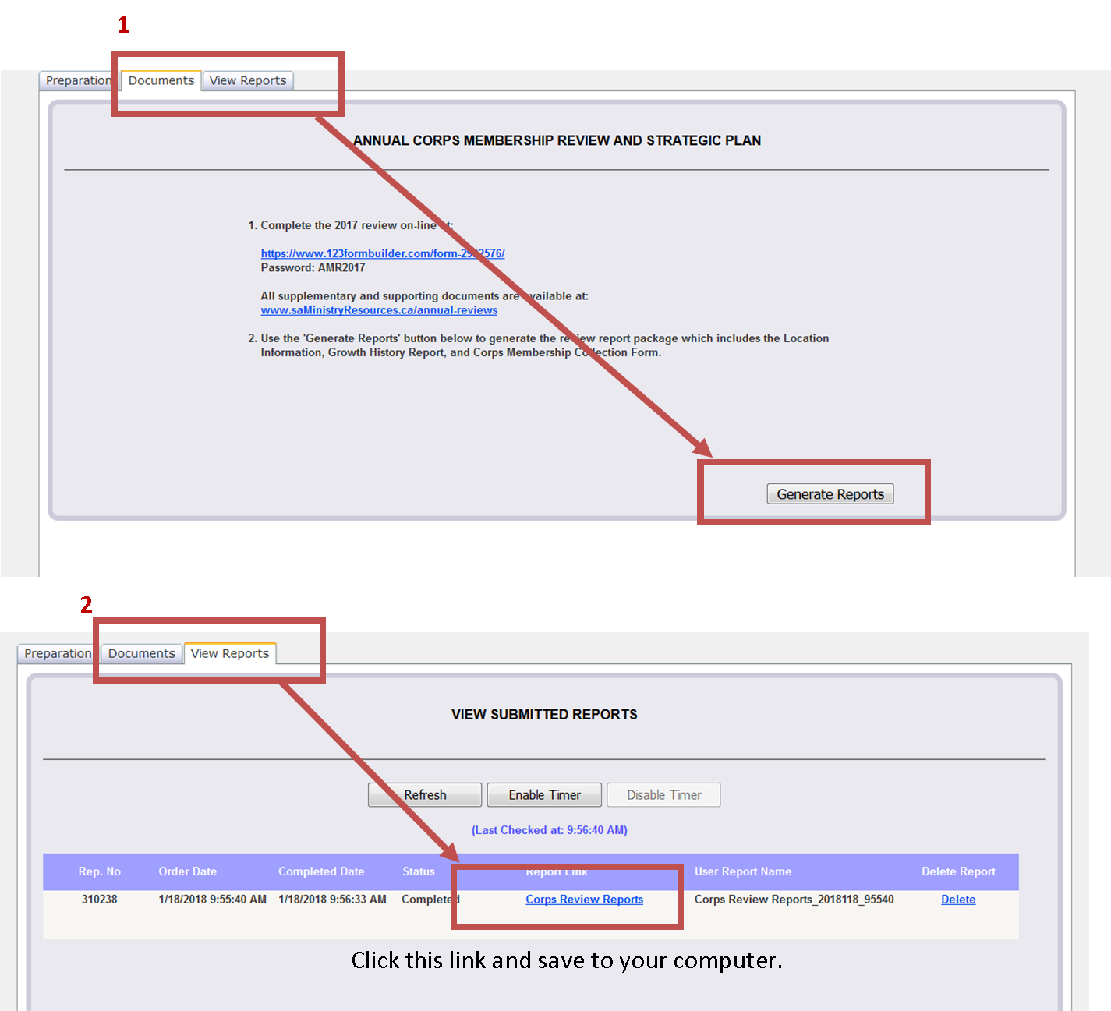
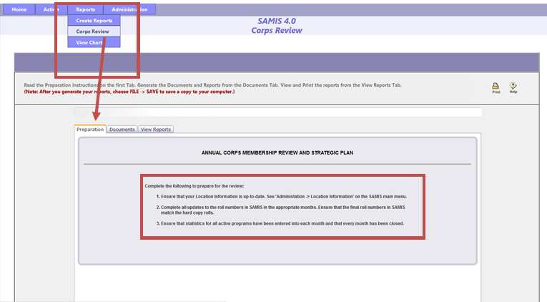
5. To view the report, click on the ‘View Reports’ tab.
6. Click the blue report link to open the report. To save a copy, choose ‘File, Save as….’ on your document menu and save the report to your local computer.
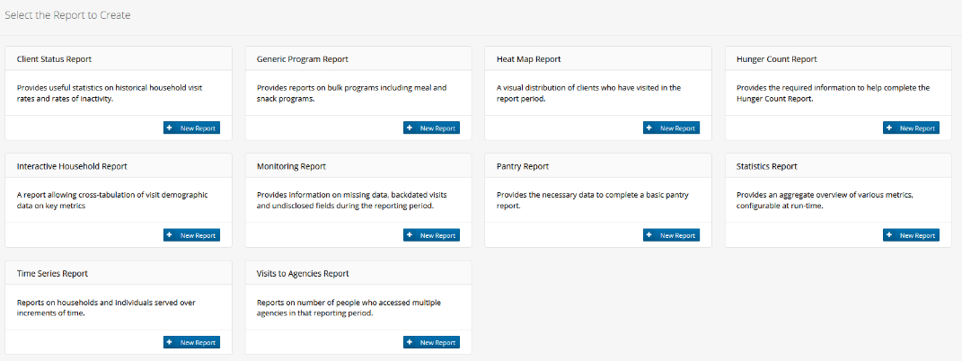
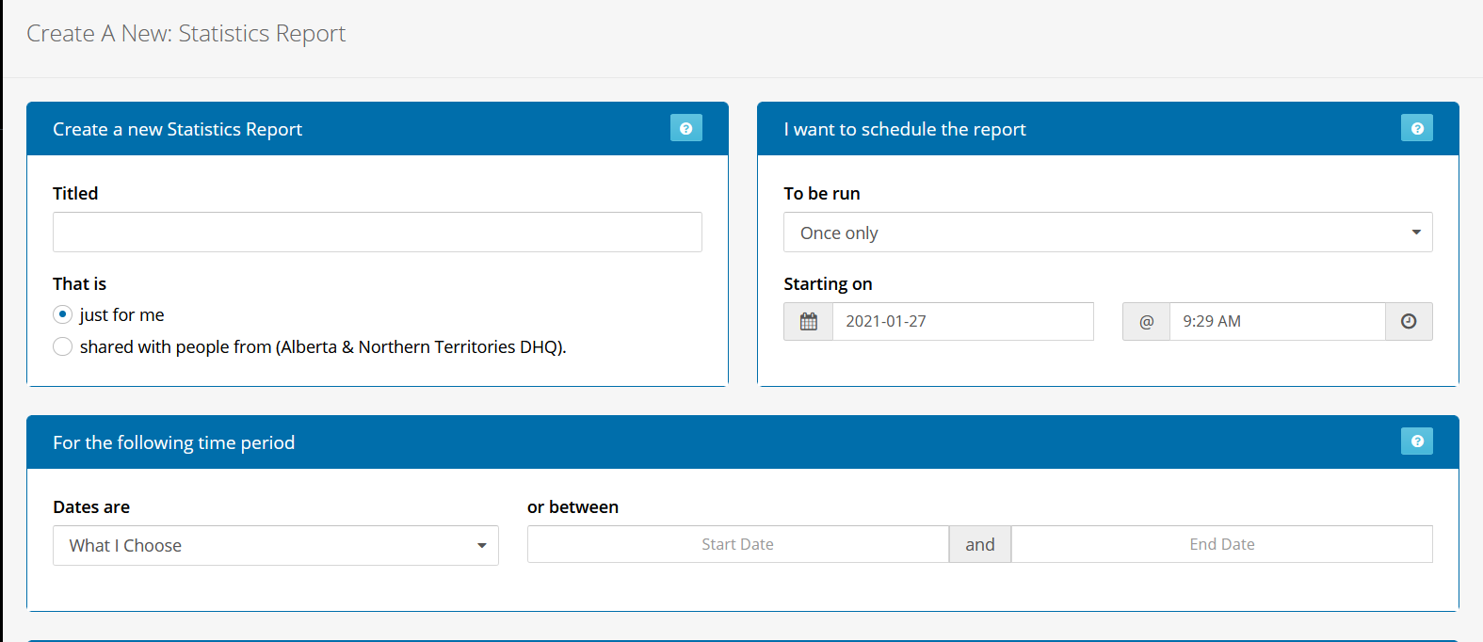
7. Choose ‘Create Report’.
8. Go to ‘Report Inbox’ - open your report and save as a PDF to your computer.
9. For locations who are not using the Salvation Army version of Link2Feed, please run the Hunger Count report. If you do not have access to any reporting features, please inform your AC before the visit.
6. Choose these buttons to create a report showing visits.
Choose January 1, 2021—December 31, 2021
Statistics Report for Annual Review
5. Complete the form fields as follows:
HOW TO CREATE A LINK2FEED REPORT FOR THE ANNUAL CORPS REVIEW
1. Log in to your Link2Feed Account
2. Click on Client Intake
3. In the left menu open the ‘Report’ tab and choose ‘New Report’.
4. Select the ‘Statistics Report’

