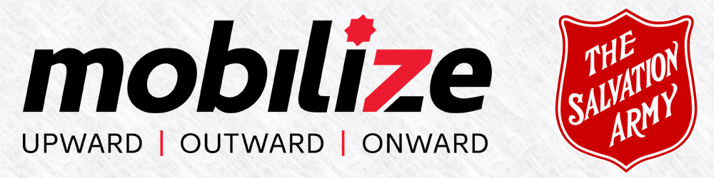

ANNUAL CORPS MEMBERSHIP REVIEW
& STRATEGIC PLANNING 2017

Corps Name: __________________________ Division: ____________________________

Contact First: __________________________ Contact Last: ____________________________

Email: __________________________ Date: ____________________________

IMPORTANT INFORMATION ABOUT THIS FORM
This form can be completed in one sitting or saved for completion at a later date.
SAVE FOR LATER: if at any time during the completion of this form you wish to pause and exit the internet, scroll to the bottom of the form and choose 'Save for Later' link.
HOW IT WORKS: Once you choose the 'Save for Later' link, a link code is provided on the screen to copy and paste AND an email will be sent to the address you submitted at the beginning of the form, containing the link for continuing. The email will be from noreply@123ContactForm. This link can also be used to update your completed submission if you discover an error.

PREPARING AHEAD
You will require the SAMIS Statistical report, and the completed Additions/Removals and WM Additions/Removals pages in order to finalize and submit your Review.
All documents should be completed and submitted with the on line form BEFORE the scheduled visit from the AC. When you complete the on line form an automatic email will be sent to your AC with all the required documents.
If you wish to print a copy of this form for your preparation notes, use your browser 'print' feature or the 'print' link at the bottom of the form.

_____________________________________________________________________________________________
PART I - ADMINISTRATIVE INFORMATION
MISSION STATEMENT
The Salvation Army's Mission Statement says: THE SALVATION ARMY exists to share the love of Jesus Christ, meet human needs and be a transforming influence in the communities of our world.

VISION STATEMENT
Provide your corps' customized vision/purpose/mission statement here.

ADMINISTRATIVE MODEL
In order to provide infrastructure and facilitate wise decision-making, every corps/church needs to have an administrative model in place. The Salvation Army recognizes two administrative models: Corps Council or Mission Board. Which of these models are you currently using?
Corps Council Mission Board Other

Meeting Frequency
How often do you meet?
Monthly Quarterly Semi-Annually Annually None

Additional Comments

PASTORAL CARE COUNCILS
It is a requirement of Salvation Army ministry units to have Pastoral Care Councils in place.
Both YP and Sr Pastoral Care Councils Only YP Pastoral Care Council
Only SR Pastoral Care Council Neither

Plans to implement
If you have neither YP nor SR Pastoral Care Councils in place, indicate your plans for implementation.

COMMISSIONED LEADERS
How many commissioned Senior leaders are in place?
How many commissioned YP leaders are in place?

LEADERSHIP DEVELOPMENT
Describe how you are training and equipping your ministry leaders.

Leader/Volunteer Screening
Do you have the required documentation on file indicating that all your leaders/volunteers have completed the required screening process?
Yes No

Compliance Target Date
If not, what is your target date and strategy to get this accomplished?

CANDIDATE DEVELOPMENT
How many prospective candidates are in your corps?

Commitment Sunday
Did your corps recognize a Call and Commitment Sunday during the review year?

Candidate Cultivation
How are prospective candidates intentionally prepared and equipped for future ministry?

SAMIS
List any ministries you are engaged in which are not captured in SAMIS. What is your greatest challenge working with statistics collection (SAMIS)?

STEWARDSHIP (Generous Living)
Cartridge Giving
What is the average cartridge giving for your corps? (Annual Cartridge Income ÷ # Cartridges ÷ #Sundays)
What percentage of the CORPS operating budget does this represent?
0 - 25% 25 – 50% 50 – 75% 75 – 100%

Did you receive a DHQ/THQ Grant?
Yes No

Corps Giving Strategy
What is your strategy to engage membership on financial generosity and ministry needs?

Generosity
Which of the following did your congregation support?

- Partners In Mission
- Home Missions
- Territorial Project
- Refugee Sponsorship
- Santa Shuffle
- Kettles
- Brighter Futures (Child Sponsorship)
- None
- Other ________________

How were funds raised for these efforts?

- Fundraising Event
- Special Offering(s)
- Regular Cartridge
- Other ________________

Stewardship of People (Adult & Children and Youth)
What percent of your congregation are engaged in discipleship? (Total Avg. Att. from Section 3 ADULT PROGRAMS – Discipleship + Total Avg. Att. From Section 4 CHILDREN & YOUTH PROGRAMS – YP Christian Education, Children's Discipleship, Youth Discipleship ÷ Section 1 OFFICIAL SALVATION ARMY ROLLS - Total Territorial Membership)
0-25% 25 – 50% 50 – 75% 75 – 100%
How are you striving to increase that number and involve more people in discipleship?

Community Ministries (Collaborative Ministry)
How are you encouraging corps members to be involved in ministries and services that impact the community around your corps? (eg. Volunteering at the Food Bank/Thrift Store or other Social Services Unit, After School Drop-In, English Conversation Circle etc.)

Leadership
Percent of your congregation that are engaged in leadership in the corps?
0 – 3% 3 – 6% 6 – 9% 10% +

How are you striving to increase that number and to develop and equip your leaders?

CONGREGATIONAL HEALTH
Indicate which of the following tools you have most recently used.

- Congregational Life Cycle Assessment
- Logic Model Program Evaluation
- Congregational Snapshot
- Natural Church Development
- Other
- None

Results
Indicate the date you completed this assessment, and a brief description of the results.

Are you interested in having an assessment?
Yes No

CHURCH PLANTING
Do you see opportunities for Church Planting in your area?
Yes No

Location
Indicate the suggested location and describe the conversations that have taken place with DHQ personnel.

SOLDIERSHIP AND ENROLMENT
Did you conduct Soldiership/Membership classes during the review year?
Yes No

Which of the following training materials were used?

- Mobilized for Mission
- Call to Arms
- Battle Ready (Teens)
- Junior Soldier Preparation
- Adherent Training
- Preparing for Battle
- Other _______________

Soldiership Promotion
How many of the Calling the Courageous monthly resources did you use?
0 1-4 5-9 9+

Enrolment
Senior Soldiers Enrolled in 2017 _______
Future Senior Soldiers _______

Junior Soldiers Enrolled _______
Future Junior Soldier _______

Adherents Enrolled _______
Future Adherents _______

Additional Comments regarding Membership and Enrolment

SOCIAL MEDIA / WEB
Describe how you are using social media and a web presence to keep your congregation and community informed and involved in The Salvation Army. (Include your website address, and whether you have Facebook, Twitter, etc)

____________________________________________________________________________________________

PART II - STRATEGIC PRIORITY FOCUS
SPIRITUAL HEALTH / DISCIPLESHIP
Describe the process you are using to make and grow disciples. (Include Prayer & Bible Study groups, Cell Groups,
Sunday School and other Children's Discipleship, Adult Ministries, Men's Ministries, etc)

Sunday Worship
Describe the worship experience at your corps on Sundays.

EVANGELISM
Indicate which of your corps programs/events are currently bringing new people into the corps' circle of influence?

How are you equipping members to share their faith and evangelize?

How many first time conversions took place through your corps' ministries? (Include YP and Sr) ________

If this number does NOT agree with the number indicated on your Growth History Report for 1st Time Seekers, please explain.

SOCIAL JUSTICE
Describe any Social Justice events or promotions that you have participated in, and indicate any positive outcomes
from your involvement. eg. Day of Prayer for Victims of Human Trafficking

MULTICULTURAL / INDIGENOUS MINISTRIES
How well do your corps programs reflect the multicultural nature of your community?

- Excellent
- Very well
- Well
- Not well
- Not at all

Multicultural Strategy
How does your corps programming include and celebrate the diversity of cultures?

Cultural Community
Describe your congregation's awareness, learning and engagement with the diversities of your neighbourhood? How has your congregation responded to and engaged with the Truth and Reconciliation Calls to Action on a local level?

INTEGRATED MISSION
“The Word became flesh and blood and moved into the neighbourhood” John 1:14 (The Message)
How have you and your congregation "moved into your neighbourhood" to engage with people and build
relationships?

Strategic Integration
Describe opportunities for /stories of sharing the love of Jesus Christ through Care (incarnational visits), Community (intentional interaction), Change (facilitating holistic transformation), Hope (giving hope to others)?

COMMUNITY & FAMILY SERVICES / THRIFT STORE
How do you promote dignity for the marginalized and vulnerable of your community in your CFS and/or TS ? (please give specific holistic examples)
Check all services that you have provided during 2017:

- Christmas Hampers
- Toy Distribution
- Send Kids to Camp
- Celebrate Recovery
- English Conversation
- Feeding Programs
- Other ________

Food Bank (Yes/No) Location Food Bank (Same / Other: )
Thrift Store (Yes/No) Location Thrift Store (Same / Other: )
Day Care (Yes/No) Location Day Care (Same / Other: )
Warming/Cooling Center (Yes/No) Location Warming/Cooling Center (Same / Other: )
Shelter (Yes/No) Location Shelter (Same / Other: )

Community Programs
Describe any community programming such as Moms & Tots, Support Groups, Community Kitchen/Garden, etc.

Evangelism
List your Evangelism goals (if not included in your High Priority Goals) and how you have shared the gospel and integrated new believers through these programs and services.

MUSIC AND GOSPEL ARTS
Indicate which of the following music ministries are operating or supporting at your corps.

- Senior Band
- Songsters
- Junior Band
- Singing Company
- Music Education
- Worship Team
- Creative Arts
- Senior Timbrels
- Junior Timbrels
- Divisional Camps
- Other ________

How are you using these programs to support any of the Territorial Strategic Priorities and your corps goals? What are your biggest challenges?

CHILDREN & YOUTH MINISTRIES
Indicate which of the following programs you are operating or supporting. Check all that apply.

- After School/Homework Club
- Moms & Tots
- Baby Song
- Junior Soldier Preparation Classes
- Ready To Serve
- Kids Club
- Vacation Bible School
- Pioneer Club
- Corps Run Day Camp
- Sunday School
- Red Cap
- Junior Youth Group
- CROSSzone
- CROSStraining
- Senior Youth Group
- College and Careers
- Youth Bible Study
- School Feeding Program
- Guiding/Scouting
- Sports Ministry
- Boys Group
- Jr Miss/Girls Ministry
- Youth Councils (FUSE)
- Jr Youth Councils
- Divisional Camps
- International DOP for Children

How are you using these programs to support any of the Territorial Strategic Priorities and your corps goals? What are your biggest challenges?

ADULT & FAMILY GROUPS
Indicate which of the following programs you are operating or supporting. Check all that apply.

- CCM Meetings
- CCM Training
- Family Night
- Messy Church
- Adult Fellowship
- Older Adult/Senior's Fellowship
- Men's Ministries
- Women's Ministries
- Single's Fellowship
- Couple's Fellowship
- Corps Fellowship
- Divisional Adult Camps
- Other ________

How are you using these programs to support any of the Territorial Strategic Priorities and your corps goals? What are your biggest challenges?

MEN'S MINISTRIES
Describe how your Men's Ministries engage in Worship, Education, Fellowship and Service. What are your greatest
challenges?

WOMEN'S MINISTRIES
WORSHIP: How are you promoting Spiritual Life Development opportunities in your Women's groups? (Spiritual
Growth, Bible Study, Prayer, Mentoring)

SERVICE: What ministry opportunities have the women of your corps been involved in? (Outreach – Social Justice
Issues, Integrated Mission, Service and Missions Projects, Community Connections)

EDUCATION: How have you promoted opportunities such as Leadership Development, Life Skills, Current Affairs, and Social Justice awareness?

FELLOWSHIP: What types of fellowship and outreach events and opportunities have your women's groups been
involved in over this past year? (Health and Fitness, Mom's and Tots, Creative Expression eg. Scrapbooking)

RESOURCES AND CAMPAIGNS
Which of the following events or resources did you utilize or participate in?

- Global Leadership Summit
- Canada 150 Pow/Wow
- SAMIS Training
- ALPHA
- Right Now Media
- Learning Cohorts
- Billy Graham Conference
- Promise Keepers
- Social Services Conference
- Adult Divisional Camps
- CMD Websites & Downloads
- Stewardship Campaign
- Divisional Training Events
- Other ________

ADDITIONAL COMMENTS
Tell us anything else not covered above that you feel we need to know about your ministry unit, or about this review process.

_________________________________________________________________________________________

PART III - GOALS
2016 GOAL REVIEW AND EVALUATION
How often were the High Priority Goals set for last year reviewed at your Corps Council/Mission Board?
Monthly Quarterly Semi-Annually Annually Not Reviewed

High Priority Goal 1
Describe one of the high priority goals set in last year's review. Indicate efforts, outcomes, successes, and challenges and key discussion points at the Corps Council/Mission Board.

High Priority Goal 2
Describe one of the high priority goals set in last year's review. Indicate efforts, outcomes, successes, and challenges and key discussion points at the Corps Council/Mission Board.

High Priority Goal 3
Describe one of the high priority goals set in last year's review. Indicate efforts, outcomes, successes, and challenges and key discussion points at the Corps Council/Mission Board.

HIGH PRIORITY GOALS FOR THE COMING YEAR
Each corps program section should have completed a Strategic Thinking form, and submit their forms for review at a leadership meeting. The High Priority Goals entered here should be discussed and agreed upon by the Corps Council/Mission Board, and the progress should be reviewed regularly.

High Priority Goal 1
Identify a high priority goal for the coming year. Include a specific description, time line for achievement, individual
responsible to drive the goal forward, and which of the seven Territorial Strategic Priorities the goal supports.

High Priority Goal 2
Identify a high priority goal for the coming year. Include a specific description, time line for achievement, individual
responsible to drive the goal forward, and which of the seven Territorial Strategic Priorities the goal supports.

High Priority Goal 3
Identify a high priority goal for the coming year. Include a specific description, time line for achievement, individual responsible to drive the goal forward, and which of the seven Territorial Strategic Priorities the goal supports.

OUR MISSION OVERVIEW
The Salvation Army exists to share the love of Jesus Christ,
meet human needs and be a transforming influence
in the communities of our world.

Mission Effectiveness
How are the goals you have set contributing to 'sharing the love of Jesus, meeting human need, and transforming your community'?

Resources
What support or resources do you need from DHQ/THQ to assist you in moving forward in the coming year?

_____________________________________________________________________________________________
PART IV - SUPPORTING DOCUMENTS
Part of the review includes information found on the Location Information, Growth History Report, Membership Collection Form, the Membership Additions/Removals Form, and the Women's Ministries Additions/Removals Form.
If you do not have your forms ready, scroll to the bottom of the page and choose 'Save For Later' so that you can return to the on line review when you are ready to complete this step.

FIND THE FORMS
Download a copy of the MEMBERSHIP FORMS as indicated below.
Visit SAMIS -> REPORTS -> CORPS REVIEW ->Documents to download the MEMBERSHIP FORMS document and use the 'Generate Report' button to create your statistical report. Then upload your documents here.
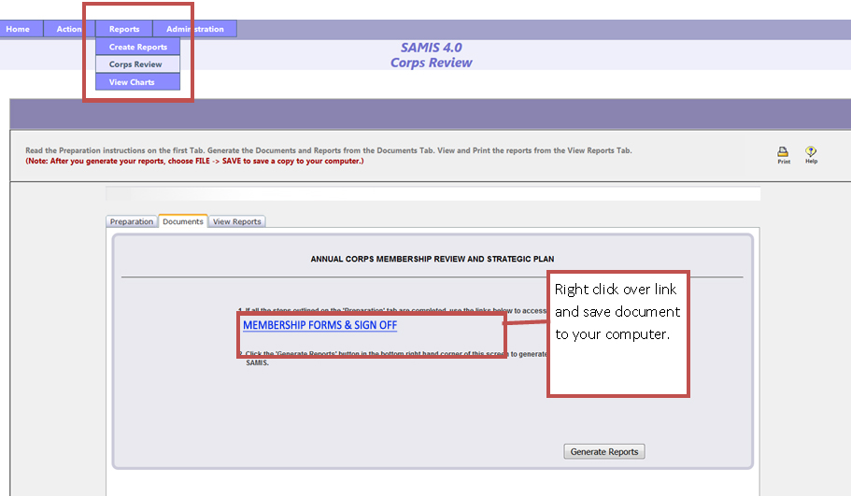
SUBMIT THE FORMS

MEMBERSHIP FORMS AND SIGN OFF
Upload your completed Membership Forms Document (this includes the Additions/Removal Pages for Corps Rolls and Women's Ministries, the list of leaders, and the sign off page.)

GROWTH HISTORY REPORT
Upload the Annual Review Report generated from SAMIS which includes: Location Information, Growth History, Corps Membership Collection Form.

