STRATEGIC THINKING INSTRUCTIONS

The annual review process is intended to encourage strategic thinking for each ministry focus of the corps. Every ministry section/program should engage in regular assessment, and set goals and objectives for the upcoming year.
The STRATEGIC THINKING worksheet provides an outline for discussion, and an opportunity to list the goals for the coming year in a concise and usable format. The HIGH PRIORITY GOALS can be copied and distributed to your leaders or posted as a reminder of the goals, and reviewed regularly at Mission Board or Corps Council. The AC will be holding you accountable for these goals.

STRATEGIC THINKING IS A PROCESS

- Make copies of the STRATEGIC THINKING worksheet for every ministry section/program.

- Plan a meeting with each group to assess the previous year and engage in strategic thinking together for the year ahead using the worksheet.

- Review the STRATEGIC THINKING worksheets with the Corps Council/Mission Board and establish 3 high priority goals for the corps. Complete the HIGH PRIORITY GOALS form (page 20) for review during the DHQ visit.

- Post and share the HIGH PRIORITY GOALS amongst the leaders of all your groups and review your goals regularly at leadership team meetings.

- Do not submit the STRATEGIC THINKING worksheets for each group to DHQ, but keep these worksheets on file for future review and evaluation.

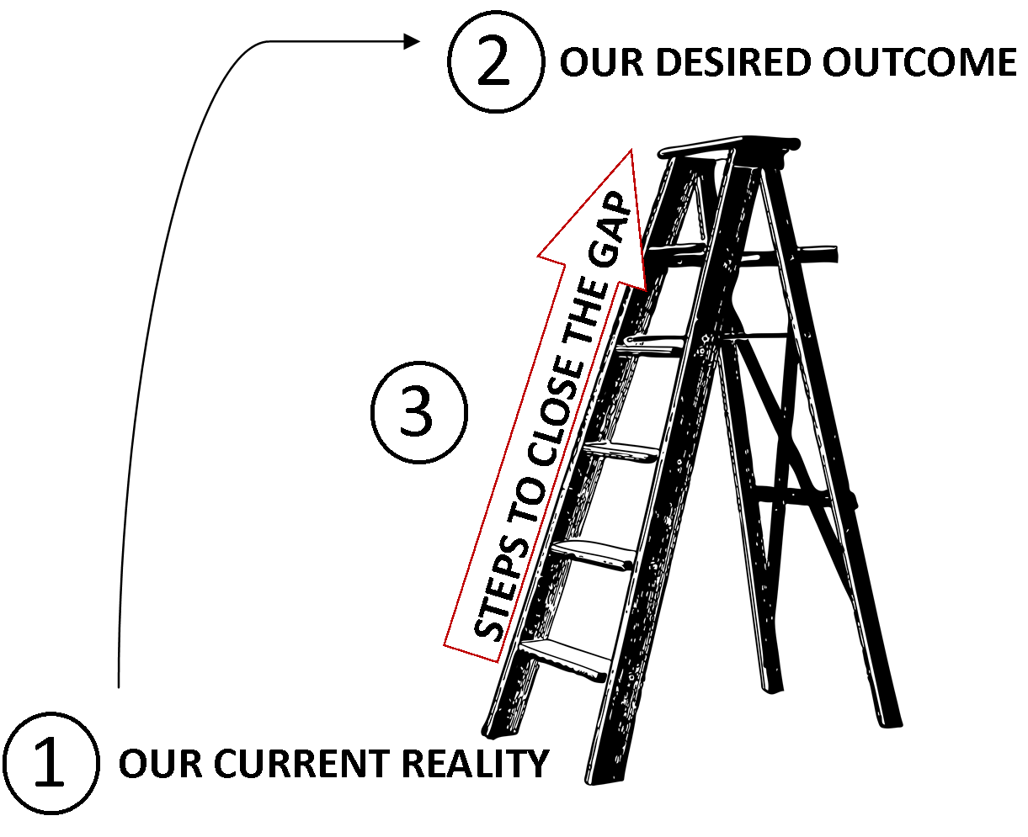

NOTE: This form is for local program/section goal planning. Only HIGH PRIORITY goals will be added to the GOAL REVIEW AND EVALUATION and submitted to DHQ.
STRATEGIC THINKING WORKSHEET _________________________________________________________
Name of ministry/program/section

STEP ① What is the current reality? Describe what the program/ministry is like now. What results have been seen from previous goals? What are the current key challenges for this ministry/program? (S.W.O.T.)

STEP ② Identify the desired outcome and goals. Consider setting specific goals for spiritual
growth, leadership development, attendances and financial outcomes. (S.M.A.R.T. Goals)

STEP ③ Identify the necessary steps to get from the current reality to achieve the
desired outcomes?

Steps |  | Target date | Person responsible
1.
2.
3.
4.
5.

