Social Services Orientation

For New Executive Directors

Canada and Bermuda Territory
April 2019

Contents
Introduction 3
Territorial Mission Statement And Core Values – Canada & Bermuda 3
Territorial Social Services Department 4
Accreditation 5
Community Councils 6
Contracts Processing 7
Employee And Labour Relations 7
Facilities And Occupational Health And Safety 8
Finance 9
Government And Legislation 9
Management Committees 10
Programs 11
Program Proposals 12
Program Proposal Process 13
Reports to DHQ/THQ 14
Spiritual & Religious Care 14
Volunteers And Auxiliaries 15

Introduction

The ministry of social services is at the heart of The Salvation Army in the Canada and Bermuda Territory. The Salvation Army operates in more than 130 countries where the purposes, practices, policies, and the scope of its programs make a difference. The Red Shield is recognized by many as the logo of a non-political organization which provides emergency assistance to individuals in need, and provides many programs and services to assist at every level of human need.

While services offered differ in each community, The Salvation Army meets human need by providing food, shelter and clothing; support for those in conflict with the law; operating shelters; providing rehabilitative programs for people with substance use disorders; operating homes and day programs for people living with developmental disabilities; and services to children, youth, adults and seniors.

Depending upon the new Executive Director’s background and previous experience, some concepts and matters regarding the operations and management of social services may be new. It is important for the newly appointed Executive Director in social services to be aware of how a social services setting may differ from a corps setting. It is expected that the Executive Director will become very familiar and develop a full working knowledge of these issues and concepts early in their new role.

Territorial Mission Statement And Core Values – Canada & Bermuda

Mission Statement
The Salvation Army exists to share the love of Jesus Christ, meet human needs and be a transforming influence in the communities of our world.

Core Values
Hope: We give hope through the power of the gospel of Jesus Christ.
Service: We reach out to support others without discrimination.
Dignity: We respect and value each other, recognizing everyone’s worth.
Stewardship: We responsibly manage the resources entrusted to us.

Territorial Social Services Department

Mission Statement

Motivated by the love of God and the life and teaching of our Lord Jesus Christ we provide leadership, consultation and expertise by pursuing excellence in the delivery of health and social services in the Canada and Bermuda Territory.
Social Services ministries are an integral part of The Salvation Army. These ministries “bring to life” the mission and mandate of the organization. The social services department fulfills a territorial role in supporting these ministries through:

Leadership
- Providing a territorial view and voice for the organization in relation to the Army’s ministries
- Influencing through communication of national, regional and local views
- Assisting with the training and development of personnel
- Identifying personnel with mission passions
- National networking

Consulting
- Providing a team of internal consultants for program, ministry and divisional development
- Partnering with Divisional Headquarters to ensure all health and social service ministry units have access to consulting support
- Identifying emerging social issues
- Providing coaching, facilitation, project management and training

Content Expertise
- Ensuring that ministry unit leaders have access to support for program development, program evaluation, knowledge sharing and networking
- Maintaining a level of program expertise in all areas of Social Services ministries
- Identifying emerging social issues

Championing Excellence
- Developing accreditation standards based on best practices
- Providing leadership to the Social Services Accreditation process
- Implementing organizational, operational and program reviews
- Developing resources, guidelines and policies
- Managing projects
- Engaging in research

Health Services
- Providing oversight and support for personnel appointed to spiritual and religious care in health services

Family Tracing
- Providing national program support and oversight
- Providing the international contact point for all family tracing activities

Accreditation
The accreditation process is a program and risk management tool to support ministry units and has the following goals:
- to support ministry units in achieving excellence in program delivery
- to provide operating standards for each area of Social Service ministry
- to provide a process for reviewing the performance of individual ministry units against these standards
- to identify high risk / critical issues in ministry units that represent liability for The Salvation Army
- to provide a tool to assist a ministry unit to improve its practices

The accreditation process is coordinated on a three-year cycle from the Social Services Department. Ministry units develop action plans to address areas that are not fully compliant with the requirements of the standard.

Ministry Units who achieve accreditation (by receiving 80% or higher in each chapter and submitting an action plan to address all standards found to be less than substantial) will be awarded one of the following statuses based on their overall average rating:

- Distinguished (>95%)
- With Commendation (90 – 94.9%)
- Accredited (80 – 89.9%)

Ministry Units who have only narrowly missed accreditation status with a rating of 70-79.9% in one or two chapters will receive a Conditional Pass. If, upon subsequent review of the one or two chapters, the conditions are met and the Ministry Unit achieves over 80%, Accredited Status will be awarded.

The THQ Social Services has a web based Toolkit that is located in a protected section of the salvationist.ca website. There is an extensive accreditation section available to assist Ministry Units in preparing for and succeeding in the Accreditation process. The toolkit contains samples of all policies and documents required for each Accreditation standard as well as several sample Policy and Procedure Manuals from a variety of Ministry Units. The salvationist.ca website can be accessed via an icon on myarmy or directly through the internet. Once at the website, navigate to Menu ►Social Services Toolkit. A “myarmy” log in is required.

Management committees should continually assess their performance in the accreditation process. Follow-up action is monitored by Divisional Headquarters.

Community Councils

A requirement of the accreditation standards is that all social services units have a community council. The community council is a representative group of local citizens who are prepared to take a genuine interest in the social services programs. The council acts in an advisory manner and works in cooperation with Divisional Headquarters, governments, and other agencies and groups within the community.

The purpose and mandate of the council can be found in the "Manual of Guidance for Community Councils" on the Social Services website. Each community council should have its own terms of reference, based on the manual of guidance, which outline how the individual council will operate. Individual terms of reference provide opportunity for the council to address local circumstances and requirements. (For example, the terms of reference should include the mission and vision statements of the service. This enables council members to identify and measure the service's focus).

Community councils are a great asset to the Executive Director and management team as they have a "pulse" on the community. Council members often have various backgrounds, skills and expertise that will assist the centre to effectively and efficiently understand and meet community needs.

Contracts Processing

The processing of contracts and related correspondence for execution by the Governing Council are directed to the THQ Legal Department for review and presentation to the Governing Council. Documentation related to property acquisition, and construction projects should continue to be forwarded to the Property Department. The Legal department staff will involve other individuals from DHQ and THQ to review contracts presented for execution and will manage the review process before presenting contracts for execution by Governing Council. The THQ Social Services consultants review contracts for completeness along with confirming that new projects are properly documented for risk assessment and completeness of program delivery and outcomes evaluation.

Employee And Labour Relations

The majority of social services units have employees. All employees will be covered under the provincial / territorial employee standards act (or equivalent) and any other act covering employment situations. The Salvation Army also has a number of policies and procedures covering employees, most of these are found in the Territorial Operating Policy Manual and the Employee Relations Policies and Procedures Manual. Most programs will also have additional employment policies, appropriate for the local conditions; these will be found in the unit's policy and procedure manual.

In some centres, some or all employees may be part of a union (the term bargaining unit is also used). A collective agreement will exist between the union and the centre. Depending on the province and the type of service, the collective agreement may be between the individual centre and the individual bargaining unit of the union or there may be a master agreement between several ministry units and the union. Provincial legalization and collective agreements regulate the rights and responsibilities of both the employer and the employee. Learning about managing the collective agreement and re-negotiating the agreement should be part of the ED’s educational training program.

Each Executive Director appointed to social services needs to be aware of and familiar with employee and labour relations acts, regulations, and agreements covering the program. Each Executive Director should also be aware of what and how The Salvation Army Operating Policies may be affected because of provincial requirements or collective agreements. (For example, the vacation policy may be different in a collective agreement than The Salvation Army Operating Policy). In all situations, provincial legislation and collective agreements take precedent over The Salvation Army Operating Policies.

Collective agreements only apply to those individuals who are within the bargaining unit. Therefore, it is not unusual to have slightly different procedures for employees within a centre where there may be more than one union and/or some employees non-unionized. Learning how to manage in such a situation and how to treat people as fairly as possible should be part of an ED’s education training program.

Facilities and Occupational Health and Safety

Programs operate in facilities that need to be continually maintained to ensure a safe working environment for staff and clients. When renovations or replacement of facilities are required, the territorial process is to be followed. This process is documented in the following Territorial Operating Policies:
Property General Guidelines
Building Projects
Health and Safety is everyone’s responsibility. Management is to encourage, support and enforce Occupational Health and Safety legislation. Provincial and Territorial regulations require safe work sites. Each jurisdiction has its own requirements for the establishment of Health and Safety Committees and/or Health and Safety Representatives. As the requirements vary by jurisdiction, Executive Directors must ensure that the specific requirements for your location are met in accordance with the relevant legislation. Executive Directors must also ensure that the Ministry Unit’s Health and Safety program meets or exceeds the applicable accreditation standards. Fire drills are to be documented, and carried out routinely.

When programs operate in rented facilities or other Salvation Army units, it is important that the Executive Director takes ultimate responsibility for health and safety (including fire) concerns of their staff and clients.

The goal is a non-adversarial atmosphere in which labour and management can work together to create a safer and healthier workplace. Safety issues raised should always be documented with an action plan developed to correct the issue.

Finance

Ministry units need to manage their financial accounts in a professional, accountable and transparent manner. This will include budget preparation, applying for funds, monitoring income and expenditures, reviewing financial variance reports and the production of reports to funders. Divisional headquarters must be informed first and should review documentation when applications or reports are being submitted to outside funders. Further information, resources and policies on finance are found in the Finance section of the Operating Policies, the Territorial Finance Manual and Divisional Headquarters.

Government And Legislation

All social services programs will be regulated by municipal, provincial / territorial and/or federal legislation. Legislation will cover three main areas:

program (service) focus
- building/property/safety, and
- employee/labour relations.

In all situations, building/property/safety and employee/labour relations will apply. Program legislation will depend on the type of service and whether or not the service(s) are government funded. In some social services areas, program legislation may also regulate building and safety issues - i.e., in many provinces Acts outlining the provision of residential services (in addictions, correctional, long term care, women, children etc.) may include additional building or safety issues beyond what is in the building code.

There are also municipal by-laws and regulations that may apply. These often address building/property/safety issues (i.e. building permits for renovations) but may also cover such things as licensing.

Each Executive Director in social services needs to be aware of, and be familiar with, any acts or regulations that govern the ministry unit. Most of the legislation will be provincially or municipally based, but in certain areas, federal requirements will also come into play (i.e. Correctional and Justice Programs). Copies of the major legislation covering the program should be on file.

Programs that receive government funding will have a working relationship with a person (or a team) representing the Ministry funds are received from. Federal funding is generally from Corrections Canada. Municipal funding is usually provided for housing and homelessness as well as food security. The four major provincial Ministries social services work with include housing and homelessness, community and social services, correctional and justice services, and health. In some programs, funds may be received from more than one Ministry. The type of working relationship depends on the province, and the ministry involved; however, usually there is a system of accountability and reporting required to the appropriate Ministry.

Management Committees

Management committees operate at all larger ministry units and exist to manage the affairs of the ministry unit. The membership of the committee should consist of the following sections: Executive Director, Finance, Employee Relations, Facility, and Program. It is important that this team deal with issues that arise, strategic planning and documentation of decisions made. Monthly management committee meeting minutes and agendas should be circulated to DHQ. The Management Committee operates through various functions, often classified as planning, organizing, leading/motivating and controlling.
- Planning: deciding what needs to happen in the future (today, next week, next month, next year, over the next five years, etc.) and generating plans for actions.
- Organizing: making optimum use of the resources required to enable the successful carrying out of plans.
- Leading/Motivating: exhibiting skills in these areas for getting others to plan an effective part in achieving plans.
- Controlling: monitoring – checking progress against plans, what may need modification based on feedback.

Programs

Ministry units may have one or many programs to meet the needs of specific persons/groups in need. Programs require specific plans and goals that are continually monitored and evaluated to make sure that needs are being met and goals realized.

Programs can be expanded and/or developed when new opportunities present themselves. Discussions with management teams and divisional headquarters should be part of the process.

The accreditation standards for various programs provide guidance on the content that should exist in program plans and evaluation.

Social Service programs:
- Meet human need
- Meet mission effectiveness
- Are sustainable
- Have program outcomes that can be measured and evaluated
- Are supported by the community
- Provide opportunities for networking as a continuum of care

Program Proposals

The Mission of The Salvation Army is realized through its program/ministry initiatives. To ensure maximum impact of personnel, finance and property resources upon mission advancement, all programs must be developed through the Program Proposal Form process in consultation with divisional personnel and territorial consultants (see Operating Policy: Program Proposals - Social Services/Corps Ministries It is important to include these person’s in dialogue early in the project. This will assist with the overall success of a project. Programs must have specific purposes and measurable outcomes. Ministry Unit Leadership/management teams must sign the form before it is forwarded to Divisional Headquarters who will examine the proposal for completeness and their support before it is forwarded to THQ.

Program Proposal Process
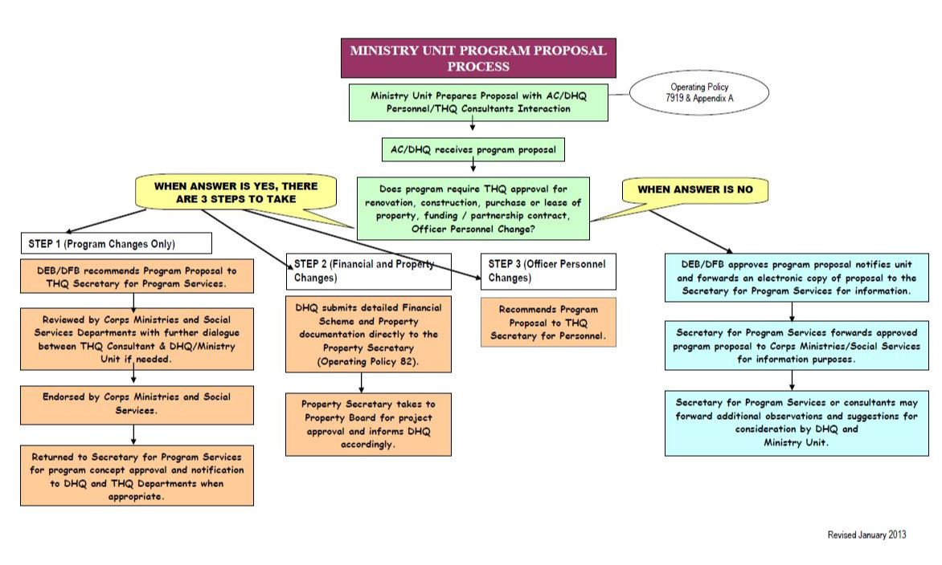

Reports to DHQ/THQ

It is the role of the Executive Director to keep DHQ/THQ informed of ministry units operation, along with proposed changes in legislation that impact their ministry. This will also include:
- Engaging DHQ/THQ in project proposals and program development
- Reporting all incidents to DHQ and government authorities when required per regulations
- Reporting Government discussions and communications
- Reporting incidents that may be news worthy
- Informing THQ Risk Management, DHQ personnel and the insurance companies when there is an occurrence that could result in a liability claim. The Liability Incident Claim Report Form to be completed for this purpose can be found in the Operation Policy “Insurance – Comprehensive General Liability.”

Spiritual & Religious Care

Every Ministry Unit must have a spiritual and religious component. When a dedicated person is not appointed to this position, it is up to the Executive Director and the management team to put in place procedures and practices to meet this requirement. This could be by one of the following methods:

- Hiring someone to fulfill this duty either full time, part time or as a volunteer
- Partner with a corps to fulfill the requirements needed at the ministry unit
- Assign this duty to existing staff member(s)

Record keeping and documentation of activities with outcomes must be kept and meet privacy legislation. The following documentation from the accreditation review process highlights the requirements:
- Policies and procedures for Spiritual And Religious Care
- Program Plan for Spiritual And Religious Care
- Roster Of Programs / Worship Services
- Spiritual and Religious Care Log
- Spiritual and Religious Care Client Files
- Position Description For Director Of Spiritual And Religious Care and / or Chaplains
- Budget For Spiritual And Religious Care

Volunteers And Auxiliaries

Many centres will have a group of volunteers or an auxiliary association. Volunteers and auxiliary members comprise a vital part of the social services "team". Most social services ministries will be enhanced through the effective use of volunteers. The volunteer group is usually community people who want to lend a hand in some way to assist the centre in meeting the needs of its clients. Ideally someone within the centre will be responsible for monitoring and supervising the volunteers including appropriate screening and "hiring" process, orientation and on-going training and supervision. Volunteers can be used in all areas of service, both direct and in-direct (i.e. administrative) services to the clients.

The auxiliary association is usually an organized group of volunteers whose primary purpose is to increase the comfort and well-being of the clients through raising funds for the program. Auxiliaries are often involved in various low key fund raising activities through a year such as sales and special events. Auxiliaries typically have their own by-laws or constitution which governs how they operate. The Executive Director is required to have a close working relationship with the Auxiliary, especially the President of the Auxiliary. The volunteer manual is located on Lotus Notes under Manuals ►Territorial ► Public Relations and Development.

