4.1 Spiritual Care
2016
POLICY & PROCEDURE MANUAL

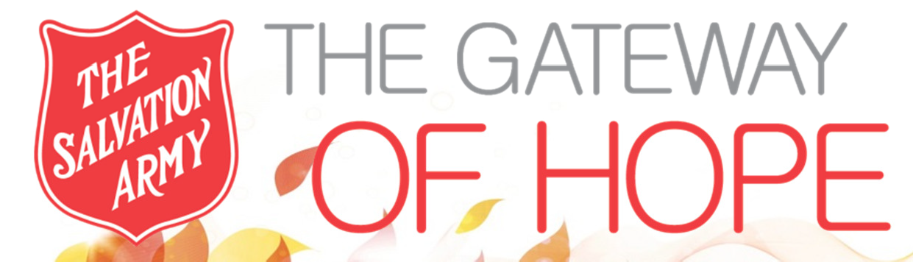

TABLE OF CONTENTS

Guest’s Spiritual Formation 4.1.0
Guests from Different Faith Backgrounds 4.1.1
Individual Spiritual Care Plan 4.1.2
Corporate Worship 4.1.3
Spiritual Care and Special Events 4.1.4
Distribution of Literature 4.1.5
Guests Decisions for Christ 4.1.6
Staff / Volunteer Access to Services 4.1.7

4.1.0 Guest’s Spiritual Formation

Department: Spiritual & Religious Care
Approved By: Planning Team
Issue Date: February 2010
Updated: June 2016

Policy

The Salvation Army, as a Christian Denomination and social service organization, is committed to proclaiming the Gospel of Jesus Christ, meeting human need and addressing suffering and poverty in the name of Jesus Christ without discrimination. Gateway of Hope is a Christ-centred community and extension of the greater ministry of The Salvation Army. In keeping with this we will facilitate spiritual care programs and services for the purpose of proclaiming the Christian Gospel and encouraging all who come to us to find hope, life and healing in Jesus Christ.

Procedure

Spiritual care activities are based upon the principles and doctrines of the Christian faith and of The Salvation Army and are focused upon the proclamation of the Gospel and more specifically, Jesus Christ.

Spiritual formation is defined as an intentional movement toward maturity of faith. On an individual basis, the Spiritual Care Coordinator will meet with guests to provide a structured program which will encourage development in relationship with Christ. Through the practice of varying spiritual disciplines and exercises, the individual will be guided in matters of faith and character.

Guests are encouraged to engage in personal prayer, religious reading and reflection.

4.1.1 Guests from Different Faith Backgrounds

Department: Spiritual & Religious Care
Approved By: Planning Team
Issue Date: February 2010
Updated: June 2016

Policy

It is understood that some of our guests may hold to religious views or belong to faith groups that differ from the views and teachings of The Salvation Army. The Salvation Army Gateway of Hope respects these differences.

Procedure

Guests who seek to pursue spirituality outside of the basic tenants of Christian teaching or receive counsel from spiritual mentors other than Gateway of Hope Spiritual Care staff may do so at the religious institution of their choice.

The formal and public observances, rituals, practices, meetings or services of other faith groups will not be permitted within The Gateway of Hope facility.

Upon request Gateway of Hope Spiritual Care staff will be available to assist these guests in locating nearby religious institutions of their choice.

4.1.2 Individual Spiritual Care Plan

Department: Spiritual & Religious Care
Approved By: Planning Team
Issue Date: February 2010
Updated: June 2016

Policy

All new guests, where possible, will be introduced to the Spiritual Care Coordinator and provided an opportunity to develop a spiritual care plan.

Procedure

Request for spiritual care information or an appointment with the Spiritual Care Coordinator may be made through any staff member.

A spiritual care intake form will be completed for OP guests upon entry to their program. Emergency Shelter guests who express a desire to connect with the Spiritual Care Coordinator may also use this form. This form will be included as part of the guests spiritual care file.

Spiritual care will take many forms such as listening and conversation, teaching the word, prayer, encouragement, guidance and the development of a spiritual care plan.

The spiritual care plan will be created by the Spiritual Care Coordinator with the input of the guest. Each person is unique; therefore the spiritual care plan will reflect the individual’s specific needs.

Spiritual Care Program information will also be available at The Gateway of Hope reception desk.

4.1.3 Corporate Worship

Department: Spiritual & Religious Care
Approved By: Planning Team
Issue Date: February 2010
Updated: June 2016

Policy

Regular worship services and teaching will be held at Gateway of Hope as an opportunity for guests, community members, staff, volunteers and visitors to engage in community worship, Christian teaching and fellowship.

Procedure

A variety of styles are used to:

- Introduce people to the love of Jesus Christ.

- Build community, connection and support.

- Provide sound Christian Biblical teaching.

- Provide inspiring worship and prayer.

Spiritual care programs include: morning chapel service, mid-week Bible study and other edifying services.

Gateway of Hope spiritual care programs and services are open to all. Attendance is not mandatory for Gateway of Hope guests.

4.1.4 Spiritual Care & Special Events

Department: Spiritual & Religious Care
Approved By: Planning Team
Issue Date: February 2010
Updated: June 2016

Policy

Gateway of Hope spiritual care will ensure a spiritual and ministry focus at special events and programs designed to celebrate the Christian calendar and traditions as well as promote Christ-centered community among guests, staff, volunteers and visitors.

Procedure

In keeping with our mission, Gateway of Hope will host special meals and services for Thanksgiving, Christmas and Easter and will ensure prayer and the recognition of God’s presence and provision.

Generally, the Spiritual Care Coordinator will be responsible for ensuring a ministry presence and for planning and leading such things as devotions, prayer or special programs of music.

Prayer at public promotional and fundraising events will also be shared between members of the Planning Team.

    - Distribution of Literature

Department: Spiritual & Religious Care
Approved By: Planning Team
Issue Date: February 2010
Updated: June 2016

Policy

The Gateway of Hope believes in the power of God’s Word to heal and transform lives. Christian literature will be available to guests, staff, and volunteers.

Procedure

Bibles will normally be kept in the supply room and the Spiritual Care Coordinator’s office. For those who desire a copy of the Bible, one will be provided.

Copies of Faith and Friends, Our Daily Bread and other approved Christian magazines will be available free of charge in the front lobby and at the Aldergrove Thrift Store.

    - Guest Decisions for Christ

Department: Spiritual & Religious Care
Approved By: Planning Team
Issue Date: February 2010
Updated: June 2016

Policy

As we are made aware, decisions for Christ will be tracked as a means to assist those new in the faith in their spiritual growth and discipleship.

Procedure

Decisions for Christ will be noted in the guest’s spiritual care case file. This information will be shared with the guest’s OP Advisor or Shelter Worker where applicable.

Where practical and with the agreement of the guest, a discipleship plan identifying courses, services and/or Bible studies essential to the guests spiritual growth will be developed and agreed upon with the guest and implemented.

A reasonable effort will be made to connect the new believer into a local church.

Decisions for Christ will be forwarded to the Planning Team at the end of each month and recorded in the appropriate statistics column of The Gateway of Hope SAMIS statistics sheet.

    - Staff and Volunteer Access

Department: Spiritual & Religious Care
Approved By: Planning Team
Issue Date: February 2010
Updated: June 2016

Policy

Spiritual Care services are available to staff and volunteers.

Procedure

The Spiritual Care Coordinator will be available upon request for foundational guidance in the Word, prayer, debriefing, encouragement and in times of crisis.

Otherwise, staff and volunteers will be encouraged to connect with their local church where there is a need for ongoing pastoral care and support.

