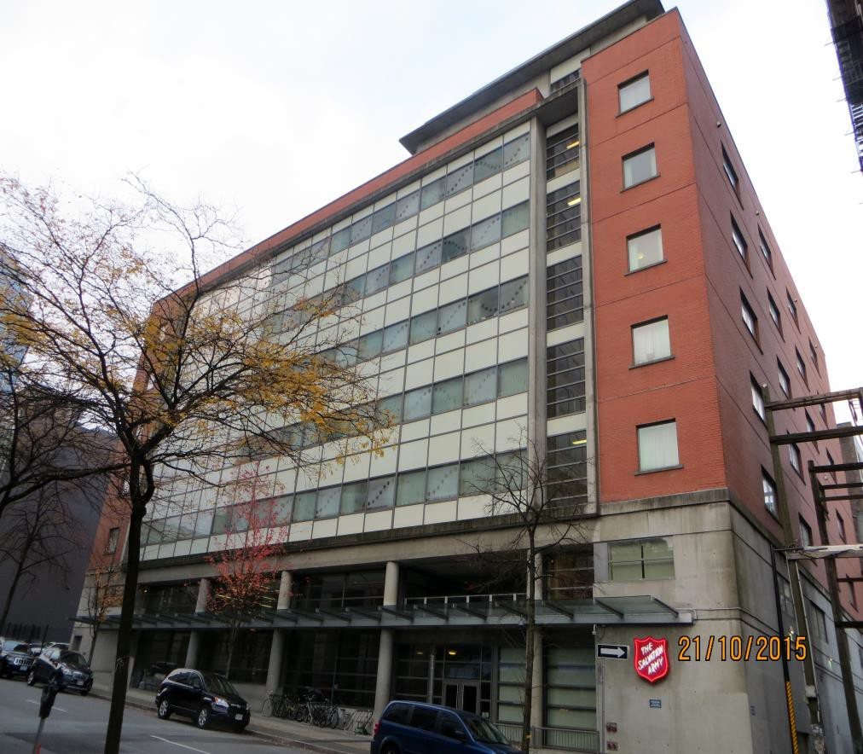
FIRE SAFETY PLAN

Fire Safety Plan
BELKIN HOUSE 555 HOMER SREET VANCOUVER

Revised: February, 2016

FIRE SAFETY PLAN

This Fire Safety Plan was prepare by:
EMT Management Inc. 679 Swanson Place
Port Coquitlam, B.C. V3B 7M2 Email: emtmgt@shaw.ca
(604) 944-8583 Fax (604) 944- 8583

NOTE: IT IS YOUR RESPONSIBILITY as owner/agent of the building equipped with a fire alarm system to ensure that these daily, monthly, and yearly tests are carried out and are properly recorded.

TABLE OF CONTENTS

FIRE DEPARTMENT INFORMATION
Smoke Control 5
Fire Department Key Box Location 6
Supervisory Staff & Appointment of the Fire Safety Director and Deputy 7
Emergency Contacts 8
Building Description 9
Fire Alarm Description / Location 11
Electrical Room Location 15
Elevators 15
Emergency Generator 17
Exiting 17
Fire Doors 17
Fire Department Access Route 17
Fire Department Connections 17
Fire Department Roof Access 18
Fire Hydrant Locations 18
Fire Pump 18
Gas Shut-Off Location 18
Hazards 18
Portable Fire Extinguishers 18
Special Suppression System (Kitchen) 18
Sprinkler System Description / Location 19
Standpipe System 19
Water Shut-Off Location 19
Site Plan Drawings Floor Plan Drawings
PART 1
OBJECTIVES OF THE FIRE SAFETY PLAN 20
PART 2
SUPERVISORY STAFF AND FIRE SAFETY DIRECTOR
& DEPUTY FIRE SAFETY DIRECTOR RESPONSIBILITES 21
PART 3
INSTRUCTIONS TO OCCUPANTS 29
PART 4
INSPECTION TESTING MAINTENANCE
OF FIRE PROTECTION EQUIPMENT 35

PART 5
CHECKLISTS 50

PART 6
LEGAL BASIS FOR FIRE SAFETY PLANNING… 65

PART 7
DEFINITIONS 69

APPENDIX
ANNUAL FIRE INSPECTION REPORTS 72

FIRE DEPARTMENT INFORMATION

FIRE DEPARTMENT KEYS:

Location: One key box at the main entrance One key box at the front desk

SMOKE CONTROL MEASURES:
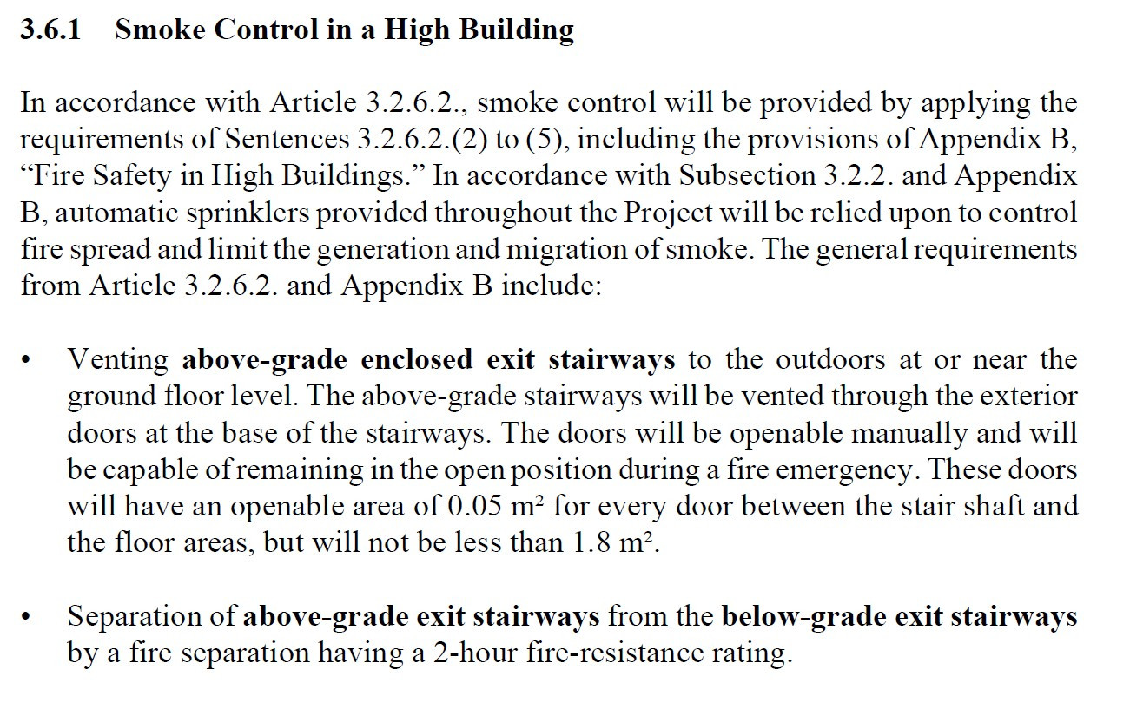

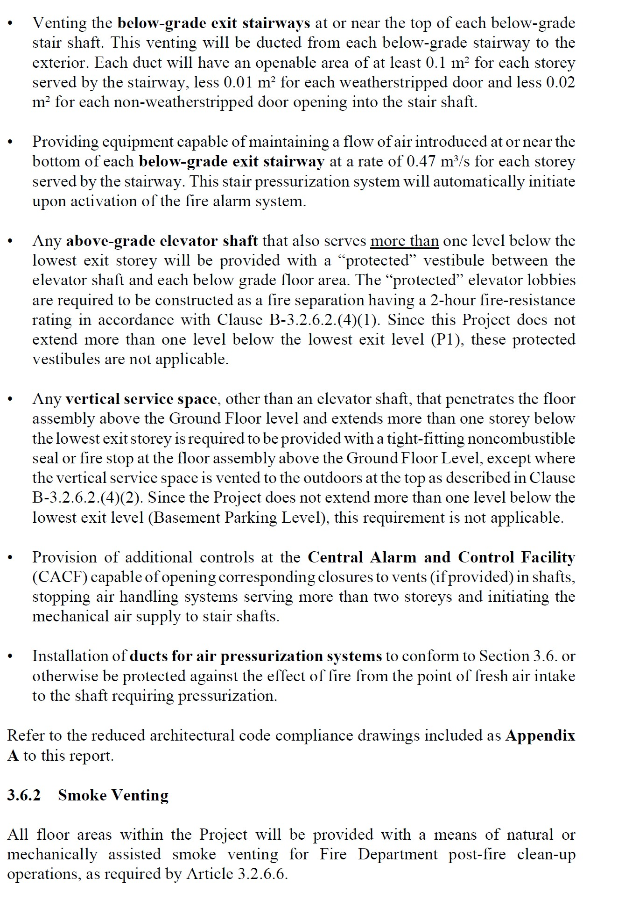

SUPERVISORY STAFF

Current Vancouver Fire Bylaw:

SUPERVISORY STAFF –

Occupants of a building who have some delegated responsibility for the fire safety of other occupants under the fire safety plan.

APPOINTMENT OF THE FIRE SAFETY DIRECTOR

DATE: February, 2016 NAME: John Pavey
TELEPHONE: 604 – 341 – 4374 HOURS: 24/7
John Pavey is the Fire Safety Director and is authorized to fulfil the duties as outlined in the Fire Safety Plan.

APPOINTMENT OF THE DEPUTY FIRE SAFETY DIRECTOR

DATE: February, 2016 NAME: Caro Lander
TELEPHONE: 778 – 228 - 6355 HOURS: 24/7
Caro Lander is the Deputy Fire Safety Director and is authorized to fulfil the duties as outlined in the Fire Safety Plan.

EMERGENCY CONTACTS & CRITICAL TELEPHONE NUMBERS

Vancouver Fire Department 911
Vancouver Fire Department (non-emergency) 311
Police Department 911
Ambulance 911

Poison Control 604 – 682 – 5050

B.C. Hydro 1 - 888 – 769 – 3766

Fortis Gas 1 - 800 – 663 – 9911

Fire Alarm Chubb Edwards 604 – 420 - 4436

Monitoring Tyco Security 604 – 683 - 4111

Elevators Richmond Elevator 604 – 274 - 8440

Emergency Lighting Chubb Edwards 604 – 420 - 4436 Emergency Generator Cummins Western Canada 604 – 882 - 5000 Fire Pump Rich-Tek Industries 604 – 557 - 0008
Portable Extinguishers Chubb Edwards 604 – 420 - 4436

Suppression System
Kitchen Great West Fire 604 – 570 - 0062

Sprinkler System Gisborne Group 604 – 520 - 7300

Standpipe System Chubb Edwards 604 – 420 - 4436
Fire Safety Director John Pavey 604 – 341 – 4374 Deputy Fire
Safety Director Caro Lander 778 – 228 - 6355 Fire Safety Plan EMT Management Inc. 604 – 944 – 8583

BUILDING DESCRIPTION

Building address: 555 Homer Street, Vancouver, BC

Building type: Non-Combustible, 2012 BCBC as per Div. B, Part 3.1.5

Occupancy:
Lounge, Chapel, Group “A” Div. 2
Community Residential Facility Group “B” Div. 2 Residential Emergency Shelter, Group “C” Offices, Group “D”
Parking/ Storage/ Workshops, Group “F” Div. 3

Number of levels above grade: 8 plus, Mechanical Penthouses

Number of levels below grade: 1

Access to underground: Lane

Main construction material: Reinforced concrete.

Exterior walls & windows: Reinforced concrete with glazing.

Interior walls & finish: Gyproc over steel studs with various types of wall coverings.

Floors: Concrete, with various coverings.

Roof construction: Concrete slab, 2 ply SBS.

AREAS OF USAGE:

Basement: Parking, Transformer Vaults, fire Pump, Emergency Generator, Storage Areas, Maintenance Shop, Electrical Distribution Room, Sprinkler Room

Level 1: Front desk, Reception, Kitchen and Dining, Multi-purpose hall, Classroom Loading bay

Level 2: Offices, Chapel, Classrooms, Computer lab. Staff lunchroom, Staff Changing Room, Washrooms

Level 3: Men’s emergency dormitories, Residential Facility for men, Garden Courtyard

Level 4: Community residential facility for men Level 5: Residential facility for men
Level 6: Residential facility for men and women

Level 7: Residential facility for women. Access to West Wing Roof Level 8: Administrative office, Boardroom, Community garden & Patio

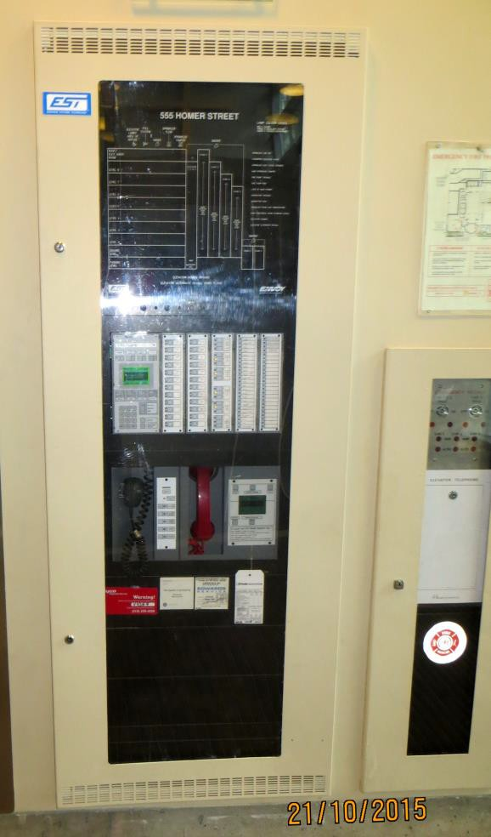
FIRE DETECTION AND ALARM SYSTEM:
Manufacturer: EST Stages: Two Supervised: Yes Monitored: Yes
Voice Communication: Yes Fire Fighter Telephone: Yes

Fire Alarm Annunciator Panel (FAAP):
(See floor plan drawings) Location: Main Lobby

Fire Alarm Control Panel (FACP):
(See floor plan drawings)

Location: Main lobby

Heat Detectors:

Top of stair Elevator shafts

Smoke Detectors:

Locations:
- Elevator lobbies
- Suites
- Top of stairs
- Common Hallways

Duct Smoke Detectors:
Locations:

7th floor, roof top AHU # 2 8th floor, roof top AHU # 1

Manual Pull Station Locations:
Adjacent to all designated fire separations, fire exit stairs, and exterior exit doors.

FIRE ALARM PANEL - SEQUENCE OF OPERATIONS:

FIRST STAGE “ALERT TONE” is initiated by the activation of any of the following:

- Automatic detection devise (smoke or heat detector)
- Manual pull stations
- Kitchen hood suppression system
- Sprinkler head flow switches

Upon ALERT initiation, the following will occur:

- Buzzer/Bell tones sound throughout all audible alarm devises at T3 temporal pattern (Slow: 1 beat follows 3 seconds silent one beat repeated)

- Initiating zone and devise is indicated on the annunciators (LED Lights and LCD screen displays and Main Fire Alarm Panel

- Electromagnetic hold close devises on fire doors will release and allow doors to open.

- The monitoring company will contact the Fire Department.

During an ALERT, occupants and staff not having designated responsibilities continue their normal activities.

SECOND STAGE ALARM IS INITIATED BY ACTIVATION OF ANY OF THE FOLLOWING:

- Automatic detection devise (smoke or heat detector)

- A key switch at a manual pull station

- Expiry of an automatic 5 minute timer that start at the beginning of the Alert condition, if action is taken in the meantime (acknowledge the Function Key)

- Buzzer/Bell tones sound throughout all audible alarm devises at T3 temporal pattern Fast: 3 beats follows 1 seconds silent one beat repeated)

- Initiating zone and devise is indicated on the annunciators (LED Lights and LCD screen displays and Fire Alarm.

- The monitoring company will contact the Fire Department.

On ALARM, evacuation procedures must begin immediately in all zones affected. All occupants and staff will evacuate to the outside and proceed to the Assembly Area, as directed by supervisory staff or the Fire Department.

ALARM MODES:
The fire alarm system can be in one of the following modes as described below:

NORMAL:
System is operating under normal status with no trouble or alarm conditions

- LED panel displays: Green AC power LED light on trouble and zone LED lights remain off

- LCD screen displays SYSTEM STATUS: NORMAL

TROUBLE:
This mode indicates system malfunction, including power or device faults, bypass or silence

- LED panel displays YELLOW LED on, local buzzer starts RED LED on, if applicable to indicate location of trouble
- LCD screen displays SYSTEM STATUS and indicates current system or device condition
- FACP sounds: local buzzer sounds to alert of trouble status, may be silenced using local silence key function

ALARM:
Alarm audible devices sound throughout the building
- LED panel displays: RED LED indicates zone in alarm
- LCD screen displays: zone in alarm, device and room location indicated on screen display
- Buzzers/Bells/Horns: activate and sound throughout building

ALARM CONTROLS:
Function keys are provided to perform the following

BUZZER SILENCE:
Press to silence panel and remote buzzers

ACKNOWLEDGE:
Press to prevent automatic time-out to second stage. This has no function in a single stage system

SIGNAL SILENCE:
Press to silence all audible signals during alarm (normally delayed for one minute) on active circuits configured to be affected by this function and cancels when a new alarm is received. Pressing this key will initiate a “panel trouble”. If key is pressed again, signals are restarted and associated “panel trouble” should clear.

SYSTEM RESET:
Press to reset all initiating circuits, device signals, system timers and clear trouble and alarms, provided the conditions that caused these signal/alarms no longer exist. The SYSTEM RESET key will not change the state of auxiliary of individual zones.

FIRE DRILL:
Press to reset audible devices throughout the building by sounding alarm to a fire drill.
**Notify alarm monitoring company before conducting a drill test and immediately after the test is concluded**

LAMP TEST:
Press to test all LED indicators on LED panels to confirm that LED function is normal.

AUXILLIARY DISCONNECT:
Press key to prevent operation of common alarm and common supervisory contacts. Pressing this key creates a system common trouble condition.

GENERAL ALARM:
Press to operate the second stage alarm signal mode in a two stage system. This has no function in a single stage system. All auxiliary devices affected by fire alarm activation will function.

Ancillary Devices:
- Magnetic hold-close fire doors in corridors release and open on second stage alarm.
- Sprinkler tamper switches.
- Kitchen suppression systems

HOW TO OPERATE THE PUBLIC ADDRESS SYSTEM:
- Activate the switch on the P.A. system for the floor(s) that you wish to address, or activate the “ALL CALL” switch of the panel if you want to address the entire building.

- Pick up the microphone and squeeze the button on the side of the microphone and give instructions. Speak into the microphone in a normal voice.

- After completing the message, deactivate the selector switch for the area called and return microphone to the cradle.

HOW TO OPERATE THE FIRE FIGHTER PHONES:
- Pick up the “Master Handset” upon determining that someone within the building wishes to communicate with you. When the party picks up a fire fighter phone, a light will illuminate on the fire alarm panel and a buzzer will sound.

- Answer the call, identify yourself and ask that the caller identify themselves.

- Upon completion of the call, return the handset to the cradle.

ELECTRICAL ROOM & EQUIPMENT:
(See plan drawing)

Location: Basement/ Parkade

EMERGENCY LIGHTING UNITS:

The emergency lighting units are on the emergency generator in case of power failure. There are also some emergency lighting units that are powered by battery (30 minutes) in case of a power failure.

ELEVATOR(S):
(See floor plan drawings)
Type: Passenger Capacity: 4500 lbs.

ELEVATORS (FIREFIGHTER’S)
(See floor plan drawings)

All Elevators are designated as fire department

Second floor is the Alternate floor

HOW TO OPERATE THE FIRE FIGHTER ELEVATORS:

In-cab:

Step One:
- Insert key into the recall switch and turn to the “ON” position.

Step Two:
- The opening of the power operated doors will be controlled only by continuous pressure on the “Door Open Button”, the Door Open Button is released during the “Open Motion” and the door will close immediately. When the doors are fully open they will remain open until the operator closes the doors.

- Door re-open devices for power operated doors shall be rendered in- operable.

- Momentary operation of the key switch to the “HOLD” position will cancel registered car calls.

- When the car is at the landing and keyed switch in the car is turned to the “Hold” position, the doors will remain open and the car cannot be registered.

- When the car is at the landing and the keyed switch in the car is turned to the “OFF” position, the car will automatically return to the recall level as on emergency recall position, regardless of the position of the emergency switch.

Step Three RESET:

- Turn selector switch to AUTO when Fire Fighting operations are complete. Return elevator control switches back to AUTO for normal operation.

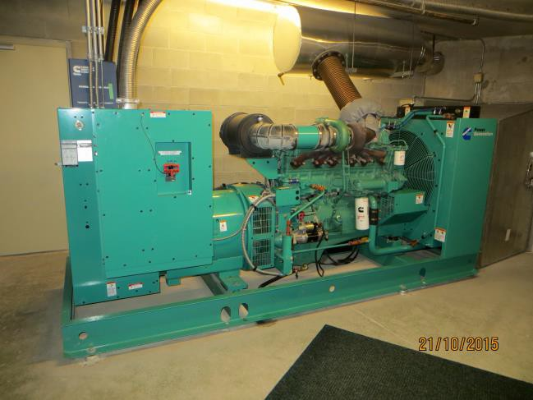
EMERGENCY GENERATOR:
(See floor plans drawings) Location: Basement/Parkade
Fuel: Diesel KVA: 375

Supplies power to:
- Emergency Lighting
- Exit lights
- Fire Alarm System
- Elevators
- Smoke Control Fans
- Fire pump

EXITING:
(See floor plan drawings)

Stairway #A: Lead from ground to the sixth floor Stairway #B: Lead from the seventh floor Stairway #C: Lead from ground to the eighth floor Stairway #D: Lead from ground to the eighth floor
Stairway #E: Lead from ground to the Basement/Parkade Stairway #F: Lead from ground to the Basement/Parkade

THIRD FLOOR & EIGHTH FLOORS ARE THE CROSS – OVER FLOOR

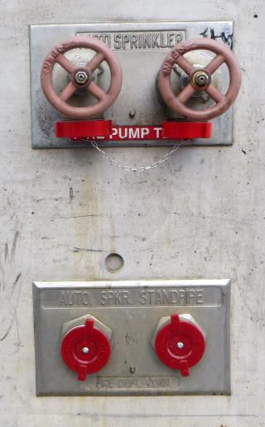
FIRE DOORS:
All designated internal fire doors have closures that are self-closing. All locking devices will disengage on first stage alarm with exception Of the fourth floor which will disengage on second stage alarm.

FIRE DEPARTMENT ACCESS ROUTE:
(See site plan drawing)

Primary: Right side of the main entrance along Homer Street

FIRE DEPARTMENT CONNECTIONS:
(See site plan drawing)
Locations: South & North ends of the building.

FIRE DEPARTMENT ROOF ACCESS:
(See floor plan drawing)
Location: North east corridor 8th floor Stairway D

FIRE HYDRANT(S): Public
(See site plan drawing)

Locations: Corner of West Pender & Homer Street

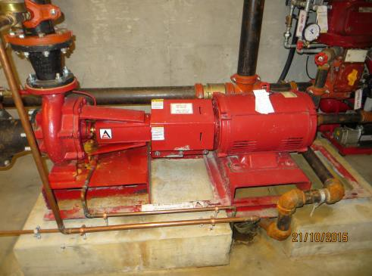
FIRE PUMP:
(See floor plan drawing)

Type: Wag PSI/GPM: 90 psi boost @ 500 gpm Location: Sprinkler Entry Room

GAS SUPPLY SHUT-OFF:
(See site plan drawings)

Location: Northwest side of the building

HAZARDS:
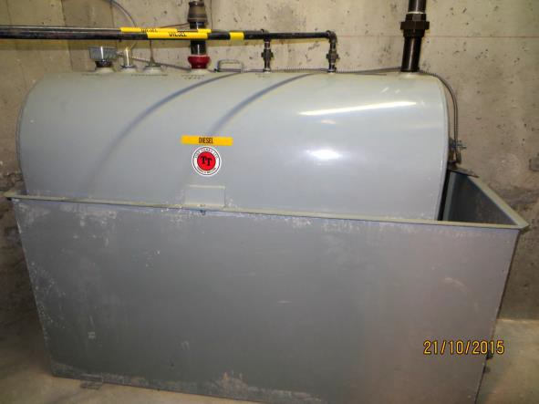
(See plan drawings) Location: Generator Room Description: Diesel Tank

HEATING, VENTILATION & AIR CONDITIONING:
Type: Forced air.

PORTABLE FIRE EXTINGUISHERS:
(See floor plan drawings)
Types: ABC Dry Chemical, CO2, K Class Locations: Dry Chemical throughout the building
CO2, Mechanical Room K Class in the Kitchens

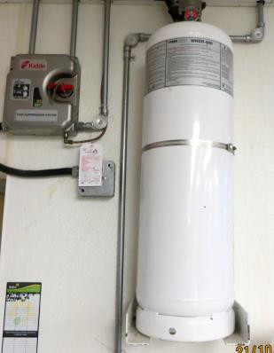
SPECIAL SUPPRESSION SYSTEM (KITCHEN):
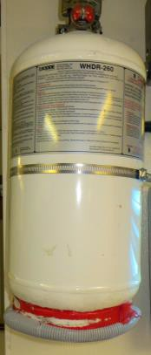
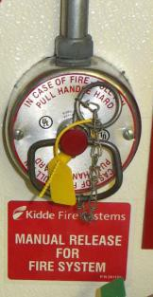
(See floor plan drawings) Location: Kitchen
Type: Wet-Chem

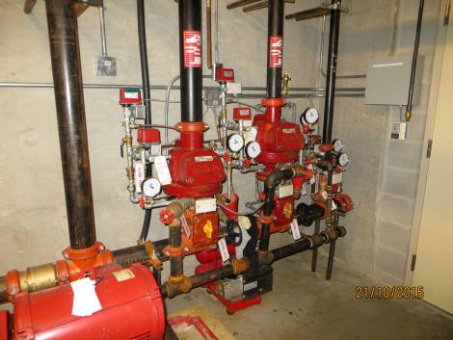
SPRINKLER SYSTEM:
(See plan drawing)
Type: Wet
Coverage: All areas above grade
Location: Water entry room, Basement/Parkade

Type: Dry
Coverage: Areas that are exposed to freezing temperatures. Location: Water entry room, Basement/Parkade

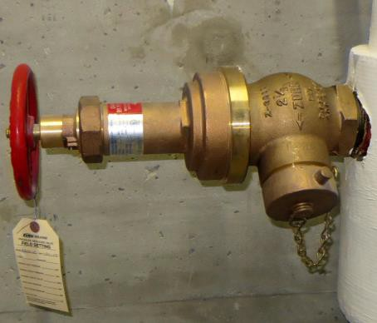
STANDPIPE SYSTEM:
(See plan drawing)
Type: Wet
Location: Stairways A, B, C, D, E, F, Basement Hallway Riser: 4 inch Connection: 2 ½ inch, VFD Thread type

WATER SUPPLY SHUT-OFF DOMESTIC:
(See plan drawing) Location: Water entry room

PART 1 – OBJECTIVES OF THE FIRE SAFETY PLAN
ENERAL:
Fire safety planning has three primary objectives:
  - Fire Hazard Control.
  - Fire Protection System Maintenance.
  - Emergency Evacuation.
Fire Safety Planning prevents the occurrence of fire by the control of fire hazards in the building. It ensures operation of fire protection systems by establishing maintenance procedures and provides a systematic method of safe and orderly evacuation of the building in the event of a fire.

EMERGENCY EVACUATION CONCEPT:
Trained supervisory staff can be of great value in directing and assisting the orderly movement of people in the event of a fire and performing fire control until the arrival of the Fire Department.
Evacuation procedures relying heavily on supervisory staff are complex in that these staff require continued training, frequent drilling and must be continuously on the premises in order to fulfil their responsibilities during an emergency. Conducting regular training and meeting sessions improve the preparedness for required response. A team approach is essential for life saving procedures to have any effect.
Based on these facts, the evacuation objectives outlined in this manual are required to be discussed and practiced regularly with consideration given to all areas of life safety.

EVACUATION SEQUENCE:
During an emergency, all occupants will exit the building via a safe exit. Physically challenged persons should proceed with their assistants, if available, to the nearest safe exit.
The Instructions for Occupants In Case of Fire posted prominently on each floor area provides quickly read information on procedures to follow in the event of a fire.
Use of this concept should ensure a systematic method of safe and orderly evacuation of the building in the event of a fire.

PART 2 – SUPERVISORY STAFF & FIRE SAFETY DIRECTOR & DEPUTIES DUTIES

The Fire Safety Director (FSD) is appointed in writing by the building owner. The FSD is not in the building on a continuous basis; however, the FSD must be available to respond to the building on notification of a fire emergency in order to fulfil his or her obligations as described in this Plan. The FSD is required to wear a designated hat or vest understood by occupants of the building as the FSD. In the event that the FSD is unavailable, a Deputy Fire Safety Director (DFSD) must be available to perform the obligations of the absent FSD.

FIRE SAFETY DIRECTOR AND DEPUTY
The BC Fire Code requires that the building fire protection and life safety systems receive a variety of regular inspections, service and maintenance. The majority of inspections are generally quick checks to ensure that the particular system is operational and not in need of service. Inspections do not require a high degree of technical knowledge of the particular system, but rather the ability to check for a specific problem and have it corrected. Such inspections can be performed by the FSD where he or she is in the building on a daily basis. Service and maintenance procedures generally involve technical procedures and will be performed by qualified individuals or private contractors specializing in the particular field. All the inspections, service and maintenance of all the life safety systems will be conducted by the Owner or authorized agent of the owner or their subcontractors.

GENERAL INFORMATION
It is important to remember that those persons on and above the floor involved in the fire are in the utmost danger and should be the first to be considered. Those people below the fire may not be in any immediate danger.
All key personnel should be instructed as to the location and use of fire fighting equipment such as fire extinguishers.
It is most important that everyone in the building be made aware of the absolute necessity of keeping stairwell doors closed at all times, except of course when the stairway is actually being used. One door propped or held open could mean that the entire stairway could become a smoke filled shaft and hinder the use of the stairwell as a means of exit.
All personnel must be instructed to close all doors behind them as they leave the building.

FIRE SAFETY DIRECTOR DUTIES AND RESPONSIBILITIES GENERAL:
Administering and maintaining of the Fire Safety Plan. This should include:
    - Updating the Fire Safety Plan when alterations are made to the building.
    - Training of Deputy Fire Safety Director(s).
    - Recording information on the following:
      - Fire incidents
      - False alarms
      - Fire drills
      - Discharge or operation of fire equipment
      - Training periods
      - Name, location and limitations of challenged persons and their assistants
      - Minutes of fire safety meetings.
Please ensure that fire protection systems are inspected, maintained, and serviced in accordance with the Plan and with the BC Fire Code. Where an inspection, maintenance or testing procedure is beyond in-house capabilities, it is his/her responsibility to have qualified personnel complete the procedure. This is the responsibility of the Owner or Authorized Agent of the Owner.

Refer to Part 4, Inspection, Maintenance and Testing of Fire Protection Equipment in this Fire Safety Plan for service requirements.
Ensuring that additional precautions are taken to offset the hazard to occupants where fire protection systems are inoperable. This should include:

    - Checking the Fire Safety Plan and BC Fire Code when fire protection systems are in need of repair.
    - Advising the Fire department of the system status.
Ensuring that building maintenance, alteration or renovation does not expose the building or occupants to undue fire hazards and precautions are taken to ensure building and occupant safety (see Precautions during Repairs, Alterations and Renovations). This should include:
    - Checking the Fire Safety Plan and the BC Fire Code when such activities take place to ensure that they meet with the Fire Safety Plan and the BC Fire Code Regulations.
Ensuring the supervisory staff is available to respond to the premises in the event of notification of an emergency. In particular, this should include notifying the DFSD when he/she will not be available.

Please provide information to occupants on general fire safety and evacuation procedures. This should include:
    - Provide new occupants with Part 3 of the Fire Safety Plan.
    - Notifying occupants whenever the FSD or DFSD changes.
    - Resolving any fire hazards that are reported by occupants, guests or the Fire Department.
    - Maintaining familiarity with the building’s fire protection systems.
    - Become familiar with fire regulations. This should include:
      - Obtain and review a copy of the BC Fire Code 2012.
      - Ensure that electrical rooms are not used for storage.
      - Ensure that established policies are adhered to.
Consider other emergency situations that could affect the building such as earthquakes or natural gas leaks.
Notify the alarm monitoring station (if applicable) when emergency contacts change.

FIRE SAFETY DIRECTOR/ DEPUTY FIRE SAFETY DIRECTOR’S EMERGENCY PROCEDURES

EMERGENCY EVACUATION:
The Fire Safety Director shall:
- Proceed to the main floor or location of the fire alarm panel.
- Be sure the Fire Department has been notified.
- Liaise with the DFSD and give instructions or requests what you want and need.
- Control and direct the evacuation once conditions have been determined.
- Maintain a checklist of floor evacuation and details of any missing or challenged persons for Fire Department personnel.

CONTROL OF FIRE HAZARDS IN THE BUILDING

Exits and Aisles – BC Fire Code [2012] 3.2.2.2.
All exits and aisles from the building must be kept free of obstructions at all times.

APPOINTMENT OF FLOOR WARDENS
Floor Wardens (Supervisors) and other appointed personnel act as Floor Wardens and are supplied to the Fire Safety Director. If for any reason the person(s) designated as the Floor Warden changes, the client/owner will make the FSD aware of the change.

GENERAL DUTIES OF FLOOR WARDENS
Their primary role is to facilitate the orderly evacuation of their designated floor area to the building’s designated assembly area(s).
Another role is to perform a daily check of their designated floor areas for:
- Accumulation of combustible or flammable materials.
- Ignition sources, example: worn extension cords, oily rags, over-heated equipment
- Exits lights illuminated, adequate lighting in the corridors
- Fire and exit doors are required to be closed and latched at all times. Door hardware shall be in good working order. Fire doors must never be blocked or wedged in the open position.
- All exit routes shall never be blocked or obstructed.

PRECAUTIONS DURING REPAIRS, ALTERATIONS AND RENOVATIONS

FIRE DETECTION AND ALARM SYSTEM:
When the system cannot be repaired such that it is in full operation by the evening, the following precautions should be implemented:

- Always notify the Fire Department when a protection system is going to be inoperative for any period of time.
- Contact a security company to have a fire watch remain at the premises until the system is fully operable.
- The fire watch shall make inspection rounds of all areas of the building every forty-five (45) minutes, twenty-four (24) hours per day and maintain a logbook.
- The fire watch shall remain on the property between rounds.

AUTOMATIC SPRINKLER SYSTEM:
Alterations:
It is the responsibility of the sprinkler contractor to test the system in accordance with the BC Fire Code following any repairs, alterations and/or renovations.
Programmed Repairs:
Where operations require a temporary shutdown of sprinkler protection, such operations shall be programmed by the contractor working on the system to enable completion in the shortest possible time so protection can be restored as promptly as possible.
Additional Precautions During Shutdowns:
During an interruption of normal sprinkler protection, emergency hose lines and portable fire extinguishers shall be provided, extra fire watch shall be placed on duty and temporary water connections shall be made to the sprinkler system where practicable.
Discontinuance of Work:
Full sprinkler protection shall be restored or provision of additional precautions during shutdowns maintained when work on the system is discontinued such as at night or during weekends and holidays.
Identification of Closed Valves:
Closed sprinkler control valves shall be tagged or identified in a manner acceptable to the responding Fire Department.

The FSD/DFSD shall initiate Fire Watch Duties where the fire protection systems cannot be restored or service work is not completed.

PORTABLE FIRE EXTINGUISHERS:
Where a service company needs to remove a Fire Extinguisher from the building, a replacement Fire Extinguisher of the same type shall be provided in its place.

BUILDING:
During repairs, alterations and renovations always ensure that the building and its occupants are not exposed to undue fire hazards created by contractors’ equipment or supplies that are brought into the building. Frequent inspection of the affected area(s) is suggested in order to ensure the following:

- Exits are free of any obstructions.
- Work areas are inaccessible to the building occupants.
- Contractors have obtained all required building and operation permits.
- Any flammable and combustible liquids are handled and stored safely.
- Heat producing equipment such as welding/cutting equipment and portable heaters are used safely.

PROCEDURES AFTER FIRE SAFETY EQUIPMENT HAS OPERATED

FIRE DETECTION AND ALARM SYSTEM:
When the system cannot be repaired such that it is in full operation by the evening, the following precautions should be implemented:

- Always notify the Fire Department when a protection system is going to be inoperative for any period of time.
- Contact a security company to have a fire watch remain at the premises until the system is fully operable.
- The fire watch shall make inspection rounds of all areas of the building every forty-five (45) minutes, twenty-four (24) hours per day and maintain a logbook.
- The fire watch shall remain on the property between rounds.

AUTOMATIC SPRINKLER SYSTEM
(For Qualified contractor Only):
Where a sprinkler has activated during a fire condition or accidentally through mechanical damage, it is necessary to place the system back in operation as soon as possible and only after receiving approval from a Fire Official. A qualified contractor or a sprinkler contractor shall conduct this procedure, as per NFPA 25 procedures. If the alarm is determined to be false or if the fire has been completely extinguished, the system may be shut down and temporarily restored by the following NFPA 25 procedures while awaiting the response of your sprinkler contractor:

- ENSURE the Fire department is aware of the incident.

- CLOSE the floor zone isolation valve. If the sprinkler system is a dry sprinkler system turn off the air compressor.

- OPEN the two- (2) inch all auxiliary system drains to drain the effected zone.

- REPLACE the damaged sprinkler head with a new one of the same type, same K factor, and same manufacturer’s listed parts.

- LEAVE the fire alarm system silenced until the system is properly checked and restored by a qualified contractor or a sprinkler contractor.

Check all valve indicators to ensure that valves are in their proper position. If the system cannot be properly reset or restored, it will be necessary to implement a fire watch throughout the affected area until the system is restored to normal operations.

PORTABLE FIRE EXTINGUISHERS:
When fire extinguishers have been used, a qualified or Applied Science Technologists & Technicians (ASTTBC) contractor is required to service them.
Where a problem is suspected, the Fire Department shall be contacted in order to provide advice or perform an inspection.

Fire Watch:
When certain components of a building’s fire protection systems are not functioning, a Fire Watch shall be maintained until the system is repaired.

A Fire Watch is:
- a trained person who continuously patrols the affected area (every 45 minutes),
- ready to access and use fire extinguishers if necessary, and
- able to promptly notify the Fire Department and the building occupants.

Such persons must also be able to help prevent fires from occurring, to extinguish small fires and to protect the public from fire or life safety dangers.

During the patrol of the area, the person shall not only be looking for fire, but shall make sure that the other fire protection features of the building such as egress routes, common lighting, portable fire extinguishers etc. are available and functioning properly.

Please contact the Fire Department to confirm once the building’s fire protection systems are fully functioning.

PART 3 – INSTRUCTIONS TO OCCUPANTS

OCCUPANT FIRE PREVENTION:
- No smoking within the building. Smoking outdoors is restricted to 6 metres minimum from doorways and air intakes.
- Use large non-tip ashtrays and empty them only when you are sure the ashes, matches and butts are cold. Make sure no one, including visitors, has left cigarettes smoldering in wastebaskets or on furniture.
- Be alert around electrical equipment. If electrical equipment is not working properly or if it gives off an unusual odor - often the first sign of a problem that could cause a fire - disconnect the equipment and call Facilities Management.
- Promptly replace any electrical cord that is cracked or has a broken connection.
- When using extension cords protect them from damage - do not put them across doorways or any place where they will be stepped on or chafed. Check the amperage load specified by the manufacturer or the listing laboratory, and do not exceed it. Do not plug one extension cord into another, and do not plug more than one extension cord into one outlet.

- Extension cords are for temporary use “only” and not to take the place of permanent wiring. Have a qualified electrician install additional outlets if required.
- Keep all heat-producing appliances away from the wall and away from anything that might burn. Leave plenty of space for air to circulate around equipment that normally gives off heat.
- Make sure all appliances in your area - such as coffee makers and hot plates - are turned off when not in use. It is best to assign one person to make this check every day.
- Do your part to keep storage areas, stairway landings, and other out-of-way locations free of waste paper, empty cartons, dirty rags, and other material that could fuel a fire.
- Report fire hazards to the Fire Safety Director.

FIRE PREPAREDNESS:
- Know the location of the two exits closest to your area. Count the number of doors between you and each of those exits - in case you must escape through a darkened, smoke-filled corridor where you can’t read the names on the doors.
- Learn where the nearest pull station is located and how to activate it.
- Post the Fire Emergency Number on your telephone.
- Learn the sound of your building’s fire alarm.
- During the annual fire drill, which will be conducted by the Fire Safety Director, do the following:
  - Review the basic IN CASE OF FIRE procedures posted in the corridors, and Evacuation Procedures
  - Ensure you know who the Fire Wardens are, and how to contact them
  - Read the other information provided in Occupant Fire Prevention, Preparedness, & Control

FIRE DRILL PROCEDURES:

Annual:
Once annually, the Fire Safety Director shall conduct a fire drill. The drill will not test any evacuation skills of the occupants, however, it will provide the Fire Safety Director, Deputies and occupants with the opportunity to hear the fire alarm bells, the suite buzzers and consider their actions in the event that the fire was real. Use the following procedures when conducting the fire drill:
    - Notify occupants of the date and time of the drill.
    - Notify the alarm supervisory service and the Fire Department on their non-emergency phone numbers that you are planning to have a non- evacuation fire drill and that you will call them back when the drill is complete.
    - Discuss evacuation procedures with the Deputy Fire Safety Director and occupants. Occupants must participate in the fire drill.
    - Have the Deputy Fire Safety Director perform the
    - “If you Discover a Fire” scenario in the “In Case of Fire” procedures for occupants. The Fire Safety Director shall perform his or her duties as detailed in the Fire Safety Plan.
    - Restore the manual fire alarm pull station and then reset the fire alarm system.
    - Notify the alarm supervisory service and the Fire Department that the fire drill is complete.
    - Discuss the fire drill with occupants in an attempt to identify problems.
    - Complete the Incident Activity Report.

INSTRUCTIONS TO OCCUPANTS IN CASE OF FIRE

WHEN YOU DISCOVER A FIRE IN THE BUILDING:
- Leave the fire area immediately.
- Sound the fire alarm by activating the nearest red fire alarm pull station.
- Call the Fire Department, dial 9-1-1 from a safe location and give address: 555 Homer Street, Vancouver, BC
- Close doors behind you while leaving the building via the nearest safe fire exit.
- DO NOT use the elevators.
- Remain calm and assist others.
- Proceed directly to the designated assembly area.

IF YOU HEAR THE FIRE ALARM:
- Check your areas for and signs of fire
- Evacuate the building via the nearest safe fire exit
- DO NOT use the elevators.
- Close doors behind you while leaving the building.
- Remain calm and assist others.
- Proceed directly to the designated assembly area and report to the Fire Safety Director.

DO NOT RE-ENTER THE BUILDING FOR ANY REASON until you have been advised to do so by the Fire Department or the Fire Safety Director.

GENERAL INFORMATION:
Walk; do not run, when exiting the building. Shut all doors behind you and alert those who have difficulty hearing that an emergency evacuation of the building is under way. Proceed along corridors and through exits in a quiet and orderly manner. High-heeled shoes are hazardous while proceeding down stairs, and it is advisable to remove them before entering the stairwell. Do not push or jostle.
Assist persons requiring assistance to reach the nearest safe exit:
When you have reached the outside of the building, move away from the doorway to allow others behind you to emerge from the exit and proceed to the assembly area.
DO NOT USE THE ELEVATORS.

There are three assembly areas:
BC Hydro Building: 6, 7, 8 floors north, Parkade, Homer Street 333 Dunsmuir Street: CRF, 4th floor
Cathedral Park: Basement, Ground, 2,3,5,6 floors

PORTABLE FIRE EXTINGUISHERS:
Portable fire extinguishers are useful only if you know how to use them, if they are right for the type of fire you are fighting, and if the fire is discovered immediately. You shall not attempt to fight even a small fire until people have been evacuated from the area and the Fire Department has been called. Never attempt to fight a fire if any of the following is true:
- You are uncertain about how to use the extinguisher.
- The fire is spreading beyond the immediate area where it started.
- The fire could block your escape route.
- You are alone.

HOW TO USE A MULTI-PURPOSE DRY CHEMICAL TYPE FIRE EXTINGUISHER

Remember the word: PASS
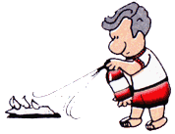
P
Pull the Pin
A Aim the extinguisher nozzle at the base of the flames
S
Squeeze trigger while holding the extinguisher upright
S
Sweep the extinguisher from side to side, covering the area of the fire with the extinguishing agent.

Most portable fire extinguishers work according to these directions, but some do not. Read and follow the directions on the fire extinguishers within your building.

PART 4 – INSPECTION, TESTING & MAINTENANCE OF FIRE PROTECTION EQUIPMENT

RESPONSIBILITY: The owner/agent is responsible to ensure that daily, monthly inspections are carried out by trained in house staff. Annual testing, inspection, and maintenance of all life safety equipment and systems are carried out and are properly recorded only by qualified technicians. ASTTBC certified technicians.

GENERAL:
The current Vancouver Fire Bylaw requires that fire protection installations be maintained in operating condition in accordance with Part 6, The current Vancouver Fire Bylaw. In most cases, the BC Fire Code does not specify in detail the necessary inspection, maintenance and testing procedures; instead, it references standards such as those developed by the BC Fire Protection Association, the Canadian Standards Association, and the Underwriters Laboratories of Canada. Where such standards are referenced by the current Vancouver Fire Bylaw, they have been identified in this Plan as “Reference Standard”.

RECORDS:
Records of inspection, testing or maintenance of fire protection equipment shall be completed by a qualified (certified) contractor only. Records of inspection, testing or maintenance of fire protection equipment shall be retained for a period not less than two (2) years from the date of such service. Any activities recorded on the Daily Inspection Report are exempted from this requirement.

QUALIFIED ASTTBC CONTRACTORS:
Contractors shall have proper certification (ASTTBC) for performing any inspections or testing of the fire protection systems. Inspection and testing procedures must meet the minimum requirements set by the applicable code. Guidelines for use by the Fire Safety Director containing information of such procedures are available in part of this Plan.

CHIMNEY, FLUE AND FLUE PIPES
Reference Standard: Current Vancouver Fire Bylaw, Article 2.6.1.4

RESPONSIBILITY: Qualified Mechanical Contractor

2.6.1.6. Operation and Maintenance Procedures
- Heating, ventilating and air-conditioning systems, including , chimneys and flue pipes, shall be operated and maintained so as not to create a hazardous condition.

  - Except for self-contained systems within dwelling units, disconnect switches for mechanical air-conditioning and ventilating systems shall be operated at intervals not greater than 12 months to establish that the system can be shut down in an emergency.

CLOSURES & FIRE SEPARATIONS
Reference Standard: Current Vancouver Fire Bylaw, Article 2.2.2.4

2.2.2.4. Inspection and Maintenance
- Defects that interfere with the operation of closures in fire separations shall be corrected, and such closures shall be maintained to ensure that they are operable at all times by
  - Keeping fusible links and other heat-actuated devices undamaged and free of paint and dirt,
  - Keeping guides, bearings and stay rolls clean and lubricated,
  - Making necessary adjustments and repairs to door hardware and accessories to ensure proper closing and latching, and
  - Repairing or replacing inoperative parts of hold-open devices and automatic releasing devices.
- Doors in fire separations shall be inspected at intervals not greater than 24 h to ensure that they remain closed unless the door is equipped with a hold-open device conforming to the BC Building Code.
- Doors in fire separations shall be operated at intervals not greater than one month to ensure that they are properly maintained in accordance with Sentence (1), as specified in the fire safety plan prepared in conformance with Article 2.8.
- Closures in fire separations shall not be obstructed, blocked, wedged open, or altered in any way that would prevent the intended operation of the closure.
- Fire dampers and fire stop flaps shall be inspected at intervals not greater than 12 months to ensure that they are in place and are not obviously damaged or obstructed.

EMERGENCY POWER SYSTEMS
Reference Standard: Canadian Standards Association CAN/CSA C282

MONTHLY TEST: The emergency electrical power supply system shall be completely tested, as outlined below at least once a month.

RESPONSIBILITY: Owner or the owner’s agent must ensure work is completed by a Qualified ASTTBC Contractor.

PROCEDURE: Simulate a failure of the normal supply,
Be arranged so that:
- an engine-generator set operates under at least thirty percent (30%) of the rated load for sixty-60 minutes, and
- all automatic transfer switches are operated under load,
Include an inspection to assess the correct functioning of all auxiliary equipment such as the radiator shutter control, coolant pumps, fuel transfer pumps, oil coolers and engine room ventilation controls.

RECORD KEEPING: Include a record of the readings of all instruments
associated with the engine and generator and a verification that they are normal, and
Be carried out, logged and reported as further prescribed in the manual of instructions for operation and maintenance.
ANNUAL TEST:
RESPONSIBILITY: Owner or the owner’s agent must ensure work is completed by a Qualified ASTTBC Contractor.

PROCEDURE: The generator set shall be subjected to a two-2 hour full load test annually.
The following data shall be observed and recorded:
- the time delay on start,
- the cranking time until the engine starts and runs,
- the time required to come up to operating speed,
- the time required to achieve a steady-state condition with all switches transferred to the emergency position,
- the voltage, frequency and amperes at start-p and at any observed change in loan,
- the engine oil pressure, water temperature where applicable and battery charge rate at five-5 minute intervals for the first fifteen-15 minutes and at fifteen-15 minute intervals thereafter,

- the time delay on re-transfer for each transfer switch, and
- the time delay on engine cool down and shutdown. Component serving and engine maintenance is outlined in CAN-CSA C282 table.

RECORD KEEPING: Include a record of the readings of all instruments
associated with the engine and generator and verification that they are normal as described above.

EXIT LIGHTING & EMERGENCY LIGHTING:
Reference Standard: Current Vancouver Fire Bylaw, Article 2.7.3.1

DAILY INSPECTION:
Facility personnel are responsible to ensure all exit signs are illuminated.

MONTHLY INSPECTION:

RESPONSIBILITY: Facility personnel

PROCEDURE: The emergency electrical power supply system must be completely tested at least once every month. Emergency exit lighting equipment shall be inspected to ensure that:
- the terminal clamps are clean and tight according to the manufacturer’s specifications,
- the emergency lights will function upon failure of the primary power supply,
- a periodic test of the system operation shall:
  - simulate a power failure of the normal supply, and
  - Include an inspection to assess the correct functioning of all auxiliary equipment.
RECORD KEEPING: Monthly Inspection and Testing Report. (See Part 5) ANNUAL TESTING:
RESPONSIBILITY: Applied Science Technologists & Technicians (ASTTBC)
contractor.

PROCEDURE: Emergency exit lighting equipment shall be tested to
ensure that the unit will provide emergency exit lighting for duration equal to the design criterion under simulated power failure conditions. Minimum operating time of thirty
(30) minutes.
After completion of the test, the charging conditions for voltage and current and the recovery period shall be tested to ensure that the charging system is functioning in accordance with the manufacturer’s specifications.

RECORD KEEPING: Annual Inspection and Testing Report. (See Part 4)

FIRE DAMPERS AND FIRE STOP FLAPS
Reference Standard: Current Vancouver Fire Bylaw, Article 2.2.2.4.

RESPONSIBILITY: Monthly: RESPONSIBILITY: Facility personnel RECORD KEEPING: Monthly. (See Part 3)
ANNUAL:
RESPONSIBILITY: Mechanical Contractor

RECORD KEEPING: Annual: Inspection and Testing Report. (See Part 5)
PROCEDURE: Ensure that fire dampers and fire stop flaps are in
place and are not obviously damaged or obstructed.

FIRE DEPARTMENT ACCESS TO BUILDING
Reference Standard: Current Vancouver Fire Bylaw, Article 2.5.1.1.

RESPONSIBILITY: Fire Safety Director or Designate

Access to Building
1) Fire Department vehicles shall have direct access to at least one face of every building by means of a street, yard or roadway in conformance with the BC Building Code.

Access Panels and Windows
1) Access panels or windows provided to facilitate access for firefighting operations shall be maintained free of obstruction.

Access to Roof
1) Where access to a roof is provided for firefighting purposes, keys shall be provided for locked roof access doors and kept in the lock box for Fire Department use.

Access to Fire Department Connections
1) Access to Fire Department connections for sprinkler or standpipe systems by fire fighters and their equipment shall be maintained free of obstructions at all times.

Maintenance of Fire Department Access
        - Streets, yards and roadways provided for Fire Department access shall be maintained so as to be ready for use at all times by Fire Department vehicles.
        - Vehicles shall not be parked to obstruct access by Fire Department vehicles and signs shall be posted prohibiting such parking.

FIRE DETECTION AND ALARM SYSTEM
Reference Standard: Current Vancouver Fire Bylaw, Article 6.3.1.2.
ULC S536 Standard for the Testing and Maintenance of Existing Fire Alarm Systems

RESPONSIBILITY: Applied Science Technologists & Technicians (ASTTBC)
contractor.

6.3.1.2. Inspection and Testing
- Fire alarm systems shall be inspected and tested in conformance with CAN/ULC- S536, “Inspection and Testing of Fire Alarm Systems.”
- Fire alarm and detection system components shall be accessible for purposes of inspection or maintenance.

Monthly Testing:
One initiating field device or manual pull station shall be operated on a rotational basis and the system inspected for operation as follows:
- An alert signal or an alarm signal confirmed on a rotational basis to a minimum of one zone or as may be required by the Fire Safety Plan for the building;
- The primary annunciator inspected to determine that the tested device annunciated correctly;
- Operation of the common audible and visual trouble signs;
- Batteries shall be inspected for the following:
- Terminals are clean and lubricated;
- Terminal clamps are secure;
- Electrolyte level and specific gravity, where applicable, are as specified by the manufacturer;
- One emergency telephone shall be tested on a rotational basis for two-way Communication and correct indication at the control unit; and
- Voice paging capability to one zone confirmed on a rotational basis.

FIRE PUMP
Reference Standard: Current Vancouver Fire Bylaw, Section 6.4 “Water-Based Fire Protection Systems”
6.4.1.1 Inspection, Testing and Maintenance
Water-based fire protection systems shall be inspected, tested and maintained in conformance with NFPA 25 (2008), “Inspection, Testing, and Maintenance of Water- Based Fire Protection Systems”.

RESPONSIBILITY: “Owner or the owner’s Authorizied Agent must ensure work is completed by qualified contractor”
General

Records
        - Records shall be kept of all fire pump tests, and such records shall be retained for examination by the Fire Chief, or any member of the Fire Department authorized by the Fire Chief, in conformance with Article 1.3.4.1.

Daily Tests:
      - Pump Room Temperature
        - Measures shall be taken to ensure that the ambient air temperature in the pump room never falls below the minimum recommended by the engine manufacturer, or 4ºC, whichever is higher.

Weekly Tests:

      - Fire Pump Testing
        - Except as provided in Sentence (2), fire pumps shall be operated at intervals not greater than 7 days at their rated speeds until the satisfactory performance of the pump, driver, and controller is verified.

Monthly Tests:
      - Fire Pump Testing
        - For fire pumps that are driven by electric motor, the tests described in shall be performed at intervals not greater than 1 month.

Yearly Tests:
6.6.3.3. Fire Pump Testing
Fire pumps shall be tested at full rated capacity at intervals not greater than 12 months to ensure that they are capable of delivering the rated flow.

HEATING, VENTILATING AND AIR CONDITIONING SYSTEMS
Reference Standard: Current Vancouver Fire Bylaw, Article 2.6.1.6.

RESPONSIBILITY: Qualified Mechanical Contractor

2.6.1.6. Operation and Maintenance Procedures
- Heating, ventilating and air-conditioning systems, including appliances, chimneys and flue pipes, shall be operated and maintained so as not to create a hazardous condition.
- Except for self-contained systems within dwelling units, disconnect switches for mechanical air-conditioning and ventilating systems shall be operated at intervals not greater than 12 months to establish that the system can be shut down in an emergency.

MEANS OF EGRESS
Reference Standard: BC Fire Code 2012, Article 2.7.1

RESPONSIBILITY: Facility personnel

2.7.1.1. Means of Egress
1) Means of egress shall be provided in buildings in conformance with the BC Building Code.

2.7.2.1. Exit Doors
- Except as provided in Sentences (2), (3) and (4), all doors forming part of a means of egress shall be tested at intervals not greater than one month to ensure that they are operable.
- Sliding doors that are required to swing on their vertical axes in the direction of egress when pressure is applied shall be tested at intervals not greater than 12 months.
- When doors are equipped with electromagnetic locks, these locks shall be tested at intervals not greater than 12 months.

PORTABLE FIRE EXTINGUISHERS:
Reference Standard: Current Vancouver Fire Bylaw, 6.2.1.1 to N.F.PA. #10
Standards for Inspection, Testing and Maintenance of Portable Fire Extinguishers

RESPONSIBILITY:
Monthly: “Owner or the owner’s Authorized Agent must ensure work is completed by qualified contractor”

Report: (See Part 5)
  - Located in designated location
  - No obstructions to access visibility
  - Operating instruction labels are facing outward
  - Seal and tamper indicators are not broken or missing
  - Pressure gauge reading or indicator in the operable range or position
  - Examine for obvious physical damage, corrosion, leakage or clogged nozzle Annual: Applied Science Technologists & Technicians (ASTTBC) contractor.

6.2.1.1. Inspection, Testing and Maintenance
1) Portable extinguishers shall be inspected, tested and maintained in conformance with NFPA 10, “Portable Fire Extinguishers”.

AUTOMATIC SPRINKLER SYSTEMS
Reference Standard: Current Vancouver Fire Bylaw, Article 6.4
to N.F.PA. #25 Standards for Inspection, Testing and Maintenance of Automatic Sprinkler Systems

Annual:
RESPONSIBILITY: “Owner or the owner’s agent must ensure work is
completed by a qualified contractor or an Applied Science Technologist & Technicians of BC (ASTTBC) contractor”

6.4.1.1. Inspection, Testing and Maintenance
1) Water-based fire protection systems shall be inspected, tested and maintained in conformance with NFPA 25, “Inspection, Testing, and Maintenance of Water- Based Fire Protection Systems”.
Gauges:
NFPA 25, 5.2.4.2* Gauges on dry, preaction and deluge systems shall be inspected weekly to ensure that normal air and water pressures are being maintained.

Control Valves:

      - All valves shall be inspected weekly.
13.3.2.1.1 Valves secured with locks or supervised in accordance with applicable NFPA standards shall be permitted to be inspected monthly.
      - The valve inspection shall verify that the valves are in the following condition:
        - in the normal open or closed position
        - properly sealed, locked, or supervised
        - accessible
        - provided with appropriate wrenches
        - free from external leaks
        - provided with appropriate identification
Alarm Devices:
      - Water-flow devices including, but not limited to, mechanical water motor gongs and pressure switch type shall be tested quarterly.
      - * Vane-type water-flow devices shall be tested semi-annually.
5.2.7 Hydraulic Nameplate:
The hydraulic nameplate for hydraulically designed systems shall be inspected quarterly to verify that it is attached securely to the sprinkler riser and is legible.

Fire Department Connections:
13.7.1 Fire Department connections shall be inspected quarterly.
The inspection shall verify the following:
- The Fire connections are visible and accessible.
- Couplings or swivels are not damaged and rotate smoothly.
- Plugs or caps are in place and undamaged.
- Gaskets are in place and in good condition.
- Identification signs are in place.
- The check valve is not leaking.
- The automatic drain valve is in place and operating properly.
- The Fire connection clapper(s) is in place and operating properly.

Inspection:
12.4.4.1.1 Valve enclosure heating equipment shall be inspected daily during cold weather for its ability to maintain a minimum temperature of at least 40°F.

STANDPIPE SYSTEMS:
Reference Standard: Current Vancouver Fire Bylaw, Article 6.4
Water-Based Fire Protection Systems

RESPONSIBILITY: Applied Science Technologists & Technicians (ASTTBC)
contractor.

6.4.1.1. Inspection, Testing and Maintenance
- Water-based fire protection systems shall be inspected, tested and maintained in conformance with NFPA 25, “Inspection, Testing, and Maintenance of Water- Based Fire Protection Systems.

SPECIAL FIRE SUPPRESSION SYSTEMS
Wet Chemical Fire Suppression System

A "wet chemical" fire suppression system has been installed to suppress a fire on cooking equipment, in the plenum behind the filters or the exhaust duct system.

System Actuation.
The suppression system has both automatic and manual methods of actuation.
Automatic operation is by way of heat responsive devices strategically located above certain cooking equipment, inside the plenum area and at the exhaust duct connection to the kitchen hood. When the temperature of the heat responsive device reaches a specified temperature, the system will operate.
Manual operation is by way of pulling hard on a readily accessible manual release mechanism. The manual release mechanism is usually located

between the cooking appliances and an exit. The manual release is required to clearly identify the hazard protected.
Familiarize the staff with the location and operation of the manual release. The manual release may need to be pulled several inches to cause activation.
Alarm - An audible or visual indicator is required to be provided to show that the system has operated, that personnel response is needed, and that the system is in need of recharge.
Upon Operation, whether automatic or manual, the fire suppression system will activate and discharge a balanced amount of fire suppressing chemical onto the cooking surfaces and into the plenum areas and duct. The fuel supply (gas, electricity, etc.) will shut-down; the exhaust system will continue to run

Owner’s Inspection
Inspection shall be conducted on a monthly basis in accordance with the manufacturer’s listed installation and maintenance manual or the owner’s manual.
Inspections shall include verification of the following:
  - The extinguishing system is in its proper location.
  - The manual actuators are unobstructed.
  - The tamper indicators and seals are intact.
  - The maintenance tag or certificate is in place.
  - No obvious physical damage or condition exists that might prevent operation.
  - The pressure gauge(s), if provided, is in operable range.
  - The nozzle blow off caps is intact and undamaged.
  - The hood, duct, and protected cooking appliances have not been replaced, modified, or relocated.
- If any deficiencies are found, appropriate corrective action shall be taken immediately.
- Personnel making inspections shall keep records for those extinguishing systems that were found to require corrective actions.
- At least monthly, the date the inspection is performed and the initials of the person performing the inspection shall be recorded. The records shall be retained for the period between the semi-annual maintenance inspections.

Maintenance

- Only a trained person having ASTTBC Certification shall perform the maintenance and recharge.
- At least semi-annually, maintenance shall be conducted in accordance with the manufacturer’s listed installation and maintenance manual.
- Maintenance shall include the following:
    - A check to see that the hazard has not changed

    - An examination of all detectors, the expellant gas container(s), the agent container(s), releasing devices, piping, hose assemblies,
nozzles signals, all auxiliary equipment, and the liquid level of all non - pressurized wet chemical containers

    - Verification that the agent distribution piping is not obstructed
- Where maintenance of any system containers or components reveals conditions such as, but not limited to, corrosion or pitting in excess of the manufacturer’s limits; structural damage or fire damage; or repairs by soldering, welding, or brazing; the affected part(s) shall be replaced or hydrostatically tested in accordance with the recommendations of the manufacturer or the listing agency.
- All wet chemical systems shall be tested, including the operation of the detection system signals and releasing devices, including manual stations and other associated equipment.
- Where the maintenance reveals defective parts that could cause an impairment or failure of proper operation of the system(s), the affected parts shall be replaced or repaired in accordance with the manufacturer's recommendations.
- The maintenance report, with recommendations, if any, shall be filed with the owner or with the designated party responsible for the system.
- Each wet chemical system shall have a tag or label securely attached, indicating the month and year the maintenance is performed and identifying the ASTTBC certified person performing the service. Only the current tag or label shall remain in place.
Fixed temperature-sensing elements of the fusible metal alloy type shall be replaced at least annually from the date of installation. They shall be destroyed when removed.

Standards
- Except as otherwise provided in this Article, where a special fire suppression system has been installed, inspection, testing, and maintenance shall be provided in conformance with the appropriate standard listed in Sentence (1).
1) Except as otherwise provided in this Article, where a special fire suppression system is required to be installed, the design and installation of the system shall conform to the following:

6-MONTH TESTS:
6.8.1.1. Standards

- Where time intervals for maintenance and inspection are not specified in the appropriate standard in Sentence (1), inspection and maintenance
routines shall be carried out at least every 6 months.

Commercial Cooking Equipment & Ducts:

Reference Standard: BC Fire Code 2012, Article 6.4
to N.F.PA. #96 Standards for Inspection, Testing and Maintenance Ventilation Control and Fire Protection of Commercial Cooking Operations”.

Commercial cooking equipment exhausts and fire protection systems shall be installed and maintained in conformance with NFPA 96, “Ventilation Control and Fire Protection of Commercial Cooking Operations”.

Ensure wet chemical or alkali based dry chemical portable fire extinguishers are provided to protect commercial cooking equipment and are readily available for use in an emergency.

Daily

Hoods, grease removal devices, fans, ducts, and other equipment shall be checked daily and cleaned at frequent intervals, prior to surfaces becoming heavily contaminated with grease or oily sludge.

Weekly

Hoods, grease removal devices, fans, ducts, and other equipment shall be checked weekly and cleaned at frequent intervals, prior to surfaces becoming heavily contaminated with grease or oily sludge.

6 Months

Inspection and servicing of the fire extinguishing system shall be made at least every six months by properly trained and qualified persons in conformance with B.C. Fire Code, Section 6.8.1.1.

Annual:

Inspection and servicing of the fire extinguishing system shall be made at annually by properly trained and qualified persons in conformance with B.C. Fire Code, Section 6.8.1.1.

PART 5 – REPORTS & CHECKLISTS

INCIDENT/ACTIVITY

[ | ] | Fire | [ | ] | False Alarm
[ | ] | Fire Drill | [ | ] | Training
[ | ] | Fire Safety Meeting | [ | ] | Fire Equipment Operated

- DETAILS:
Date: Time: Device/Equipment: Floor: Zone: Injuries:
Cause or Reason for Incident: Any Damage or Loss:

ACTION:

Who discovered the fire:

Did the Fire Department attend?
If not, why:

Who operated fire equipment?

- Comments/Recommendations:

- DISTRIBUTION LIST: [ ] Fire Department
[ ] Management

[ ] Insurance Company [ ] Police

DAILY INSPECTION CHECKLIST

Daily Inspections:

Daily inspections may be conducted by trained facility personnel. Daily inspection reports shall be maintained and be available on site for the review by the Authority Having Jurisdiction.

Common Public Areas:

[ ] No flammable or combustible liquid storage [ ] No combustible or refuse accumulations
[ ] No worn or soaked rags Means of Egress:
[ ] Fire Exit Doors are operable.

[ ] Corridors and exits are clear of obstructions

[ ] Exterior landings and routes leading from the building are clear of obstruction (snow, ice, etc.)

Fire Detection and Alarm System:

[ ] Fire Alarm A/C power lamp is on [ ] Fire Alarm not indicating trouble
Fire Access to Building:

[ ] Access routes are clear of obstructions Sprinkler System
[ ] Valve enclosures protected from freezing Special Suppression Kitchen:
[ ] Hoods, grease removal devices, fans, ducts, and other equipment shall be checked daily and cleaned at frequent intervals, prior to surfaces becoming heavily contaminated with grease or oily sludge.

WEEKLY INSPECTION AND TESTING CHECKLIST

Weekly inspections may be conducted by trained facility personnel. Weekly inspection reports shall be maintained and be available on site for review by the Authority Having Jurisdiction.

FIRE DETECTION AND ALARM SYSTEM:
Reference Standard: BC Fire Code 2012, Article 6.3.1.2.
ULC S536: Standard for the Testing and Maintenance of Existing Fire Alarm Systems.

[ ] Fire Alarm A/C Power Lamp is ON.

[ ] Fire Alarm is not indicating TROUBLE.

AUTOMATIC SPRINKLER SYSTEM:
Reference Standard: BC Fire Code 2012, Article 6.4
to N.F.P.A. #25: Standards for Inspection, Testing, and Maintenance of Automatic Sprinkler Systems.

Sprinkler System:

[ ] Control Valves: All valves shall be inspected weekly.

WEEKLY INSPECTION REPORT

OF WATER BASED FIRE PROTECTION SYSTEMS

Wet Sprinkler System | Dry Sprinkler System
Sprinkler supply gauge: psi | Air pressure gauge: psi
Sprinkler system gauge: psi | Accelerator gauge: psi
Standpipe supply gauge: psi | Water pressure gauge: psi
Standpipe system gauge: psi
Standpipe top floor gauge: psi
System in service on inspection: | System in service on inspection:
Control valves seal open: | Compressor operational:
Standpipe control valve seal open | Oil level full:
Trim piping leak tight: | Control valve seal open:
Backflow assembly valve seal open: | Alarm test valve closed:
Control valve accessible: | Alarm line valve open:
Signage identification tag in place: | Intermediate chamber leak tight:
Alarm panel clear: | Low point drum drips drained:
System left in service: | Valve enclosed secure:
 | Low temperature alarm operational:
 | Signage identification tag in place:
 | Alarm panel clear:
 | System left in service:
Fire Department Connection | Sprinkler Heads
Caps or plugs on FDC: | Extra sprinkler heads in head cabinet:
Swivel rotational non-binding: | Heads appear to be correct temperature:
FDC location visible | Head wrench for each type of head:
FDC easily accessible | Heads in cooler appear to be free of ice:
FDC identification plate in place: | Heads appear free of leakage or damage
Wall hydrant plainly visible: | Heads appear free of paint
Wall hydrant easily accessible | Heads appear to be un-obstructed
Wall hydrant identification plate in place:
 | Standpipe heads less than 50 years:
 | Residential heads less than 20 years:
 | Fast response heads less than 20 years:
 | High temperature heads less than 5 years:

All “NO” answers will require a full explanation.

EMERGENCY GENERATOR
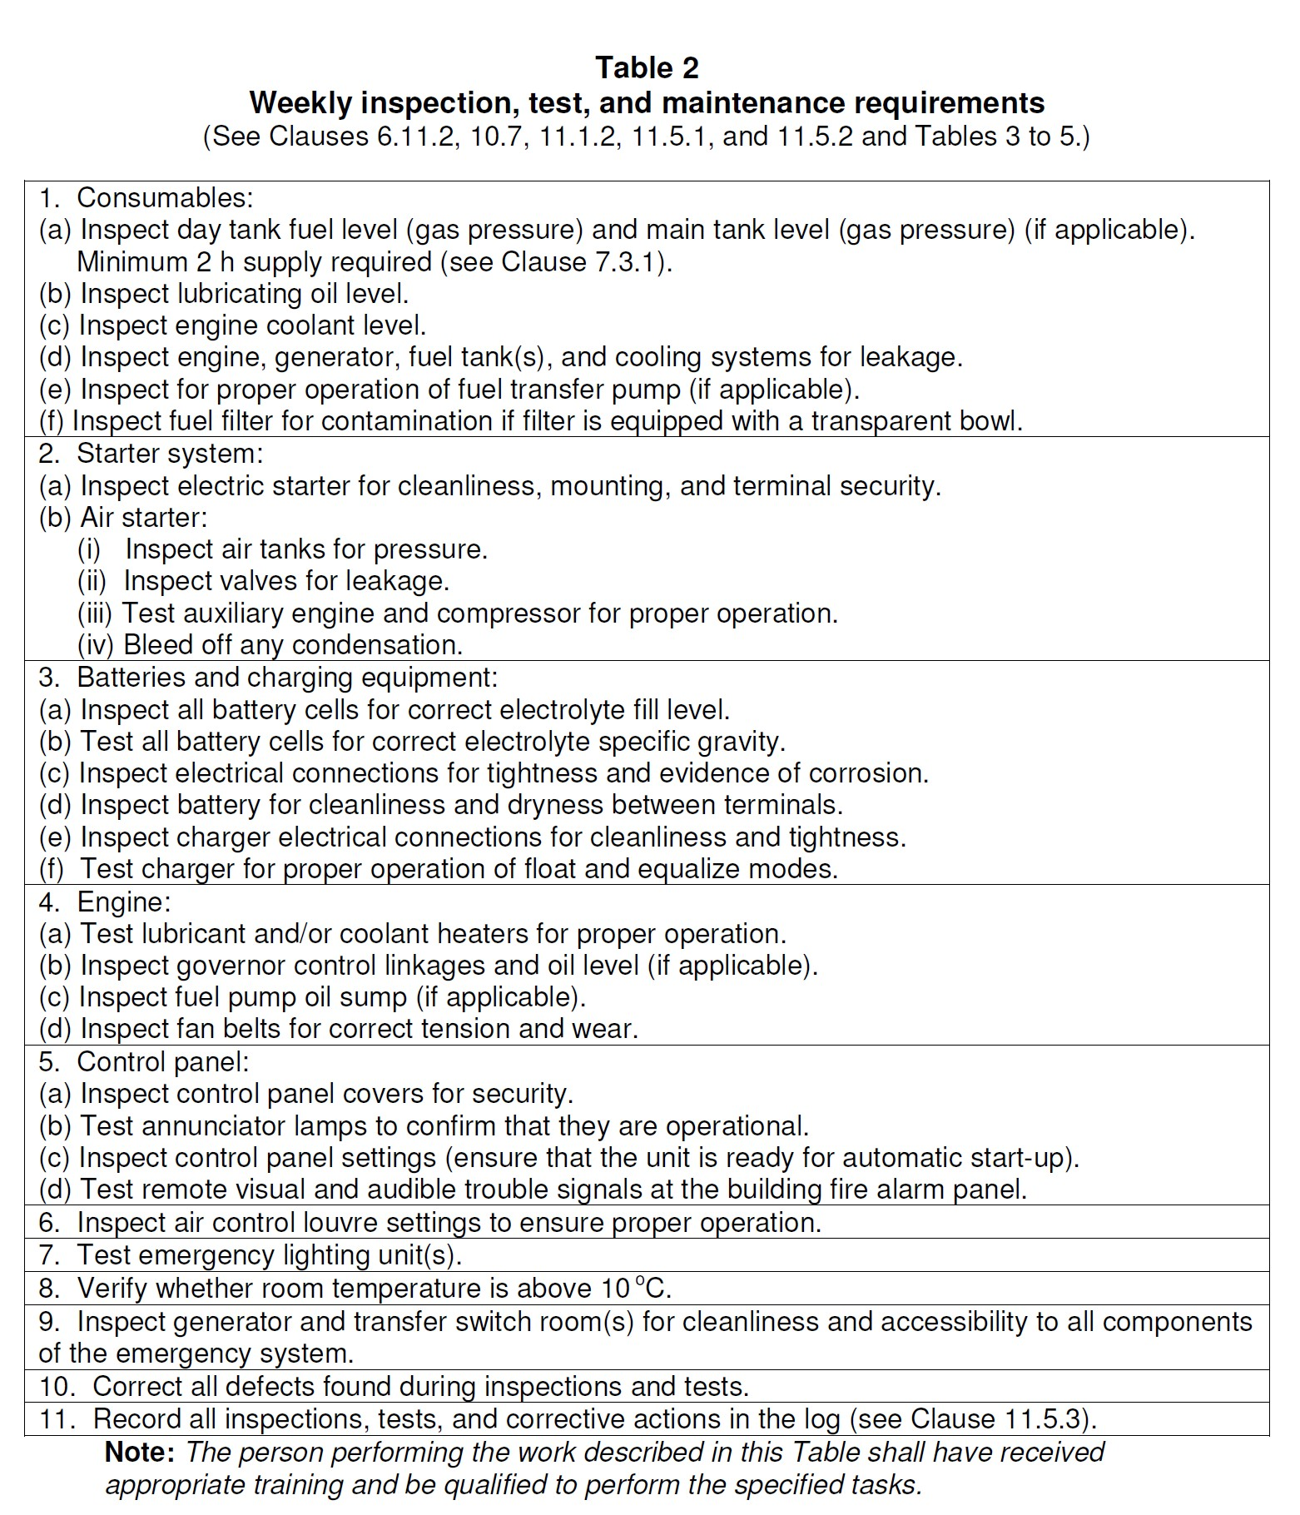

MONTHLY INSPECTION AND TESTING CHECKLIST

Monthly Inspection:

Monthly inspections shall be conducted by trained facility personnel. Monthly inspection reports shall be maintained and be available on site for the review by the Authority Having Jurisdiction.

PORTABLE FIRE EXTINGUISHERS:

  - Located in designated location
  - No obstructions to access visibility
  - Operating instruction labels are facing outward
  - Seal and tamper indicators are not broken or missing
  - Pressure gauge reading or indicator in the operable range or position
  - Examine for obvious physical damage, corrosion, leakage or clogged nozzle

EMERGENCY LIGHTING UNITS:

  - Pilot lights are functioning and not obviously damaged or obstructed.
  - The terminal connections are clean, free of corrosion and lubricated when necessary.
  - The terminal clamps are clean and tight as per manufacturer's specifications, and the battery surface is kept clean and dry.

EMERGENCY GENERATOR:
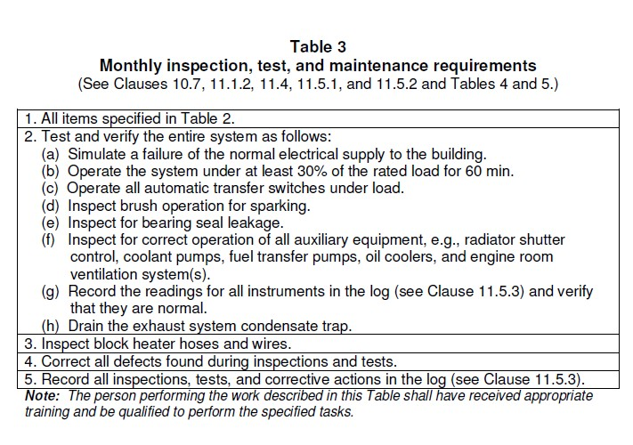

Monthly Inspection:

Monthly inspections shall be conducted by trained facility personnel. Monthly inspection reports shall be maintained and be available on site for the review by the Authority Having Jurisdiction.

FIRE DETECTION AND ALARM SYSTEM, DEVICE LOCATIONS:

  - One initiating field device or manual pull station shall be operated on a rotational basis and the system inspected for operation as follows:

  - An alert signal or an alarm signal confirmed on a rotational basis to a minimum of one zone or as may be required by the Fire Safety Plan for the building;

  - The primary annunciator inspected to determine that the tested device annunciate correctly;

  - Operation of the common audible and visual trouble signs;

  - Batteries shall be inspected for the following:

  - Terminals are clean and lubricated;

  - Terminal clamps are secure;

  - Electrolyte level and specific gravity, where applicable, are as specified by the manufacturer;

  - One emergency telephone shall be tested on a rotational basis for two-way

  - Communication and correct indication at the control unit; and
  - Voice paging capability to one zone confirmed on a rotational basis.

QUARTERLY INSPECTION AND TESTING CHECKLIST

SPRINKLER SYSTEM:

Reference Standard: BC Fire Code 2012, Article 6.4
to N.F.P.A. #25: Standards for Inspection, Testing, and Maintenance of Automatic Sprinkler Systems.

Maintenance:

Only a trained person having ASTTBC Certification shall perform the maintenance and service.

Alarm device: Alarm devices shall be inspected quarterly to verify that they are free of physical damage.

Water flow alarm devices including, but not limited to, mechanical water motor gongs, vane-type water flow devices, and pressure switches that provide audible or visual signals shall be tested quarterly.

Hydraulic Nameplate: The hydraulic nameplate, if provided, shall be inspected quarterly to verify that it is attached securely to the sprinkler riser and is legible.
Main Drain: A main drain test shall be conducted quarterly at each water- based fire protection system riser to determine whether there has been a change in the condition of the water supply piping and control valves.
Water flow Alarm: All water flow alarms shall be tested quarterly in accordance with the manufacturer’s instructions.

SEMI - ANNUAL INSPECTION AND TESTING CHECKLIST

Responsibility: Qualified Contractor / ASTTBC Contractor

[ ] Range Hood Kitchen Suppression System

One form per 6 months
Retain copy of Contractors Service Report

EMERGENCY GENERATOR:
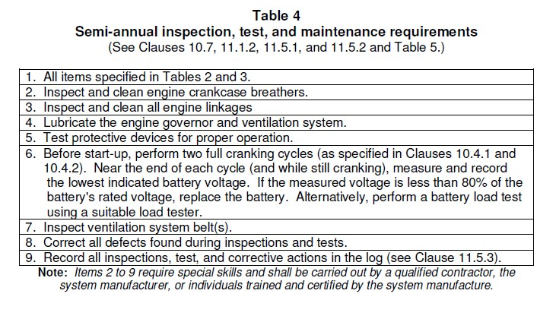

EMERGENCY GENERATOR:
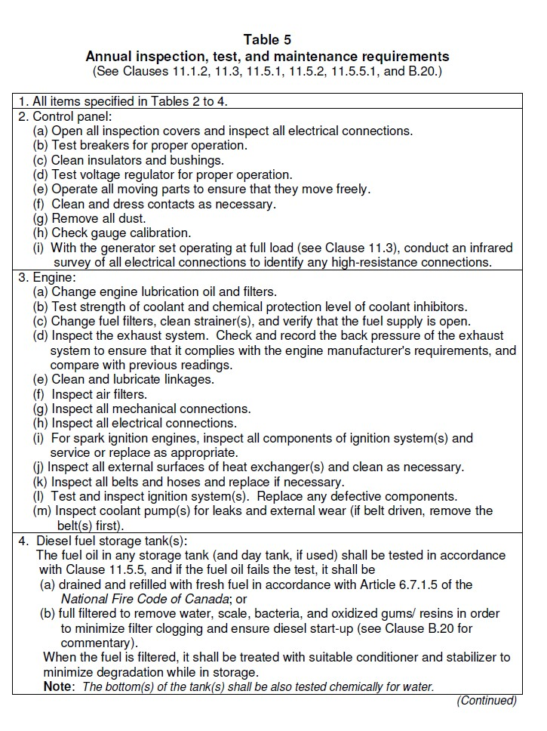

EMERGENCY GENERATOR:
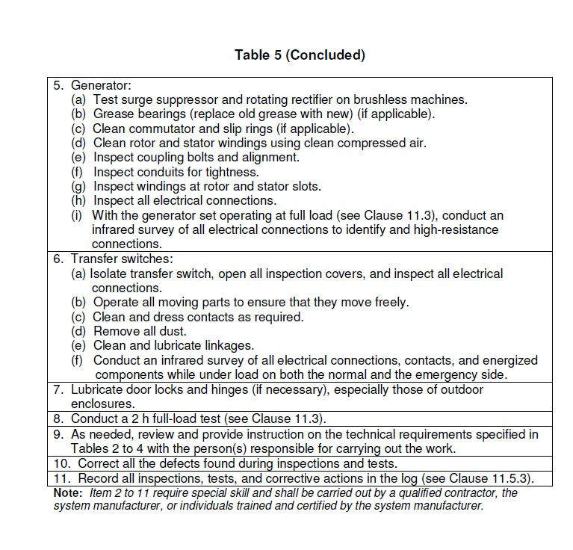

ANNUAL INSPECTION AND TESTING CHECKLIST

Responsibility: Applied Science Technologists & Technicians (ASTTBC) contractor.

[ ] Chimney, Flue and Flue Pipes [ ] Emergency Generator
[ ] Emergency Lighting Units

[ ] Fire Detection and Alarm System [ ] Fire Dampers and Fire Stop Flaps [ ] Fire Pump
[ ] Heating, Ventilation and Air Conditioning [ ] Portable Fire Extinguishers
[ ] Sprinkler System

[ ] Kitchen Suppression System

One form per year
Retain copy of Contractors Service Report

EMERGENCY GENERATOR:
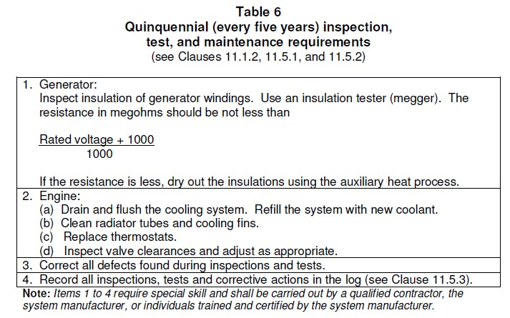

FIFTY YEAR TEST CHECKLIST

Responsibility: Applied Science Technologists & Technicians (ASTTBC) contractor.

SPRINKLER SYSTEM

[ ] Will be required a 50 year service from date of construction:

One form per period
Retain copy of Contractors Test Report

PART 6 – LEGAL BASIS FOR FIRE SAFETY PLANNING

Vancouver Fire Bylaw

SECTION 2.8. EMERGENCY PLANNING
SUBSECTION 2.8.1. GENERAL

Application
      - Notwithstanding other requirements in this Code, this Section applies to every building containing a Group A or B occupancy and to every building required by the Vancouver Building Code to have a fire alarm system.
A-2.8.1.2. Adequately trained supervisory staff can be of great value in directing people to move in an orderly fashion in the event of a fire and in carrying out appropriate fire control measures until the public Vancouver Fire Rescue Services arrives. These measures are, as described in the fire safety plan, developed in cooperation with the Vancouver Fire Rescue Services. The supervisory staff referred to in this Section is assigned their responsibilities by the building owner, unless the public Vancouver Fire Rescue Services is prepared to take on these responsibilities. Except in hospitals and nursing homes, it is not intended that supervisory staff should be in the building on a continuous basis, but that they should be available to fulfill their obligations as described in the fire safety plan on notification of a fire emergency. In hospitals and nursing homes, however, staff must be in the building at all times to assist occupants who are not capable of caring for them in an emergency.

Instructions in emergency procedures
      - Supervisory staff shall be instructed in the fire emergency procedures as described in the fire safety plan before they are given any responsibility for fire safety.

Firefighting Procedures:
2.8.1.4. Firefighting procedures shall be prepared by the Vancouver Fire Rescue Services in cooperation with the person in charge of the building for all buildings within the scope of Subsection 3.2.6. of the Building Regulations of British Columbia.

SUBSECTION 2.8.2. FIRE SAFETY PLAN
Measures in a fire safety plan
      - (1). In buildings or areas described in Article 2.8.1.1., an acceptable fire safety plan shall be prepared in cooperation with the Vancouver Fire Rescue Services and other applicable regulatory authorities and shall include:
        - the emergency procedures to be used in case of fire including:

          - sounding the fire alarm,
          - notifying the Vancouver Fire Rescue Services,
          - instructing occupants on procedures to be followed when the fire alarm sounds,
          - evacuating endangered occupants, including special provisions for the disabled, and
          - confining, controlling and extinguishing the fire
        - the designation and organization of supervisory staff to carry out fire safety duties,
        - the instruction of supervisory staff and other occupants in their responsibilities for fire safety,
        - the preparation of diagrams showing the type, location and operation of the building fire emergency systems,
        - the holding of fire drills,
        - the control of fire hazards in the building, and
        - the inspection and maintenance of building facilities provided for the safety of occupants.
A-2.8.2.1. (1) (a) (i). These procedures should also include instructions to authorized personnel for silencing fire alarm and alert signals under specified conditions.
A-2.8.2.1. (1) (a) (iv). Fire safety for disabled persons in buildings will depend to a large extent on preplanning and on their awareness of the fire protection measures incorporated into the building. In some buildings, it may be appropriate to advise disabled occupants of what these provisions are by means of posted notices or handouts. In certain residential occupancies, such as hotels or motels, staff should be aware of which rooms are occupied by disabled persons and should notify the responding Vancouver Fire Rescue Services of these facts.

High buildings
      - (1). In buildings within the scope of Subsection 3.2.6. of the Building Regulations of British Columbia, the fire safety plan shall, in addition to the requirements of Sentence 2.8.2.1. (1). include:
        - the instruction of supervisory staff on the use of the voice communication system,
        - the procedures for the use of elevators and for the evacuation of non- ambulatory occupants,

        - the action to be taken by supervisory staff in initiating any smoke control or other fire emergency systems installed in a building in the event of fire until the Vancouver Fire Rescue Services arrives, and
        - the procedures established to facilitate Vancouver Fire Rescue Services access to the building and fire location within the building.
      - The fire safety plan shall be kept in the building for reference by the Vancouver Fire Rescue Services, supervisory staff and other personnel.

Maintenance of plan
      - (2). The fire safety plan and record of the fire emergency systems installed in a building within the scope of Subsection 3.2.6. of the Building Regulations of British Columbia shall be maintained at the central alarm and control facility.
(3) The fire safety plan and record in Sentence (2) shall include instructions to the supervisory staff and Vancouver Fire Rescue Services for the operation of the systems.

Distribution
      - A copy of the fire emergency procedures and other duties for supervisory staff, as laid down in the fire safety plan, shall be given to all supervisory staff.

Posting of instructions
      - (1). A minimum of l copy of the fire emergency instructions procedures shall be prominently posted on each floor area.
2.8.2.6. (3). Where a fire alarm system has been installed with no provisions to transmit a signal to the Vancouver Fire Rescue Services, a legible, permanently mounted notice shall be posted at each manually operated fire alarm station requesting that the Vancouver Fire Rescue Services be notified.

SUBSECTION 2.8.3. FIRE DRILLS
Procedures
2.8.3.1. (1). The procedure for conducting fire drills in buildings specified in Article
      - shall be determined by the Vancouver Fire Rescue Services in consultation with the person in charge of the building, taking into consideration:
        - the building occupancy and its fire hazards,
        - the safety features provided in the building,
        - the desirable degree of participation of occupants other than supervisory staff,

        - the number and degree of experience of participating supervisory staff, and
        - the testing and operation of fire emergency systems installed in buildings within the scope of Subsection 3.2.6. of the Vancouver Building By-law.

Frequency
      - (1). Fire drills as described in Sentence 2.8.3.1. (1). shall be held at least once during each 12-month period for the supervisory staff, except that:
        - in buildings within the scope of Subsection 3.2.6. of the Vancouver Building By-law, such drills shall be held at least every 2 months.

Log Books
      - (1). Records of fire drills shall be recorded by the occupants in a log book kept on the premises for examination by the Fire Chief or any member of the Vancouver Fire Rescue Services authorized by the Fire Chief.

PART 7 – DEFINITIONS

Access to Exit –
Part of a means of egress with a floor area that provides access to an exit serving the floor area

Alarm Signal –
An audible signal transmitted throughout the building to advise occupants that a fire emergency exists

Class “A” Fire -
A fire involving combustible materials such as wood, clothes, or paper.

Class “B” Fire -
A fire involving flammable or combustible liquids, fat, or grease.

Class “C” Fire -
A fire involving energized electrical equipment.

Closure -
A device or assembly for closing an opening through a fire separation (such as a door), and including all components such as hardware, closing devices, frames, and anchors.

Combustible Liquid -
Liquids having a flash point at or above 37.8°C and below 93.3°C.

Deputy Fire Safety Director (D.F.S.D.) -
A person who will assume the duties of the Fire Safety Director in his/her absence.

Exit -

That part of a means of egress that leads from the floor area it serves, including any doorway leading directly from a floor area, to an open public thoroughfare or to an exterior open space protected from fire exposure from the building and having access to an open public thoroughfare.

Fire Alarm Control Panel (FACP) -
The Fire Alarm Control Panel (FACP) is the main fire alarm panel.

Fire Alarm Annunciator Panel (FAAP) -
The Fire Alarm Annunciator Panel (FAAP) is the remote fire alarm annunciator panel.

Fire Bylaw –
Local Fire Department Fire Bylaw pursuant to the Fire Act.

Fire Code -
The current Vancouver Fire Code Regulations, pursuant to the Fire Act.

Fire Safety Director (F.S.D.) –
A person appointed by the owner or authorized agent of the owner in writing and will assume to implement and maintain the Fire Safety Plan

Fire Safety Plan -
A plan, which provides information to occupants for control of fire hazards, maintenance of fire protection systems, and evacuation procedures for their building.

Fire Protection Systems -
A general term used in this document which includes sprinkler and fire alarm systems, hose stations, portable fire extinguishers, fire dampers, emergency lights, exit signs, fire doors, smoke control equipment, and voice communication systems.

Flammable Liquid -
Any liquid having a flash point below 37.8 ° C and having a vapour pressure not exceeding 275.8 kPa (absolute) at 37.8 ° C.

Means of egress -
A continuous path of travel provided by a doorway, hall-way, corridor, exterior passage-way, balcony, lobby, stair, ramp, or other egress facility or combination thereof, for the escape of persons from any point in a building, room, or contained open space to a public thoroughfare or other acceptable open space (means of egress includes exits and access to exits).

Qualified Contractor -
A person certified under the ASTTBC Act as a Fire Protection Technologist or a person having other certification acceptable to the Fire Chief, the qualifies the person to perform inspections and testing of fire protection equipment.

Smoke Detector –
A fire detector designed to operate when the concentration of airborne combustible products exceeds a pre-determined level.

Sprinklered –
(as applying to a building or part thereof) the building or part thereof is equipped with a system of automatic sprinklers.

Supervisory Staff -
Those occupants of a building who have some delegated responsibility for the fire safety of other occupants under the fire safety plan.

Sprinkler System (Wet)-
A fire sprinkler system, which has sprinkler supply piping containing water. Such a system cannot be installed in areas subjected to freezing conditions as water is always in the sprinkler piping.

Dry Sprinkler System (Dry)-
A fire sprinkler system, which has sprinkler supply piping containing air. Such a system can be installed in areas subjected to freezing conditions as air is always in the sprinkler piping.

ADDITIONAL SOURCES
Additional sources used to compile this document are available upon request from EMT Management Inc. and from the Fire Department.

APPENDIX

FIRE DEPARTMENT ACCESS MAP

THE SALVATION ARMY BELKIN HOUSE

555 Homer Street, Vancouver, BC

STORAGE

GENERATOR

SPRINKLER ROOM
STAIR E

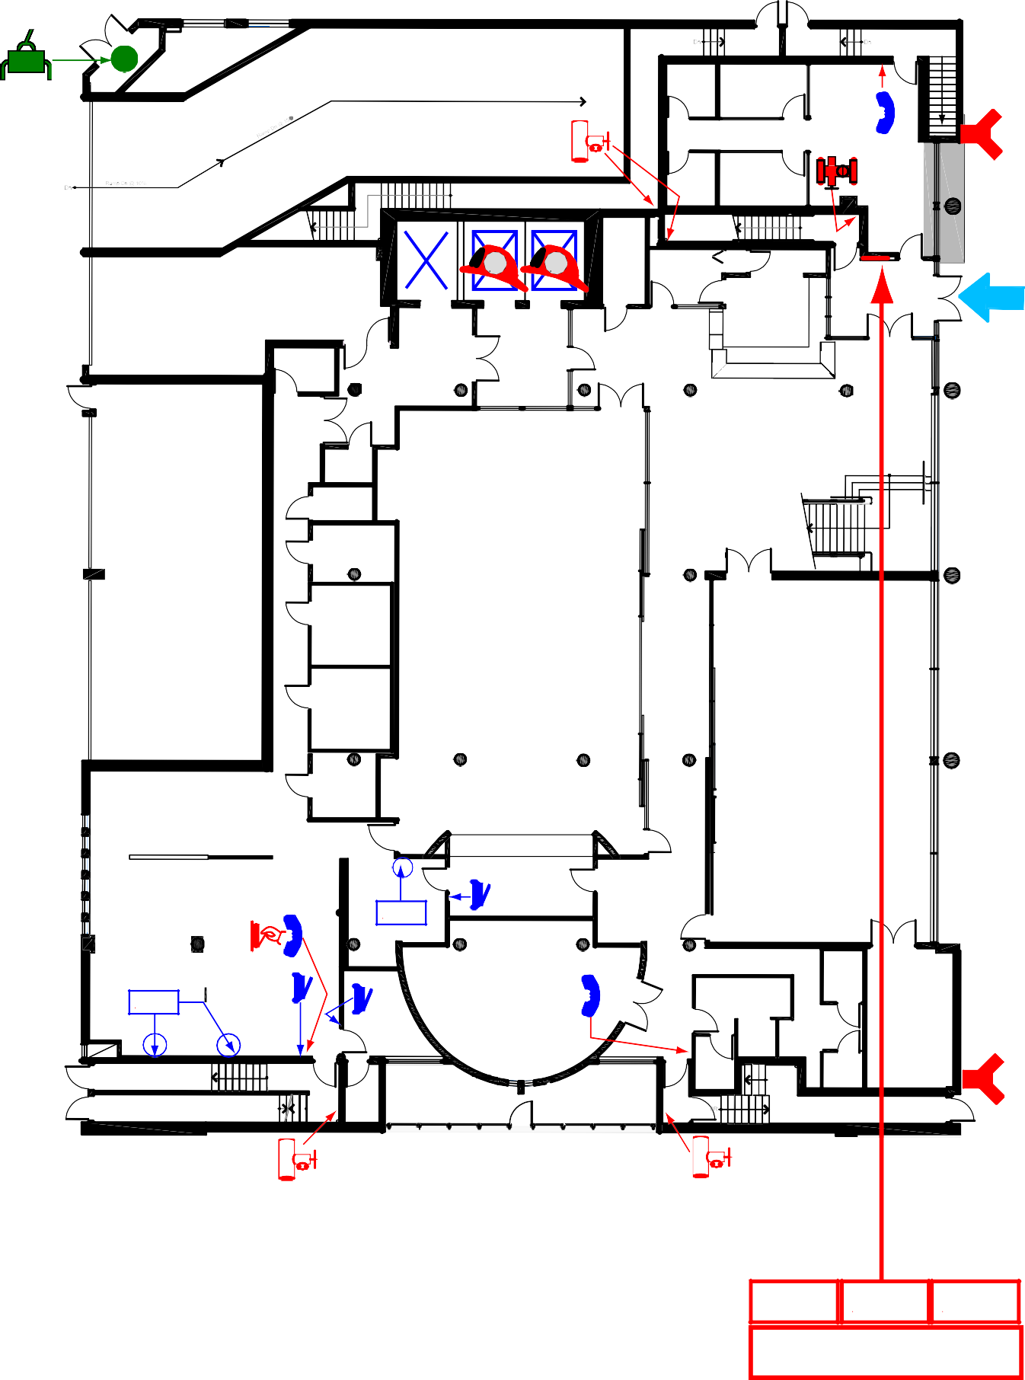
DN DN

OFFICE

STAIR E
DN
LEGEND

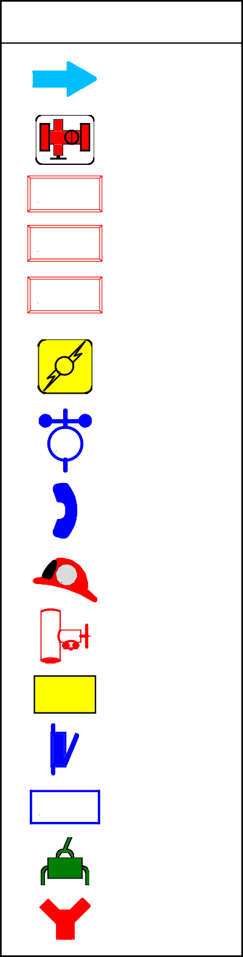
FD ACCESS

ROOM
STORAGE

ELECTRICAL DISTRIBUTION
Gen

E

W
UP

#3 #2 #1

UP STAIR C

#2 #1
#3

W.R.

STAIR D

OFFICE
RESOURCE CENTRE

UP

SPRINKLER VALVES

FIRE ALARM CONTROL PANEL
FACP

HOUSEKEEPING STORAGE
M F F
STORAGE

GARBAGE/LOADING BAY

W.R.
F F W.R.

FRONT DESK
FIRE ALARM ANNUNCIATOR PANEL
FIRE SAFETY PLAN BOX
FAAP
FSP

COMM.

ELECTRICAL VAULT

BC HYDRO GARAGE

JAN.

JAN.

STORAGE

MAIN LOBBY

UP

E MAIN ELECTRICAL
M ROOM & SHUT-OFF

DOMESTIC
W WATER
SHUT-OFF

ADMIN ARCHIVE

FREEZER

COOLER

DINING HALL/ CAFETERIA
FIREFIGHTER PHONE

F FIREFIGHTER ELEVATOR

WOODSHOP

GENERAL STORAGE
COMPRESSORS

KITCHEN

STORAGE

MULTIPURPOSE HALL

Gen

STANDPIPE CONNECTION

EMERGENCY GENERATOR

LAUNDRY

FREEZERS

MAINTENANCE WORKSHOP

KSS
KSS

OFFICE
SERVERY

CLASSROOM

FEMALE W.R.

MALE W.R.

STORAGE

KSS
PULL STATION FOR KITCHEN SUPPRESSION SYSTEM
KITCHEN SUPPRESSION SYSTEM

GAS

STAIR F
UP
UP UP
SHUT-OFF

STAIR F
STAIR A
UP DN
GARDEN
UP STAIR B

FIRE DEPARTMENT CONNECTION

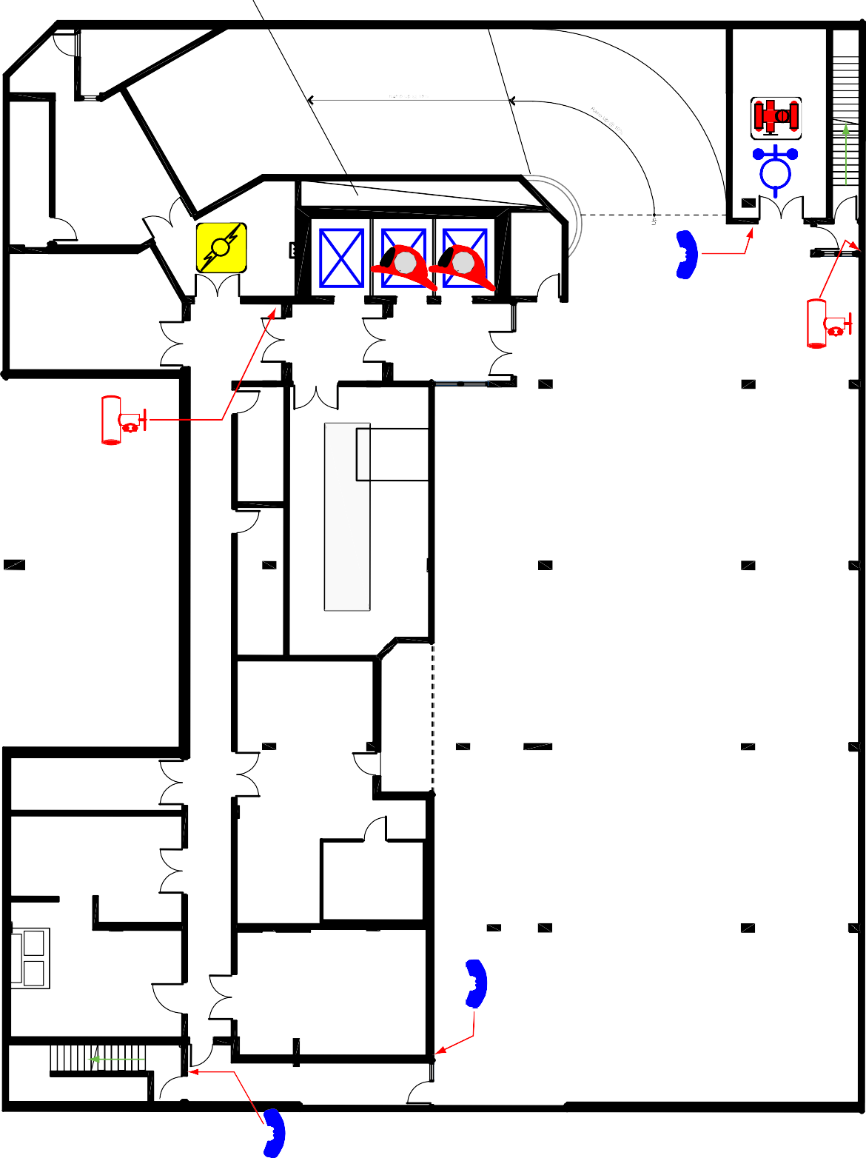
BASEMENT/PARKING LEVEL
LEVEL 1 - GROUND FLOOR N

FACP FAAP FSP
YOU ARE HERE

November 2015

LEGEND

FIRE DEPARTMENT CONNECTION

LANE
PARKADE ENTRANCE

MUNICIPAL HYDRANT

PRIVATE HYDRANT

GAS SHUT-OFF
WEST PENDER STREET

PARKING
LANE

THE SALVATION ARMY BELKIN HOUSE

555 Homer Street, Vancouver, BC
FIRE ALARM CONTROL PANEL
FIRE ALARM ANNUNCIATOR PANEL
FACP

FAAP

FIRE SAFETY PLAN BOX
FSP

FD ENTRY

HOMER STREET
FACP
FAAP
FSP

November 2015
N

THE SALVATION ARMY BELKIN HOUSE

555 Homer Street, Vancouver, BC
Site Plan Fire Safety Plan

STAIR E

STORAGE

SPRINKLER ROOM

GENERATOR ROOM
STORAGE

Gen

ELECTRICAL DISTRIBUTION

E

#3 #2 #1

W
UP

STORAGE

M F F

HOUSEKEEPING STORAGE

LEGEND

COMM.
FIRE EXIT

FIRE ALARM PULL STATION

ELECTRICAL VAULT

FIRE EXTINGUISHER

ADMIN ARCHIVE

FIREFIGHTER PHONE

EMERGENCY GENERATOR
Gen
COMPRESSORS

WOODSHOP

LAUNDRY

GENERAL STORAGE

FREEZERS
E MAIN ELEC.
M ROOM/SHUT-OFF
MAIN SPRINKLER VALVES

DOMESTIC WATER SHUT-OFF
W

FIREFIGHTER ELEVATOR
F

STANDPIPE CONNECTION

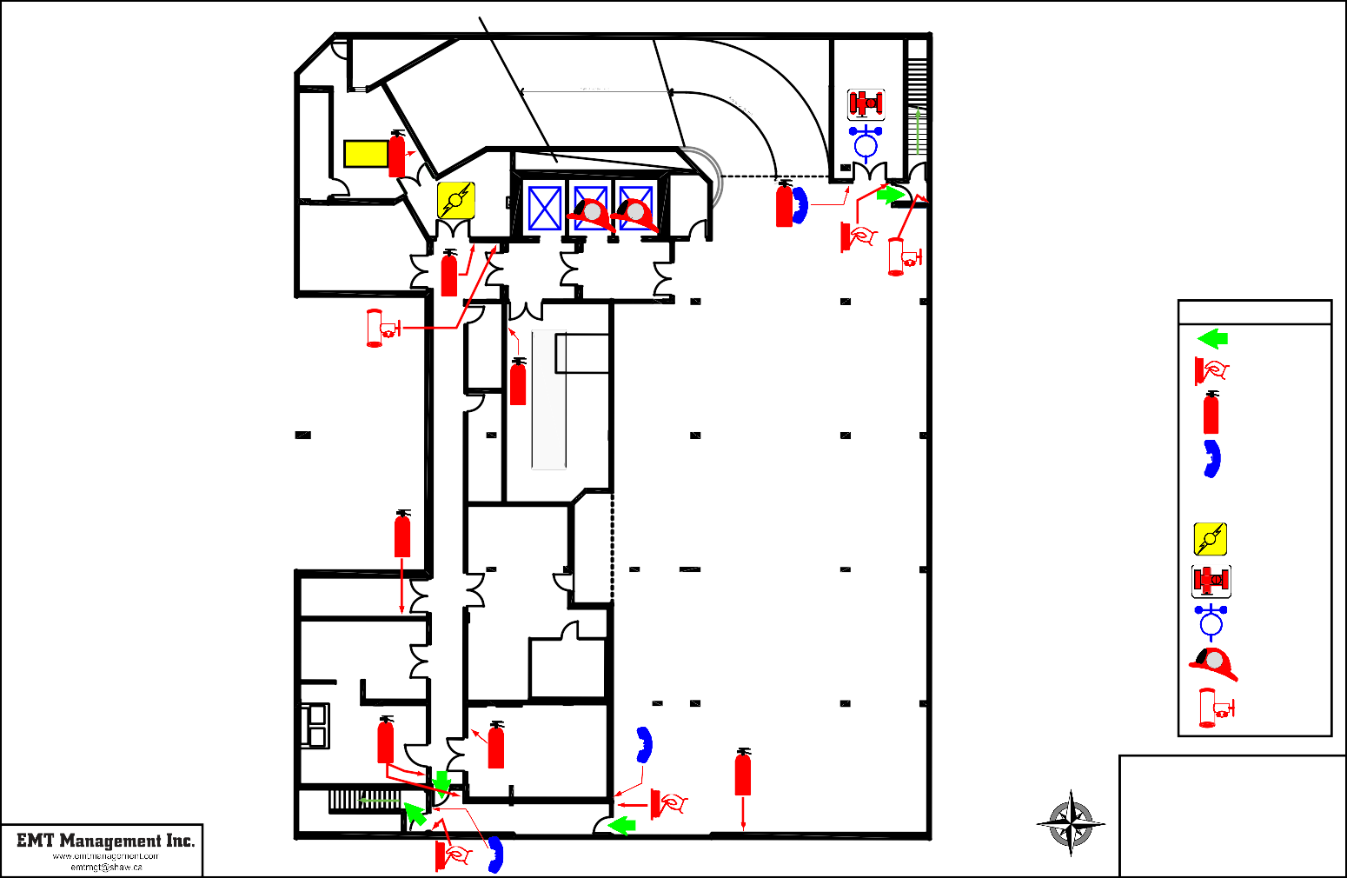

UP

STAIR F
MAINTENANCE WORKSHOP

N

November 2015

THE SALVATION ARMY BELKIN HOUSE

555 Homer Street, Vancouver, BC
Level 0 - Basement/Parking Fire Safety Plan

DN DN
STAIR E
DN

OFFICE

RESOURCE CENTRE

UP STAIR C
W.R.
OFFICE

#2 #1
#3

F F

W.R.
STAIR D UP

LEGEND
FIRE EXIT

GARBAGE/LOADING BAY

BC HYDRO GARAGE

KITCHEN

W.R.

JAN.

JAN.

STORAGE

FREEZER

COOLER

STORAGE

DINING HALL/ CAFETERIA

SERVERY
KSS

FRONT DESK

MAIN LOBBY

UP

MULTIPURPOSE HALL

FIRE ALARM PULL STATION

FIRE EXTINGUISHER
FACP
FAAP
FSP

FIREFIGHTER PHONE

STANDPIPE CONNECTION

SPRINKLER FLOOR VALVE

FIRE ALARM ANNUNCIATOR PANEL
FAAP

FIRE ALARM CONTROL PANEL
FACP

FIRE SAFETY PLAN BOX
FSP

FIREFIGHTER ELEVATOR
F

PULL STATION FOR KITCHEN SUPPRESSION SYSTEM

KITCHEN SUPPRESSION SYSTEM
KSS

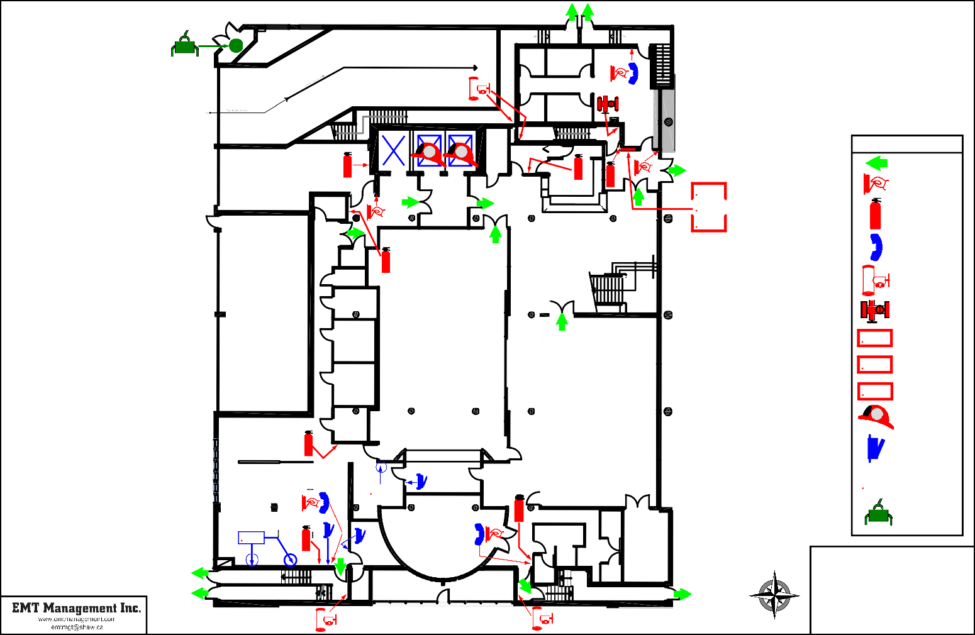

KSS

STAIR F STAIR A

UP

UP DN

OFFICE

GARDEN

CLASSROOM

FEMALE W.R.

UP

UP

MALE W.R.

STAIR B

STORAGE

N

November 2015
GAS SHUT-OFF

THE SALVATION ARMY BELKIN HOUSE

555 Homer Street, Vancouver, BC
Level 1- Ground Floor Fire Safety Plan

STAFF
LUNCH ROOM

FEMALE MALE
FEMALE W.R.
MALE W.R.

OFFICE

OFFICE

OFFICE

STAIR C

UP DN

MEETING
DN

OFFICE

OFFICE

#2 #1

F F
#3
UP

STAIR D

BALCONY

OFFICE

OPEN TO BELOW

OPEN TO BELOW

CLASSROOM

OFFICE

OFFICE

OFFICE

OFFICE

OFFICE

OPEN TO BELOW

CHAPEL

DN

OPEN TO BELOW
LEGEND
 | FIRE EXIT
 | FIRE ALARM
 | PULL STATION
 | FIRE
 | EXTINGUISHER
 | FIREFIGHTER
 | PHONE
 | STANDPIPE
 | CONNECTION
 | SPRINKLER
 | FLOOR VALVE
F | FIREFIGHTER
 | ELEVATOR

CLASSROOM

COMPUTER LAB
W.R.

DN UP

STORAGE

OFFICE

PUMP

UP DN

CLASSROOM

THE SALVATION ARMY
N BELKIN HOUSE

555 Homer Street, Vancouver, BC

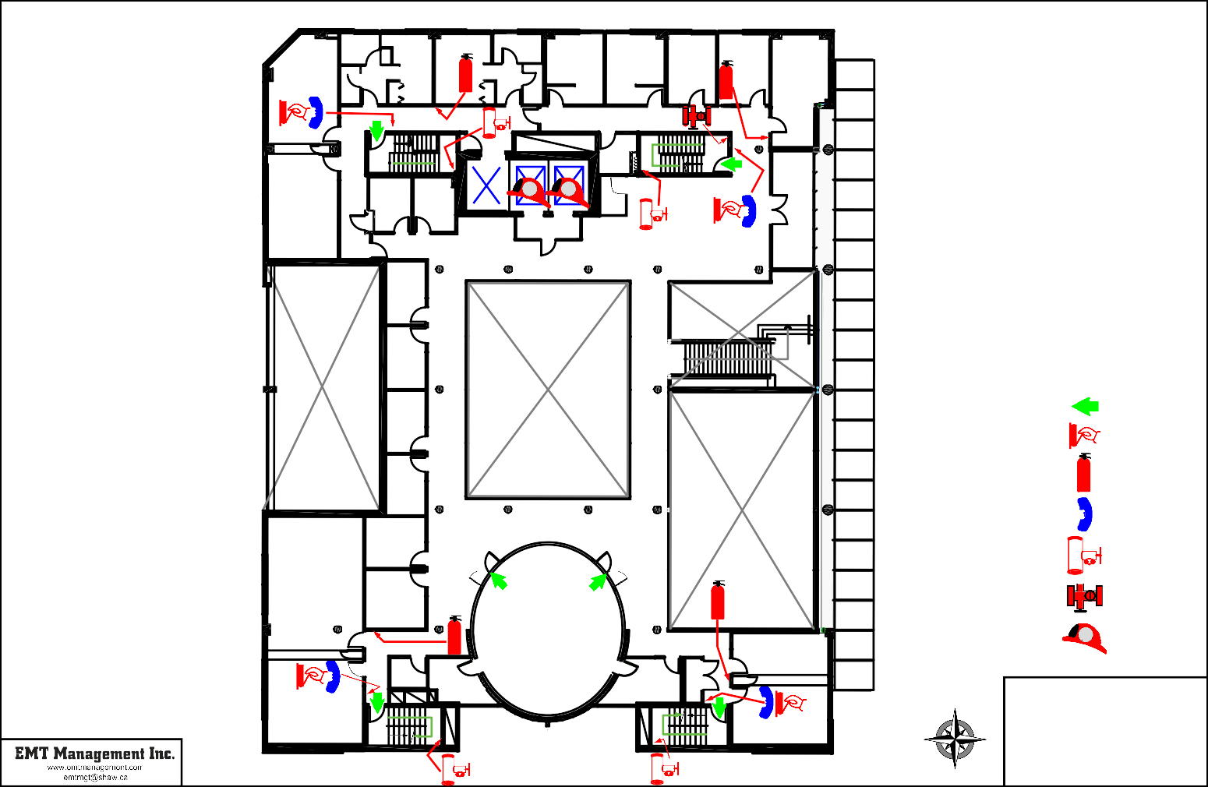
STAIR A STAIR B

November 2015

Level 2
Fire Safety Plan

DORMITORY DORMITORY
324 325

326 327

328 329 330 331

STAIR C

UP
NORTH WING

STORAGE

STAIR D

DN

DN UP
#3
#2 #1

301

DORMITORY

323

DORMITORY

322

LAUNDRY

JAN.

W.R.

OFFICE

MALE EMERGENCY SHELTER

STORAGE
F F

LOUNGE

OFFICE

STORAGE

COMMON TV ROOM

LAUNDRY

302

303

MALE W.R.
316
304

DORMITORY

321

DORMITORY
320
MALE W.R.

317
WEST WING
DORMITORY

318
DORMITORY

GARDEN

PATIO

315

314

313

312

311

305

306
EAST WING
LEGEND
 | FIRE EXIT
 | FIRE ALARM
 | PULL STATION
 | FIRE
 | EXTINGUISHER
 | FIREFIGHTER
 | PHONE
 | STANDPIPE
 | CONNECTION
 | SPRINKLER
 | FLOOR VALVE
F | FIREFIGHTER
 | ELEVATOR

307

308

309

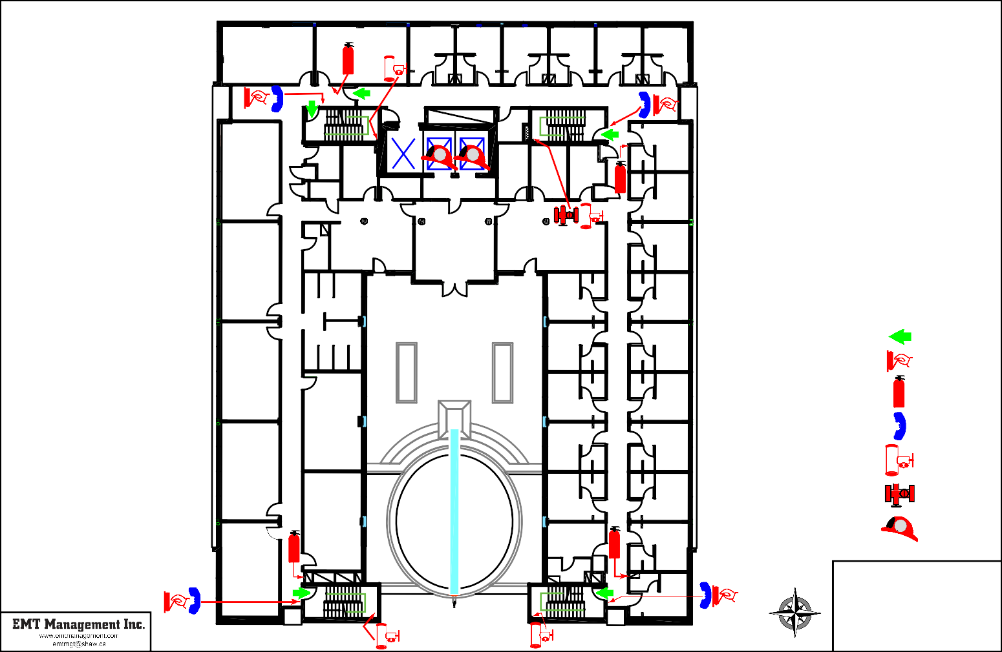
DORMITORY
319

DN UP

UP DN

STAIR A STAIR B

310

N

November 2015

THE SALVATION ARMY BELKIN HOUSE

555 Homer Street, Vancouver, BC
Level 3 Fire Safety Plan

W.R. W.R.

413 414A
POD
414
414B 414C 414D
415

STAIR C
NORTH WING

STAIR D

UP

412 DN

#2 #1
#3

F F
DN UP

OFFICE

401

LAUNDRY OFFICE
OFFICE

JAN.

411
W.R.

402

410D
W.R.

OFFICE OFFICE OFFICE

COMMON TV ROOM

OFFICE

OFFICE

W.R.

403A

410C

POD
410

410B

410A

409

408

W.R.
W.R.

W.R.
WEST WING

DN UP

407A

407B

POD
407

407C

407D

BALCONY

406D

406C

POD
406

406B

406A

W.R.

W.
R.

UP DN

W.R.

403B

POD
EAST WING
403

403C

403D

404

405

LEGEND
 | FIRE EXIT
 | FIRE ALARM
 | PULL STATION
 | FIRE
 | EXTINGUISHER
 | FIREFIGHTER
 | PHONE
 | STANDPIPE
 | CONNECTION
 | SPRINKLER
 | FLOOR VALVE
F | FIREFIGHTER
 | ELEVATOR

THE SALVATION ARMY
N BELKIN HOUSE

555 Homer Street, Vancouver, BC

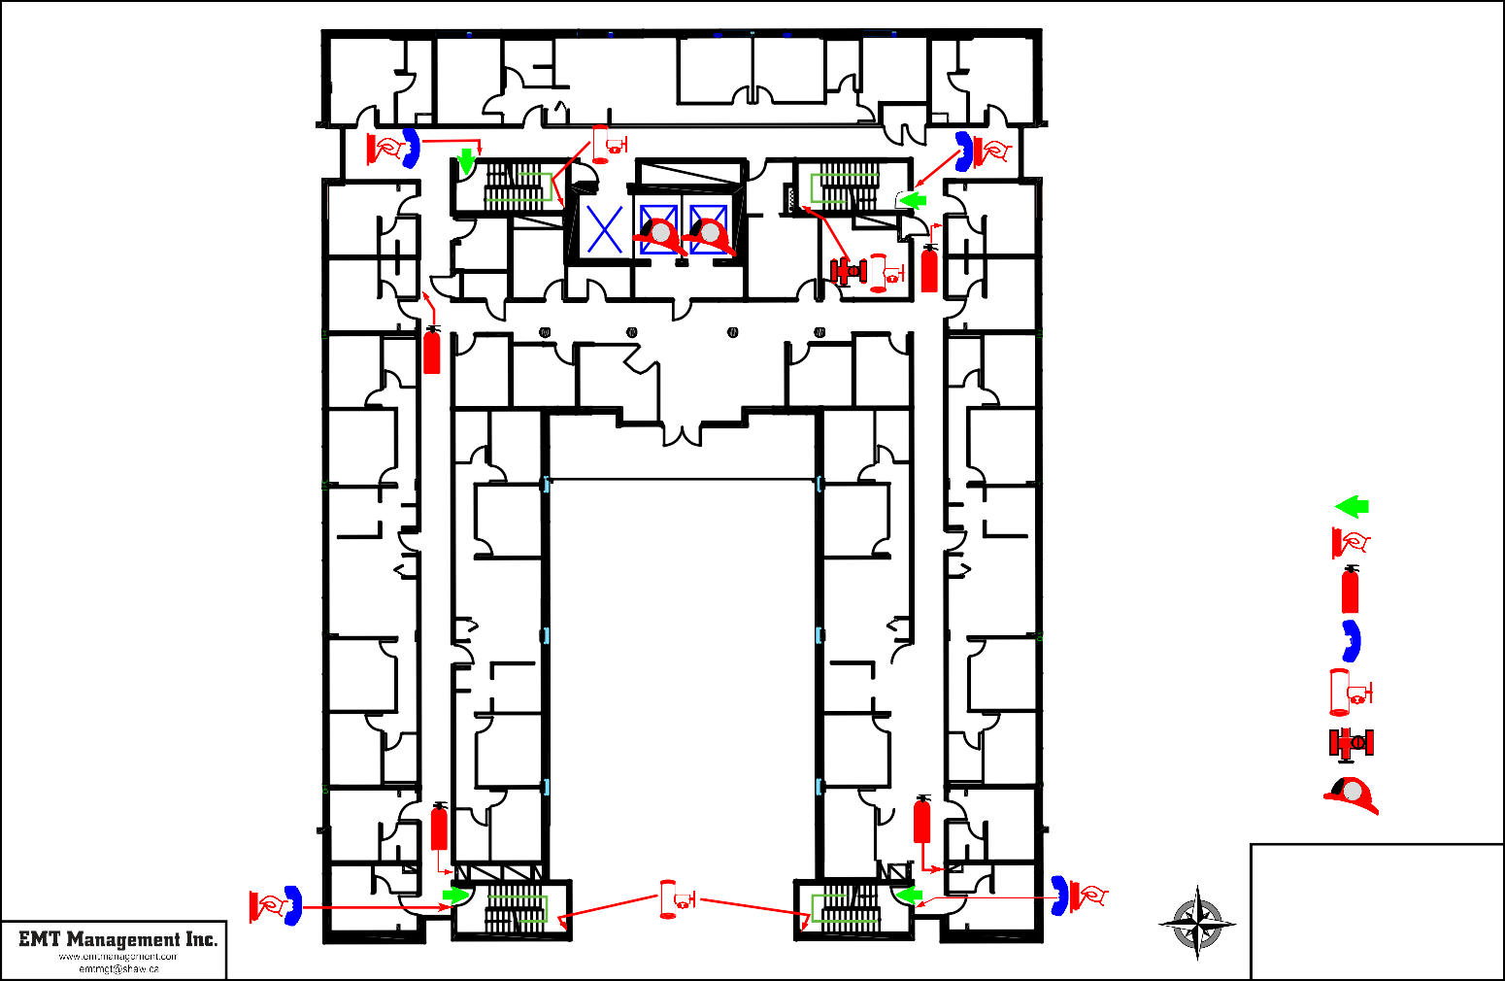
STAIR A STAIR B

November 2015

Level 4 Fire Safety Plan

531 532 533 534 535 536 537 538 539 540

UP

530 DN

LAUNDRY

STAIR C
NORTH WING

#2 #1
#3

F F

STORAGE

STAIR D

DN UP

501

529

528

JAN.

STORAGE

W.R.

STORAGE STORAGE
LAUNDRY

502

503

LOUNGE
TV ROOM TV ROOM

STORAGE STORAGE
527 BALCONY

504
LEGEND
 | FIRE EXIT
 | FIRE ALARM
 | PULL STATION
 | FIRE
 | EXTINGUISHER
 | FIREFIGHTER
 | PHONE
 | STANDPIPE
 | CONNECTION
 | SPRINKLER
 | FLOOR VALVE
F | FIREFIGHTER
 | ELEVATOR

526

525

524

523

522

516

517
WEST WING

518

519

520

515

514

513

512

511

505

506
EAST WING

507

508

509

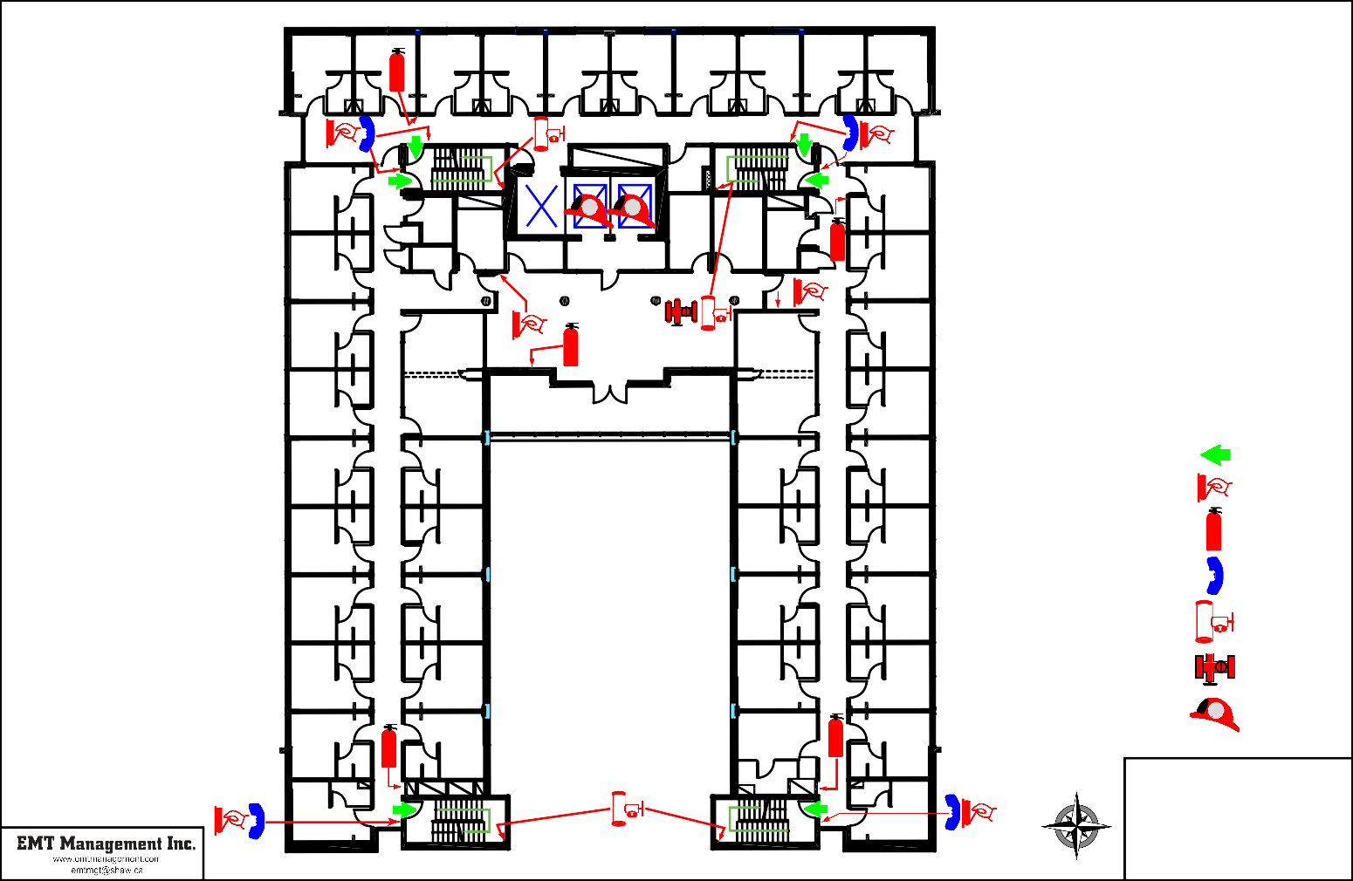

521 DN
UP

UP DN
STAIR A STAIR B

510

N

November 2015

THE SALVATION ARMY BELKIN HOUSE

555 Homer Street, Vancouver, BC
Level 5 Fire Safety Plan

631 632 633 634 635 636 637 638 639 640

630

629

628

STAIR C

UP DN

LAUNDRY

JAN.

STORAGE

W.R.
NORTH WING

#2 #1
#3

F F

STORAGE

STORAGE

STAIR D

OFFICE

DN UP

LAUNDRY

601

602

603

STORAGE

LOUNGE

TV ROOM

TV ROOM

627

626

625

624

623
STORAGE

616
WEST WING

617

618

619

BALCONY BALCONY

615

614

613

612

604

605
EAST WING
LEGEND
 | FIRE EXIT
 | FIRE ALARM
 | PULL STATION
 | FIRE
 | EXTINGUISHER
 | FIREFIGHTER
 | PHONE
 | STANDPIPE
 | CONNECTION
 | SPRINKLER
 | FLOOR VALVE
F | FIREFIGHTER
 | ELEVATOR

606

607

608

622 620

611
609

THE SALVATION ARMY
N BELKIN HOUSE

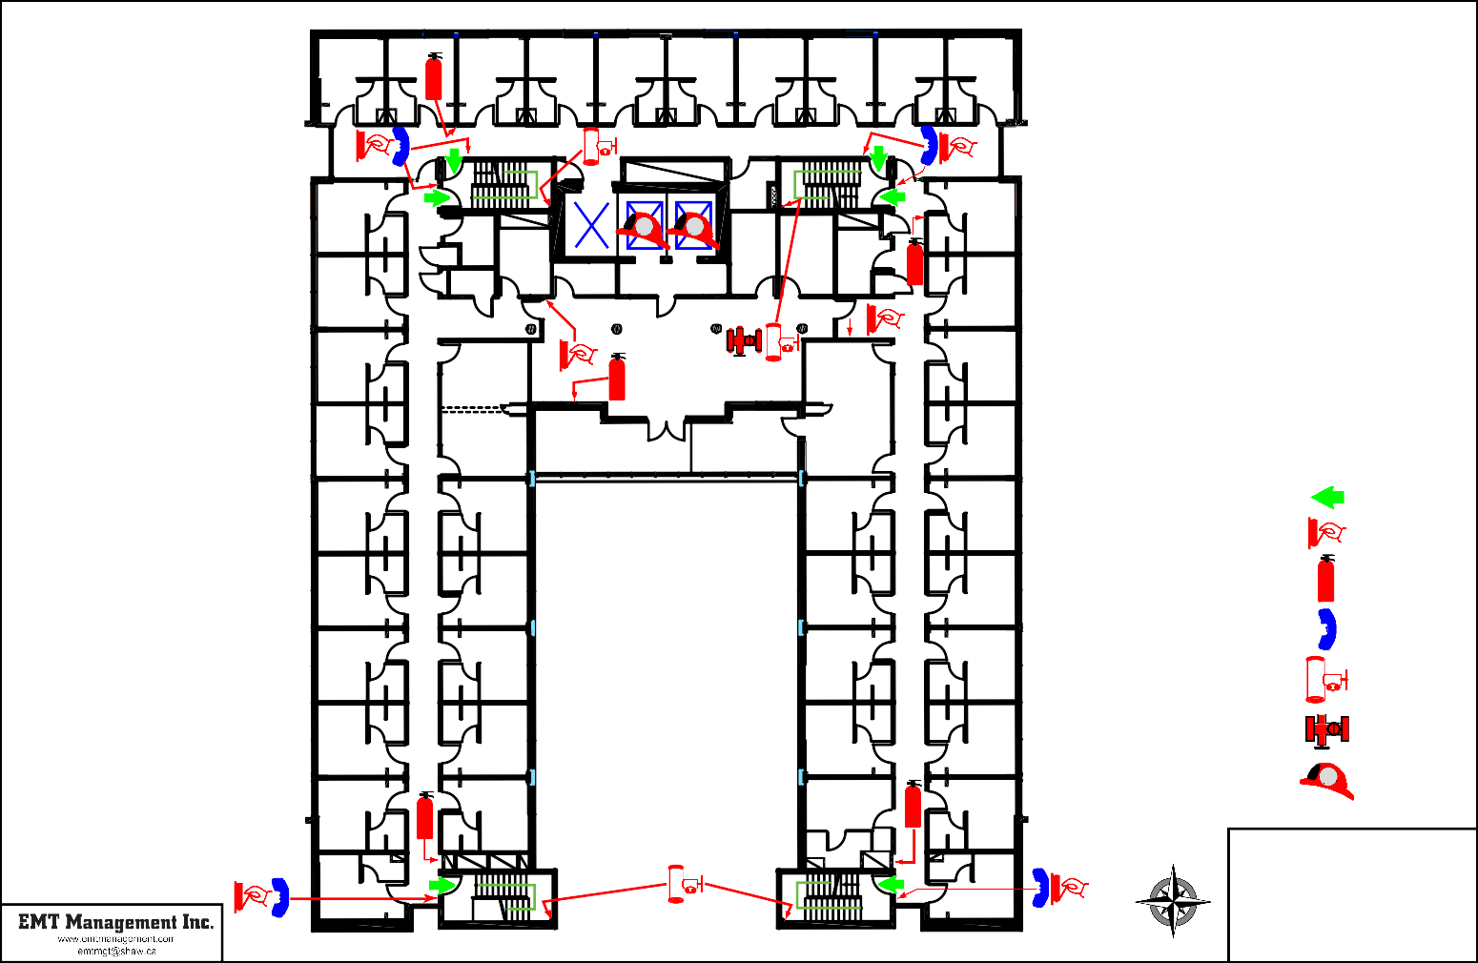
621 DN UP
DN

STAIR A STAIR B

610

November 2015

555 Homer Street, Vancouver, BC
Level 6 Fire Safety Plan

709A 709B 709C 710D 710E 711F 711G 712H 712I 712J

OFFICE

STAIR C
NORTH WING

STAIR D

UP STORAGE

DN

STOR.
DN UP
#2 #1
#3

LAUNDRY

JAN.

LAUNDRY
F F

STORAGE

STORAGE

W.R.

DORMITORY
701

LOUNGE

OFFICE

LOUNGE
FEMALE EMERGENCY SHELTER

OFFICE

STORAGE

W.R.

DORMITORY
702

BALCONY

DORMITORY
LEGEND
 | FIRE EXIT
 | FIRE ALARM
 | PULL STATION
 | FIRE
 | EXTINGUISHER
 | FIREFIGHTER
 | PHONE
 | STANDPIPE
 | CONNECTION
 | SPRINKLER
 | FLOOR VALVE
F | FIREFIGHTER
 | ELEVATOR

708

GARDEN

KITCHEN EXHAUST FANS

FAMILY ROOM
707B

FAMILY ROOM
707A

FAMILY ROOM
706B

FAMILY ROOM
706A

DORMITORY
703
EAST WING

DORMITORY
704

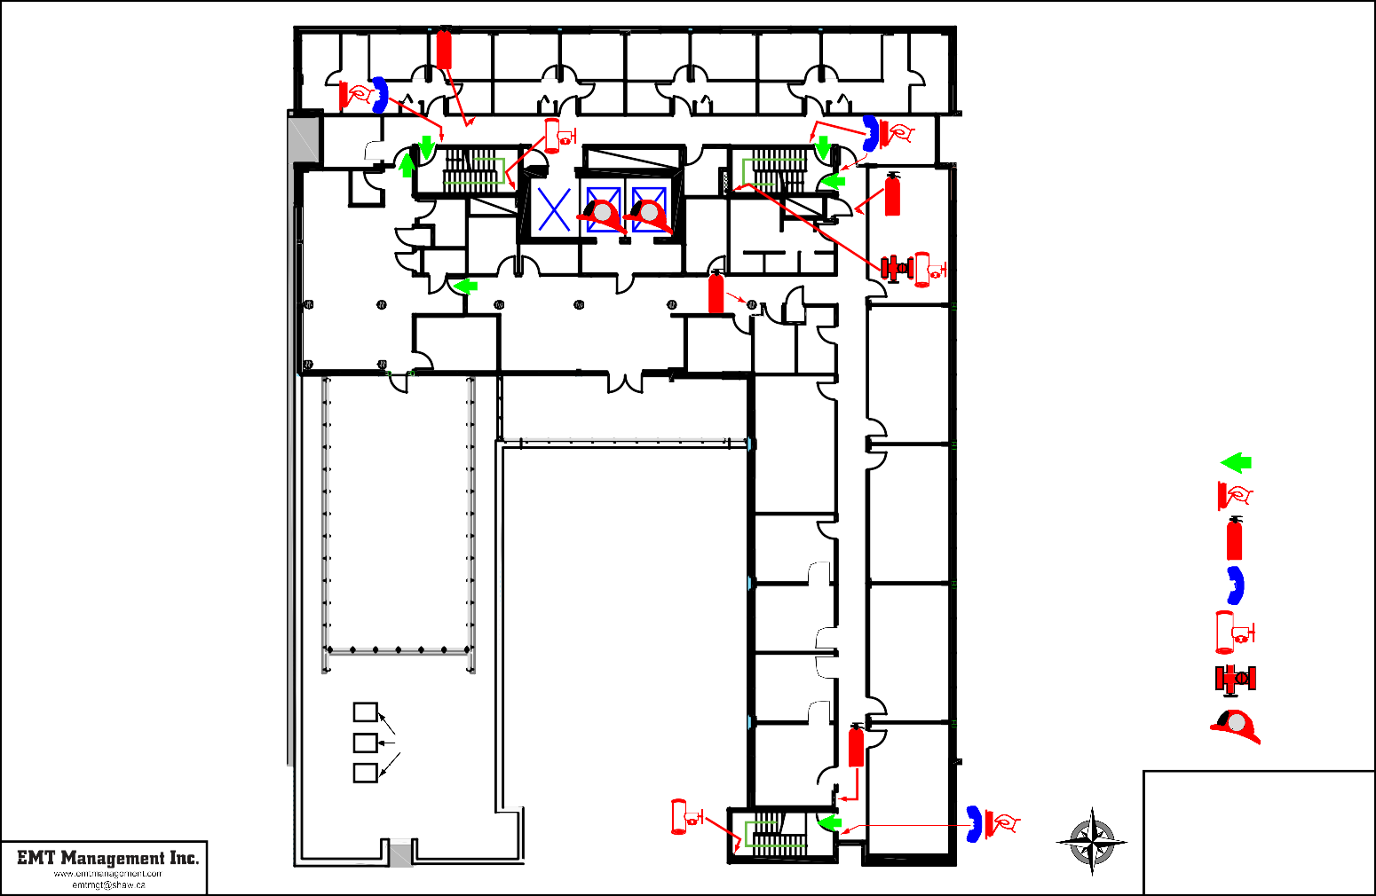

AIR HANDLING UNIT

DN

STAIR B

DORMITORY
705

N

November 2015

THE SALVATION ARMY BELKIN HOUSE

555 Homer Street, Vancouver, BC
Level 7 Fire Safety Plan

PROGRAMS

MALE W.R.

STAFF LUNCH ROOM

FEMALE W.R.

EMPLOYEE RELATIONS

SUPPORT SERVICES IT COMM.

STAIR C

STORAGE

STAIR D

DN

ADMINISTRATION

DN UP

ENVIRONMENTAL SERVICES
#3 #2 #1

STATIONARY
F F W.R.

SERVER

RESIDENTIAL SERVICES
EXECUTIVE
DIRECTOR

RECEPTION

LOUNGE

BOARDROOM
ADMINISTRATION

PATIO
LEGEND
 | FIRE EXIT
 | FIRE ALARM
 | PULL STATION
 | FIRE
 | EXTINGUISHER
 | FIREFIGHTER
 | PHONE
 | STANDPIPE
 | CONNECTION
 | SPRINKLER
 | FLOOR VALVE
F | FIREFIGHTER
 | ELEVATOR

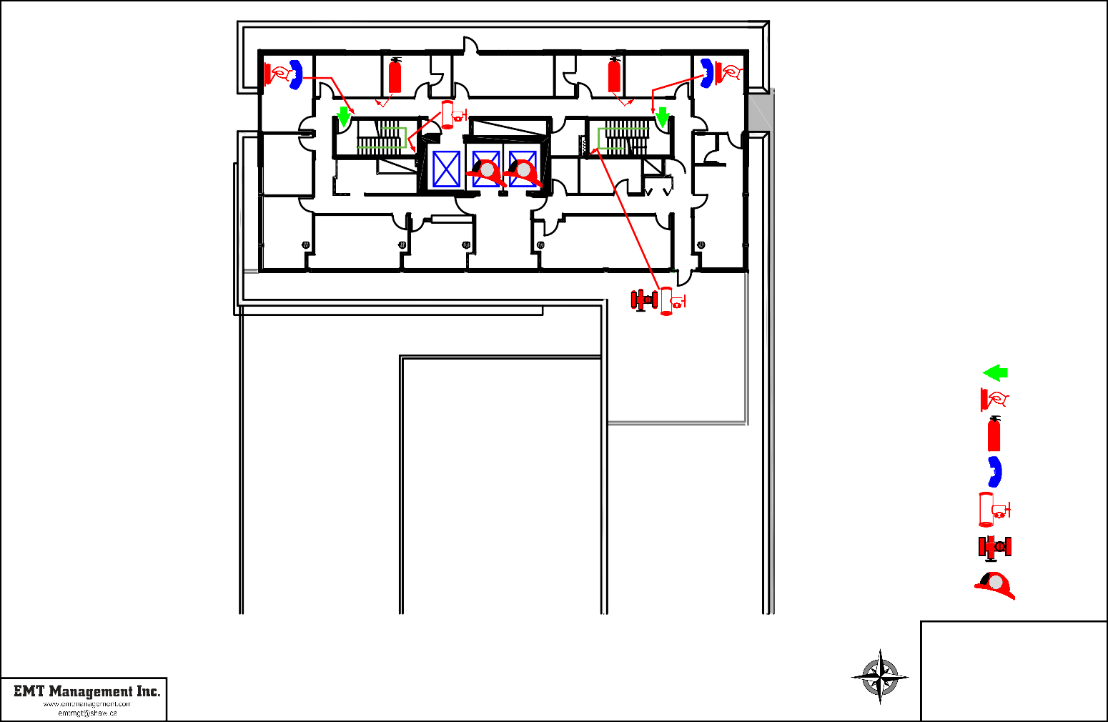

N

November 2015

THE SALVATION ARMY BELKIN HOUSE

555 Homer Street, Vancouver, BC
Level 8 Fire Safety Plan

CHILLER
AIR HANDLING UNIT
STAIR D
DN

UP

EXHAUST FAN
PUMPS
ELEVATOR ROOM
MECHANICAL

BOILERS
HOT WATER TANK

LEGEND

FIRE EXIT

FIRE ALARM PULL STATION

FIRE EXTINGUISHER

FIREFIGHTER PHONE

SPRINKLER FLOOR VALVE

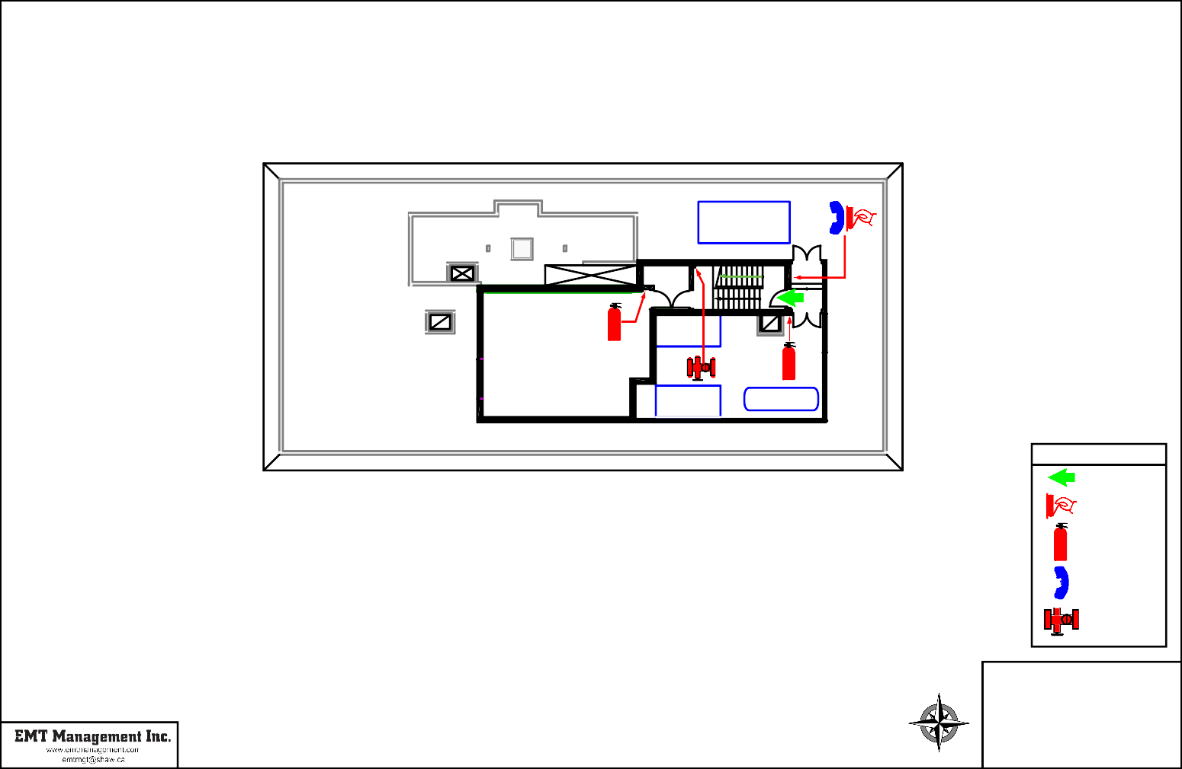

N

November 2015

THE SALVATION ARMY BELKIN HOUSE

555 Homer Street, Vancouver, BC
Roof Level Fire Safety Plan

