The Salvation Army Women’s Counselling Centre

Community Needs Assessment 2016
Mississauga

Prepared By:
Major Catherine Skillin
June 2016
Reviewed: August 2016

Contents
Executive Summary 3
Introduction 4
Population Growth 4
Immigration / Migration 6
Unemployment 7
Ontario Works 8
Low Income Families 9
Crime/Violence 9
Violence Against Women 11
Service Gaps 13
Map of Peel Region 14

Executive Summary

As of 2015, 766,000 people live in Mississauga. Since 2014, the population of Mississauga grew by 14,000 people.

In 2011, immigrants comprised more than half of Peel Region’s total population (50.5%). Immigrants represent 52.9%, of the total population in Mississauga. 57.6% of the immigrant population in Peel Region live in Mississauga. Of the population of Mississauga, 374,575 people identify as members of the immigrant population. This is 52.85% of the population of Mississauga.

In 2014 the unemployment rate in Mississauga increased to 8.7%.

In 2015, the level of Ontario Works (OW) caseloads in Peel remained elevated. For the full year 2015, the total number of OW caseloads recorded in Peel was 214,701 cases, an increase of 6.0 per cent relative to the 202,529 cases registered in 2014.

The Peel Regional Police crime statistics show some decreases in the number of violent crimes in Mississauga from 2014. There were a total 2897 crimes against persons committed in Mississauga (including the airport) in 2014. This is down from 2940 in 2013. While this report is focusing primarily on Mississauga, it should be noted that the crime stats in Brampton are considerably higher than in Mississauga.

Female victims of spousal violence are more likely than males to report being injured, suffer lost productivity, experience multiple assaults, fear for their lives, and experience negative emotional consequences.
The wait for subsidized housing in the Region of Peel continues to be very long. It is now reported as approximately 6 depending on how many building the applicant selects. The wait list for Senior’s (65+) buildings is now slightly less than 6 years. These wait times, while they are improving, are still by far one of the longest in the province and are much too long for the people who are in need.
Most counselling agencies who provide free or geared to income services have lengthy waiting lists. It is not uncommon for a woman to wait 2 months for counselling. This wait is much too long for a woman in crisis.

There are only 3 shelters for abused women and children and only one second stage housing program in all of Peel Region. The second stage housing program has a total of 9 apartments. This means that only 9 families a year can be housed and supported in this program. This is a huge service gap in Peel Region.

Introduction

To gain a better understanding of the population, several factors have to be taken into consideration in order to assess the needs of the community. The following report will highlight the current situation and changes in the Mississauga area and in some cases, Peel region, over the past number of years and assess the growing needs of the current population.

The City of Mississauga continues to experience increases in the population. This has resulted in many changes. The areas which have been most affected are housing, education, employment and social services.

Although we are able to provide service to women living in any part of Peel Region, due to our geographic location in the southwest corner of Mississauga, over 98% of our clients come from the City of Mississauga. For that reason, many of the detailed statistics discussed in this report will focus primarily on Mississauga. In some cases, where specific by city statistics were not available, the regional statistics are given.

Due to the fact that the 2016 Census information was not yet available at the time of updating this document, some of the statistics contained herein are still from 2011. Where possible more recent statistics gleaned from a variety of sources have been included.

Population Growth

As of 2014, 766,000 people live in Mississauga. Since 2006, the population of Mississauga grew by 99,000 people. The city of Mississauga predicts that there will be a building shift from single family dwellings to high rise high density dwellings. This will be largely due to the depletion of land required for building.
The City of Mississauga registered a 1.82 per cent (13,700 persons) increase in its total population to reach approximately 752,300 persons in 2015.
Indicative of a maturing urban community, Mississauga’s age structure is anticipated to shift considerably over the next 20 years. The senior population (those 65 years and over) will increase significantly from 11% of the population to 29%, while those from 40 to 64 years will decline from 36% to 28%. This is largely due to the huge demographic of baby boomers moving into their retirement years.

The transition from a fast growing and relatively young population to a more stable and older population has important implications for planning and growth management. The aging population will affect all services delivered by the city including, for example, parks and recreation, transit, and community planning.

The increase in the population further propels the need for community resources allowing for the growth to be sufficiently supported.

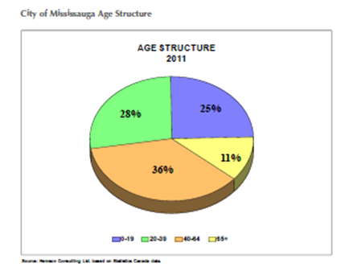
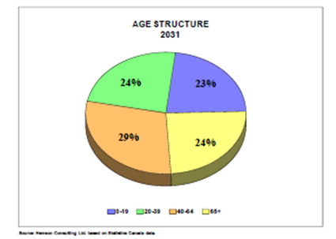

This shift in age of the population will also require additional services in health care and housing and social services for senior adults to be put in place to handle the increased demand.

Immigration / Migration

Second only to Toronto and likely due to geographical proximity, Peel Region (primarily Mississauga and Brampton) is the number two immigration area in the Greater Toronto Area. The below chart shows the most recent information available regarding the immigrant population in the GTA:

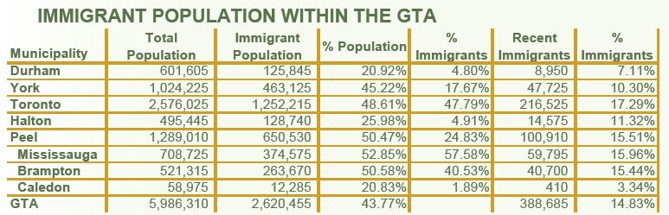

In 2011, immigrants comprised more than half of Peel’s total population (50.5%). Immigrants represent 52.9%, of the total population in Mississauga. 57.6% of the immigrant population in Peel Region live in Mississauga. Of the population of Mississauga, 374,575 people identify themselves as immigrants. This is 52.85% of the population of Mississauga.

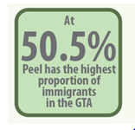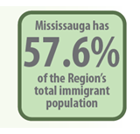

These numbers indicate the growing need for cultural sensitivity within the services offered throughout our City and Region. These statistics indicate the significant need for community resources within the region that will support the diversity of the growing population and support their growing needs. The below chart shows the primary countries of birth of the immigrant population through Peel Region: The chart also highlights the need for services to be provided in languages other than the official languages of Canada.

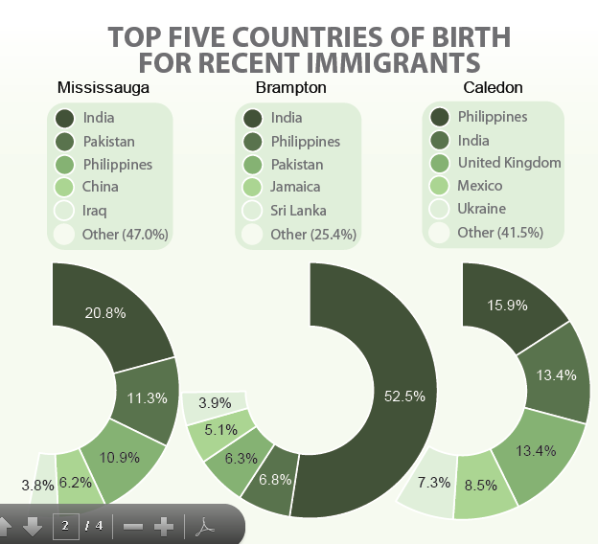

Language Summary – Peel Region 2011 Census
According to the 2011 Census, 15.6% of Seniors in Peel have no knowledge of English or French. The top languages spoken at home in Peel Region are Punjabi In Brampton, Urdu in Mississauga, and Italian in Caledon. 3.9% of people in peel have no knowledge of either official language. In Mississauga, 6.9% of people have no knowledge of English and French. In Peel, there are 375 people whose home language is non-verbal.

Unemployment

With the recent changes in the Canadian economy, the unemployment rate in Mississauga has increased to 8.7%.

Ontario Works
In 2015, the level of Ontario Works (OW) caseloads in Peel remained elevated. For the full year 2015, the total number of OW caseloads recorded in Peel was 214,701 cases, an increase of 6.0 per cent relative to the 202,529 cases registered in 2014. This translated into an average monthly caseload of 17,892 cases, up from with a monthly average of 16,877 cases recorded in 2014. The increase registered in 2015 represented the ninth annual increase in OW caseloads in Peel.

Notwithstanding the sustained increase in OW caseloads in Peel, the annual increases have moderated significantly since the recession. From an annual increase of 28.5 per cent during the recessionary year 2009, annual increases moderated to 14.3 per cent in 2010 and further to a low of 1.2 per cent in 2013 and 0.9 per cent in 2014. In the case of 2015, the 6.0 per cent also occurred amidst a change to a new system that now monitors OW caseloads in Ontario, and as such, the increase may be also a reflection of transitional challenges.

The increase in the number of persons on social support may not only be a function of the broader economy, but also be a result of increasing population. In the case of an increasing population, the number of cases as a proportion of total population may remain relatively stable although the number of persons increased, as the same proportion of a larger population translates into more persons.

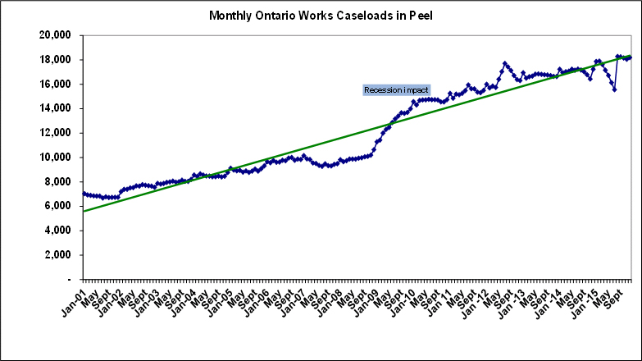

Low Income Families
In 2011, 13.6% of Mississauga's economic families were considered to be living on low income. This includes families who are on social assistance as well as those who are working but in minimum wage or low wage jobs.
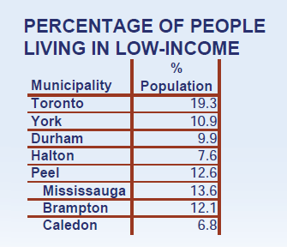

In 2011, Peel’s residents aged 15+ reported the second lowest median after tax income ($27,200) in the GTA, however, they retain the greatest percentage of pre-tax income (84.3%). Among the GTA municipalities, Peel also has the second highest prevalence of low-income (12.6%), with those less than 6 years of age making up 10.2% of this group.

With regard to affordable housing, 69.0% of Peel households spend less than 30% of total income on housing, and Peel had the lowest percentage of tenants in subsidized housing in the GTA (13.5%). However, while on the surface, this may sound positive, it is in fact not positive. It is due to the fact that Peel has the longest wait list for subsidized housing of any municipality in Ontario. The wait for subsidized housing in the Region of Peel continues to be very long.
Although Peel Region wants to house as many of the people who need subsidized housing as possible, the demand for housing far exceeds the supply and so most people experience long wait times.
Subsidized Housing Current Average Wait List Times (as of June 2016):

The average waiting time for subsidized housing in Peel Region is approximately 6 years. This does depend on how many buildings the applicant selects during their application process. The more buildings the applicant selects generally the quicker she will receive housing offers. The waiting list is slightly shorter for Seniors 65+ who select seniors only buildings on their application. However, the applicant must already be at least 65 when they select a 65+ building.

Crime/Violence

The most recent crime statistics available at the time of preparation of this document is for the 2014 year. The Peel Regional Police crime statistics show primarily decreases in the number of violent crimes in Mississauga from 2013-2014.

There were a total 2897 crimes against persons committed in Mississauga (including the airport) in 2014. This is down slightly from 2940 in 2013. While this report is focusing primarily on Mississauga, it should be noted that the crime stats in Brampton are considerably higher than in Mississauga. This decrease in crimes against persons is due largely to the good work done by the Peel Regional Police.

In spite of the overall decrease noted, there are still a significant number of crimes being committed. Those that most directly affect our clients are attempted murder, sexual assault and assault.

Crimes such as criminal harassment, harassing phone calls, making threats and deprivation of freedom also significantly affect our clients. In their statistics, Peel Police call these crimes “other crimes against persons”. In 2014 these crimes increased in Mississauga. Police reports the following crime statistics for 2014:

Attempted Murder 2 (increased from 2013)
Sexual Assault 245 (increased from 2013)
Assault 1688 (decreased from 2013)
Other Crimes Against Persons 705 (increased from 2013)

It should be noted that these statistics represent the crimes that are reported and investigated by the Police. However, from knowledge of our clients, we are aware that there are many more assaults, criminal harassment and deprivation of freedom violations that are never reported to the Police and therefore are not included in these statistics. Police also reports that in 2014, there were 5924 calls related to Domestic Violence. This is an increase over the previous year. However, they do not specifically report any resulting crimes in separate statistics. For that reason, it is not possible to be more specific in assessing crimes that are Domestic Violence related. It should also be noted that calls to the police for assistance related to mentally ill people increased approximately 7% in 2014.

Violence Against Women

Along with the general decrease in crime in Canada, so violent crimes against women are decreasing. However, violence against women remains an ongoing problem in Canada and around the world. It affects women’s social and economic equality, physical and mental health, well-being and economic security.

Gender-based violence is perhaps the most wide-spread and socially tolerated of human rights violations. It both reflects and reinforces inequities between men and women and compromises the health, dignity, security and autonomy of its victims.

The Canadian Criminal Code has no specific offence of violence against women or spousal assault. The Criminal Code provisions that most commonly apply to cases of violence against women include the offences of assault, sexual assault, criminal harassment, threats of violence, forcible confinement and homicide.

Prevalence And Severity

Consider these statistics on Violence Against Women in Canada:
- Half of all women in Canada have experienced at least one incident of physical or sexual abuse since age 16
- 67% of Canadians report knowing at least one woman who has been physically or sexually assaulted.
- More than 3000 women along with their children reside temporarily in shelters fleeing abusive relationships
- In a 2009 Canadian national survey, women reported 460,000 incidents of sexual assault in one year.
- Only about 10% of all sexual assaults are reported to the police
- About 80% of sex trafficking victims in Canada are women and girls
- More than one in ten Canadian women say they have been stalked by someone in a way that made them fear for their life.
Woman abuse occurs in all societies and cultures. Refugee and non-status women in Canada are at high risk of experiencing violence because of the vulnerable position they live in.
- They have very limited access to information, counselling and other social services;
- They are reluctant to call the police in an emergency because they may fear being deported, as the police have authority to arrest or detain someone on behalf of Immigration Canada;
- If her partner is charged with assault, this could lead to devastating consequences including deportation for her; and
- They cannot easily access medical services.
Impact

Women that have experienced abuse are likely to be impacted emotionally, physically, socially, and financially. It may affect work and intimate relationships. Some women may face additional problems related to child-care, housing, and poverty. Immigrant and refugee women may face specific problems, such as racism, language barriers, isolation, lack of experience accessing social services, low economic status, immigration policies and fear of the criminal justice system.
Female victims of spousal violence are more likely than males to report being injured, suffer lost productivity, experience multiple assaults, fear for their lives, and experience negative emotional consequences.

According to the Department of Justice, each year Canadians collectively spend $9 billion to deal with the aftermath of spousal violence. These costs include medical care, social assistance, housing programs, legal costs and funerals. These costs also include less tangible aspects including pain and suffering.

Service Gaps

There are only 3 shelters for abused women and children in all of Peel Region. Frequently these shelters are full. The Peel Family Shelter will take women and children waiting to get into an Abuse Shelter, but their program is not geared to the kind of support that women fleeing abuse need. There is only one second stage housing program in all of Peel Region. It is a program where woman and children can live up to one year less a day after being in an abuse shelter. This one program in Peel has a total of 9 apartments. This means that only 9 families a year can be housed in this program. While more second stage housing programs are desperately needed in Mississauga, so far there are no funding sources available for such a program.

While there are several agencies in Peel Region who offer Counselling Services to abused women, many of them are fee based services. Most women who are fleeing abusive relationships have little or no income, thus paying for counselling is out of the question. Many of the counselling services that are not fee based only offer a small number of sessions without fees. Our clientele have such complex needs that many sessions are required in order to begin to address those needs. We are also noticing an increase in clients with concurrent mental health issues. Where there is the presence of a mental illness, the issues faced by the client are magnified. There is not a good network of support services for people with mental illness in Peel Region.

Historically, there are trends in the numbers of women seeking to access our services. The summer period seems to be a time of increased need for services. It is thought that women with children will sometimes stay in an abusive relationship until their children finish school in June. They do this to minimize the impact on their children. These women seek counselling and shelter services during the summer. For counselling agencies, this time period coincides with staff vacations and lack of students and interns providing services. This results in lengthy waiting lists. It is not uncommon for a woman to wait 2 months for counselling. This wait is much too long for a woman in crisis.

Many agencies operate a variety of groups for women living in or fleeing abusive relationships. But due to staff vacations, many of these groups do not operate during the summer months when the demand for services is high.

There are several agencies who provide transition, legal and court support. Accompanying a client to court often takes all day. This limits the amount of service that agencies are able to provide to the community. Some agencies are moving away from providing court support in favour of other less intensive transition supports.

The high number of immigrants to Peel Region requires that there be a greater degree of cultural awareness and sensitivity in all agencies serving this area.

Map of Peel Region

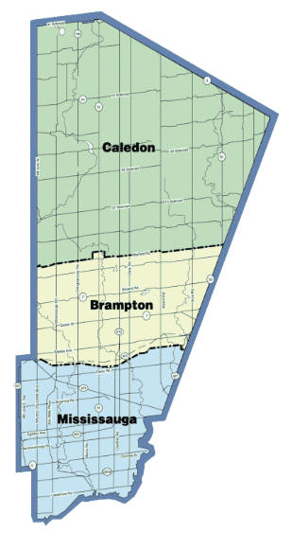
Sources Of Information

The information contained in this report is based on the most recent statistical information available at the time of preparation.

The information was retrieved from the following internet sites:

http://www.peelregion.ca

http://www.peelpolice.ca

http://www.pcawa.org

http://canadianwomen.org/facts-about-violence

http://www.cbc.ca/strombo/news/7-sobering-stats-about-violence-against-women-in-canada

https://www.peelregion.ca/finance/dashboard-eco/peel-eco-pulse/ontarioworks.htm

