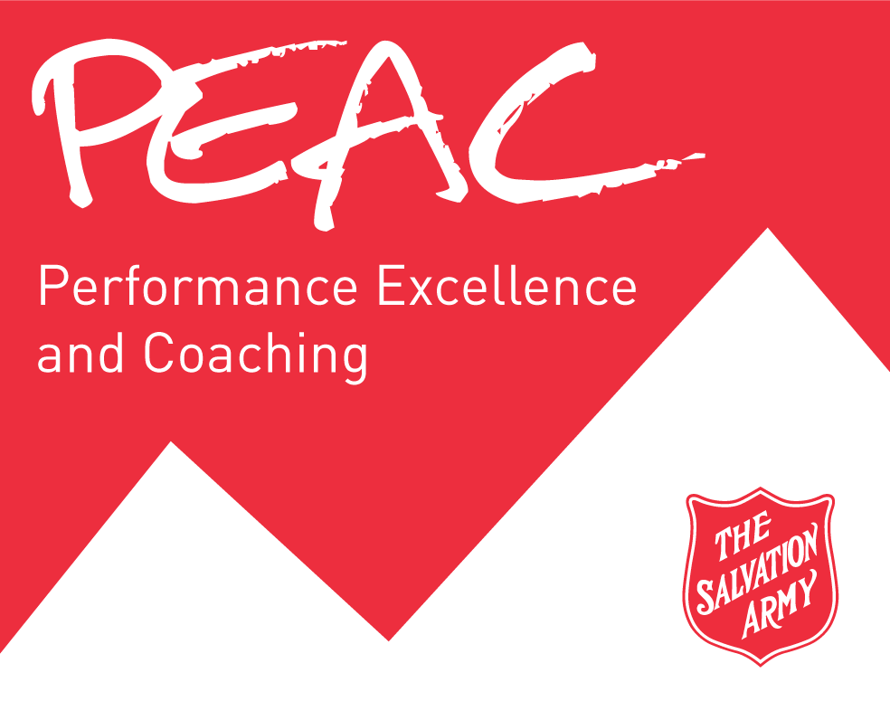

**Performance Coaching Form**

**The Salvation Army Canada & Bermuda Territory**

Staff Member: _________________________ Supervisor: ________________________ Timeframe: _____________________

|  |  |
| --- | --- |
| **What do you think is working well?** | **Here’s what I think is working well.** |
|  |  |
| **Where do you think there could be improvement?** | **Here’s where I think there could be improvement.** |
|  |  |