7 Operating Principles for Emergency Shelter
The Operating Principles are a tall order, and when taken together, they represent in some ways a substantial gap between the ideal they propose and our current reality. Many of our Ministry Units have made great strides to bridge the gaps that exist between these ideals and our current reality. The purpose of this toolkit is to shorten that gaps that still exist and to begin addressing some of the barriers Ministry Units face in implementing the principles. By now, we have a better sense of what Ministry Units are up against: they are being pulled in many directions and the required implementation of the Operating Principles was another pull on their already scarce time and resources. All of this is true.

But it’s also true that…
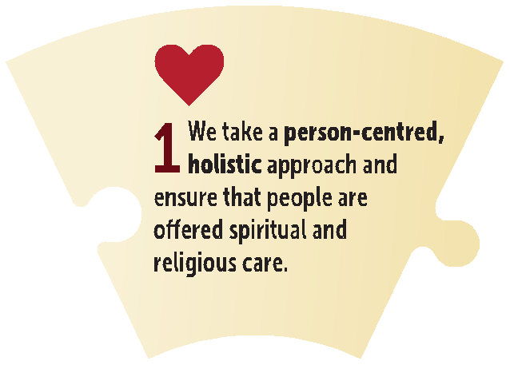
Housing First was adopted as a federal policy, and governmental funding for social services is increasingly being distributed according to an organizations’ fidelity with Housing First (albeit interpreted sometimes differently by region, funder, etc.).
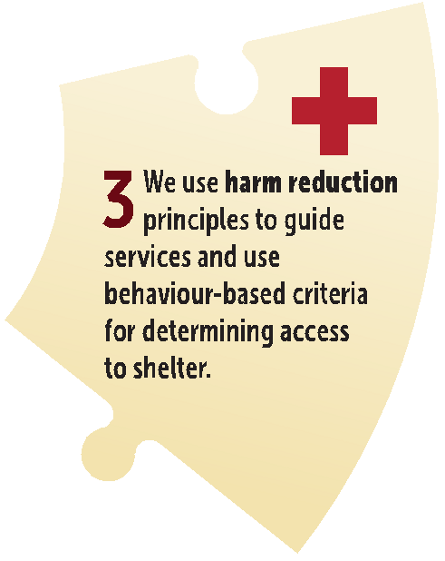
In order to sustain our reputation and presence as an integral part of the social safety net in Canada, it’s imperative that we find and can communicate the intersection between our mission and public policy (e.g. Housing First, Harm Reduction). The Operating Principles are an attempt to do that—to attune ourselves to what is going on around us, with particular focus on our Canadian context, and find a way to participate in federal, provincial, municipal and territorial plans to solve homelessness with confidence and cooperation while simultaneously knowing clearly who we are and how we can be of service to others in the way THEY need.
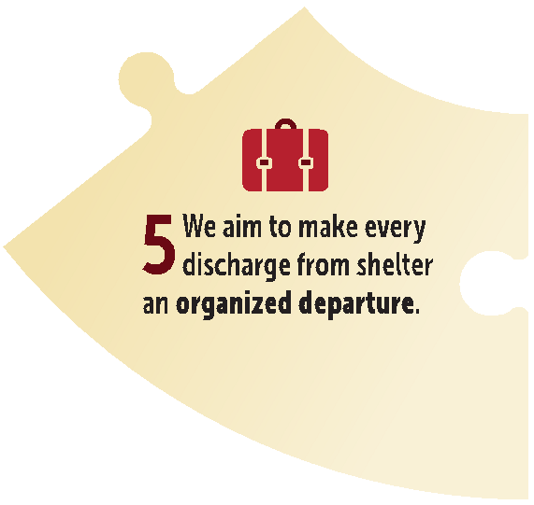
It is true that a home is, in many ways, better than a shelter. We are often the place where people feel known and cared for, in ways easily associated with home. Shelters are places of rhythms and routines, not unlike the home-making many of us do at home – the places we usually sit, the habits we easily slip into, the alliances we naturally adopt, the ways of passing time, of coping, or caring for each other that we naturally associate with home. As such, there exists a tension and desire across The Salvation Army to be something like home to people who are, at the moment, without it.
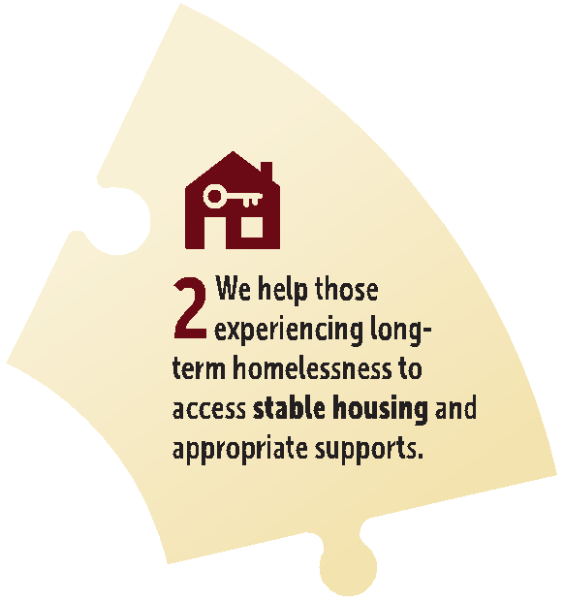
But, by and large, we agree that a ‘home’ can do better than a shelter. The affordable housing into which we help our clients move is not always better, to be sure – the dilapidated rooming house, the bachelor apartment in the cheaper part of town, far away from the familiar. But ‘home’ still needs to be the goal: helping people move out of places with dormitories, shared rooms and rules designed to govern larger groups of people into the housing and communities of their choice where they can live happily and stably, whatever that means or looks like for them . By now we know that this isn’t happening all that easily – homelessness is swelling, housing prices are climbing, the number of affordable housing units is dwindling, which is to say nothing of the deteriorating quality of those housing options over time. To make a dent, we all have to make it happen, on purpose, every day.
It’s true that some people are staying in our shelters for a long time. In a recent survey of our Ministry Units, we found that 70% of our shelters reported an average occupancy rate of 90% or higher. We also found that some people had been living for as many as 19 years in Salvation Army Ministry Units that were neither designed nor intended for long-term/indefinite stays. In our shelters we see experiences of “chronic” and “episodic” homelessness lived out over many, many years. We see people get housed and unhoused over and over again, and because of who we are and how much we care about them, we let that cycle perpetuate itself, letting people come and go through our compassionately revolving door. It’s true that it would be easier to help those who have not been homeless very long or are otherwise “housing ready,” but we know from experience that those who have been homeless a long time – some who have maybe never known what it means to be at home or felt at home– face greater barriers to housing and lower access to services. They need us. The Salvation Army has a long history of doing “what no one else will” or being the place for people who have “nowhere else to go”, and it’s time that meant focusing on those people who need us the most and helping them get home.
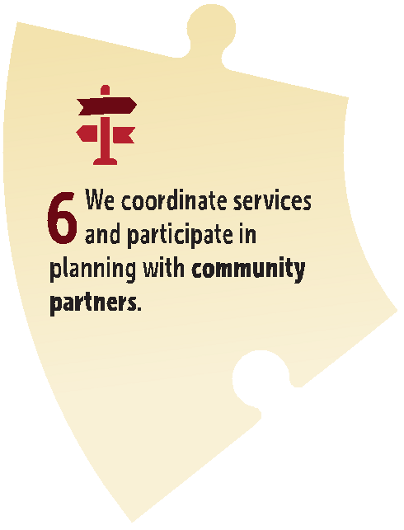
It’s also true that the problem is much bigger than any one person or organization: we can’t do it alone. No service provider can be all things to all people. We need to know and perfect our place in a range of options and services, help in dividing up all the jobs that need doing in our community and be the best we can be at our piece of the puzzle. If someone else is doing something better than we are, maybe we retreat and seek to get better at doing something else. If there’s a gap that needs filling, we need to assess whether we can take on that piece of work and if it means letting go of something else.

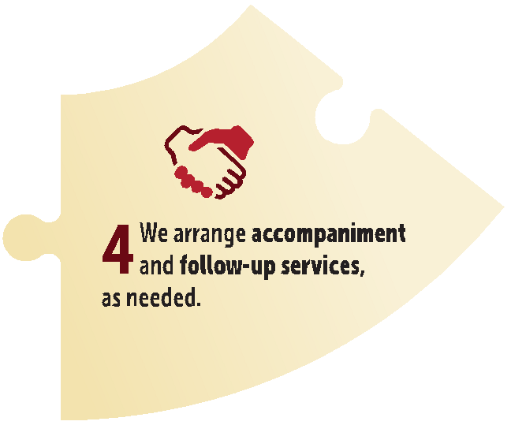
And if it’s true that no agency, charity or church is self-sufficient, how much more true must it be that no person is self-sufficient? We all need others, albeit to varying degrees and for different reasons. But, none of us are doing anything in life ALL alone. We need each other – whether to go to an appointment or on an adventure. Homelessness will not be solved until we realize that as service-providers we need each other, that people experiencing homelessness will never “make it on their own,” and that indeed there is no such thing. It takes all of us working together to care for our neighbours and transform our communities.
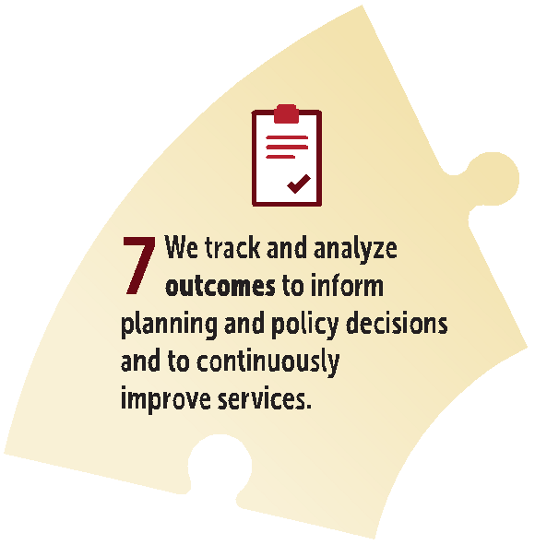
And finally, it’s true that our plates are full, money is limited, and we’re constantly scrambling to keep up with demand. But being clear and cohesive about a collective mission and common approach to Salvation Army shelters means that we can rely on each other: developing policies and procedures together, sharing information, tipping each other off to coming surprises, building communities of practice, etc. Getting all on the same page about these things will help us all conserve energy for the long fight, for love and for justice for others.

These are principles, and they were never disconnected from our mission and values, but there may yet be ways in which they need to become actions and behaviours, calling us to different decisions and a changing character in our approach to shelter provision.
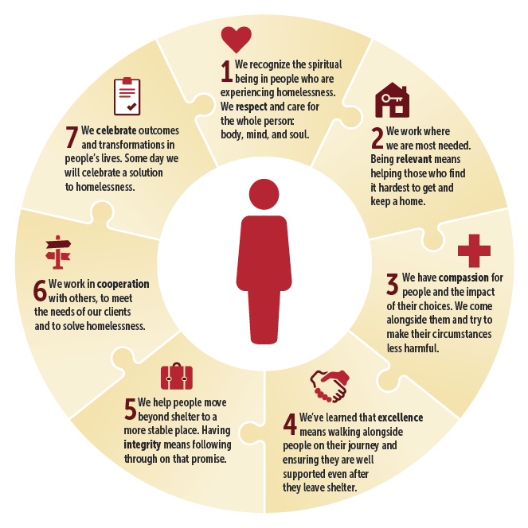
This Toolkit invites you to explore opportunities that may exist in your shelter for the Operating Principles to shape culture and guide practice, as you help people experiencing homelessness to get home.

