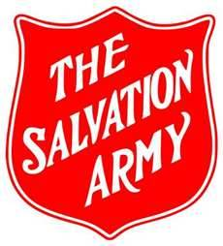
Salvation Army Correctional and Justice Services:[City, Province].

Weekly Supervision and Activity Reporting Log

Chaplain: ________________________________ Week Ending Date (Sunday): ______________________

Activity | Mon Hr:Min | Tues Hr:Min | Wed Hr:Min | Thurs Hr:Min | Fri Hr:Min | W/E Hr:Min | Weekly Total | Notes
Visits: Clients/Participants
Visits: Staff/Volunteers/Students
Visits: Institutions
Court Room Support/Appearance
Client Assistance & Referrals
Groups (Bible ST, Spiritual Formation, Retreats, Crisis Support, etc., & Prep)
Corporate Worship (Funerals, Memorials, Dedications, etc., & Prep)
C&JS Programs/Events/Activities (Attend, Facilitate, Support, etc.)
Interagency Meetings, Networking, Engagement
Staff/Volunteer/Student Training, Supervision, HR
Self-Development (Attend Training, Education/Courses, Research)
Professional Development (Meetings, Events, Research, Collaboration)
S&RC Program/C&JS Meetings
General Administration & lunch ½ hr
Program Development, Planning, Evaluation
PR, Advocacy, Public Education

Total Weekly Hours: ____________

