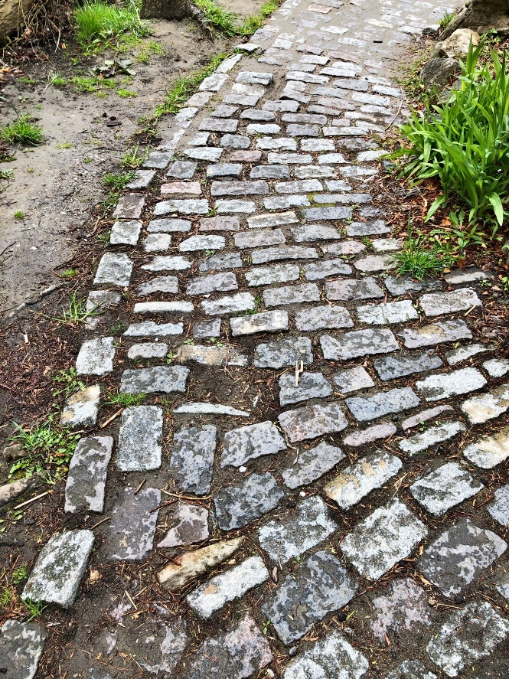

Retreat time – interactive with nature.

This is an invitation for you to combine your love for God and your love of nature. With each page/category listed below there is room left for you to add your own picture of your outdoor experience. For example: Psalm 1 and a tree invites you to meditate on the Psalm and then we’ve left room for a picture that you take today while you are out experiencing nature. Take your phone/camera with you. When you get back you can insert the photos you’ve taken and voila! You’ve created your own personalized interactive nature retreat.

“For his invisible attributes, namely, his eternal power and divine nature, have been clearly perceived, ever since the creation of the world, in the things that have been made.” Romans 1:20
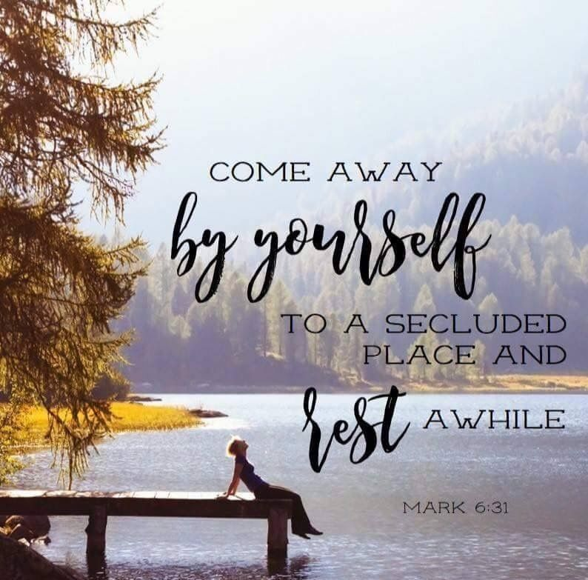

The Naturalist - is a person who would prefer to leave a building – however beautiful or austere – to pray to God beside a river. Leave the books behind, forget the demonstrations, and just let this person take a walk in the woods, mountain hike or bike, or gaze at a field of daises.

Naturalists believe that nature itself proclaims, “God is!” They may learn more from watching an ant colony or looking at a peaceful lake than from reading a book or listening to a sermon. Their favorite scriptures are likely the parables of Jesus based in nature, or the psalms.

Think about all the Biblical encounters with God that occurred outside … in the wilderness, the desert, the mountain, or at the river. Listen to this ancient text through the ears of the Naturalist….

The Lord is my shepherd;
I shall not want.
He makes me to lie down in green pastures;
He leads me beside the still waters.
He restores my soul;
He leads me in the paths of righteousness
For His name’s sake.
Yea, though I walk through the valley of the shadow of death,
I will fear no evil;
For You are with me;
Your rod and Your staff, they comfort me.
You prepare a table before me in the presence of my enemies;
You anoint my head with oil;
My cup runs over.
Surely goodness and mercy shall follow me
All the days of my life;
And I will dwell in the house of the Lord forever. Psalm 23

Psalm 1 and a Tree
Sit near a tree as you meditate on Psalm 1. Reflect on what you fill your mind with as you go about your daily life. Perhaps there’s some clutter in your head (e.g., worries, gossip, wishing things were different in your life, self-criticisms, angry conversations, lustful thoughts, lists of things you need to do, diversions).
Pray that you’d be like the Psalm 1 Man who delights continually in God’s law and his Word and so he easily and naturally bears much fruit. “He is like a tree planted by the streams of water” and “his delight is in the law of the Lord and on his law he meditates day and night” (verses 2-3).
What is the Lord saying to you through the tree?

Psalm 16 and a Path
Take a walk with Jesus on a path. Consider a decision you need to make and with that in mind imagine yourself following Jesus or walking with him. Pray about what path you’re to take. Perhaps it’s even more important to pray about how you’re to walk on whichever path you take.
Let David’s words in Psalm 16 inspire you: “I have set the Lord before me. Because he is at my right hand, I will not be shaken. Therefore my heart is glad and my tongue rejoices; my body will also rest secure… You have made known to me the path of life; you will fill me with joy in your presence, with eternal pleasures at your right hand” (verses 8-11).
What is Jesus saying to you on your path? In your daily life what helps you to walk in the joy of the Lord?

Psalm 19 and the Sky
Look up at the sky as you contemplate Psalm 19 and the sweetness of God’s Word – his personal message of kindness and love for you!
Especially meditate on these words: “The heavens declare the glory of God; the skies proclaim the work of his hands. Day after day they pour forth speech… In the heavens he has pitched a tent for the sun, which is like a bridegroom coming forth from his pavilion, like a champion rejoicing to run his course” (verses 1-2, 4-5).
How is Jesus like the sun ? Your Champion who sets the way and pace for your life’s race? What else do you notice about the sky?

Psalm 36 and a Fountain or any Flowing Water
Pray by a fountain. Perhaps you’ve been busy or dry lately. Let the fountain speak to your soul. Listen to the Spirit in its splashing waters. Attune your life rhythm to its rhythm; go with its flow.
Ask God to use the fountain to help you to meditate on Psalm 36, which includes these words: “We feast on the abundance of your house; you give [us] drink from your river of delights. For with you is the fountain of life; in your light we see light” (verses 8-9).
In what ways or situations has God been a fountain for you in 2020?

Psalm 42 and a Waterfall, Ocean, or Stream
Sit and listen to “the Deep” in God calling to “the deep” in your soul at a stream or waterfall while you meditate on Psalm 42.
Let the flowing waters help you to pray with the Psalmist: “Deep calls to deep in the roar of your waterfalls; all your waves and breakers have swept over me. By the day the Lord directs his love, at night his song is with me” (verses 7-8).
What do you appreciate about this image from scripture?

Psalm 46 and a Lake, stream or ocean
Pick a quiet spot by a lake to be still with Jesus and pray Psalm 46 (or pray as you walk around the lake).
After you’ve spent some time with the Psalm focus in on verse 10. Take in the peace of the lake as you slowly repeat to yourself God’s words to the Psalmist: “Be still and know that I am God.” Make your prayer a “Breath Prayer” by breathing in the words slowly and deeply.
What does the lake teach you about the kind of person God dreams for you to be? In what areas of your life do need to learn from Jesus to “Be still”?

Psalm 62 and a Rock
Find a rock – a large one to sit on (or near) or a small one to hold. In his desert trials David often found shelter, safety, rest, and prayer in a cave in the rocks. Perhaps in some area you’re feeling unsure or unstable, fearful or fickle.
Use the rock to meditate on Psalm 62. Pray that his words would be true of you: “My soul finds rest in God alone; my salvation comes from him. He alone is my rock and my salvation” (verses 1-2).
How do you need Jesus to be your Rock today?

Psalm 72 and a snow (or grass if you can find it)
.Let the snow help you to meditate on Isaiah 55:10-12, ”As the rain and the snow come down from heaven, and do not return to it without watering the earth and making it bud and flourish, so that it yields seed for the sower and bread for the eater, so is my word that goes out from my mouth: it will not return to me empty, but will accomplish what I desire, and achieve the purpose for which I sent it. You will go out with joy and be led forth in peace; the mountains and the hills will burst into songs before you, and all the trees of the field will clap their hands.”
What promises of God have you clung to throughout your life? What promises of God are you resting and finding comfort in today?
See if you can get a picture of a snowflake.

Psalm 92 and a Tree
Find a fir tree or cedar tree (or any tree will do!). Consider your need for regular and ample rest and how this helps you to notice and participate in what God is doing.
Meditate on the fir or cedar along with Psalm 92, the one Psalm in the Bible designated as “For the Sabbath Day.” Especially pray that verses 12-14 would be true for you: “The righteous will flourish like a palm tree, they will grow like a cedar of Lebanon; planted in the house of the Lord, they will flourish in the courts of our God. They will still bear fruit in old age, they will stay fresh and green.”
In your life today what would it look like for you to flourish in the courts of the Lord?

Psalm 104 and the Birds

Look and listen for the birds. Notice how joyfully they sing! The same Father that cares for them cares for you. Let the birds lead you to give thanks and praise to God. With the birds and the angels of the heavens you are joining God’s love song – he sings his love over you first!
Meditate on the birds and on Psalm 104:1, 12, 28, 30: “Praise the Lord, O my soul. O Lord my God, you are very great… The birds of the air nest by the waters; they sing among the branches… When you open your hand, they are satisfied with good things… When you send your Spirit, they are created, and you renew the face of the earth.”
What have you been appreciating about God’s goodness and care? Right now is a good time to give thanks to God!

