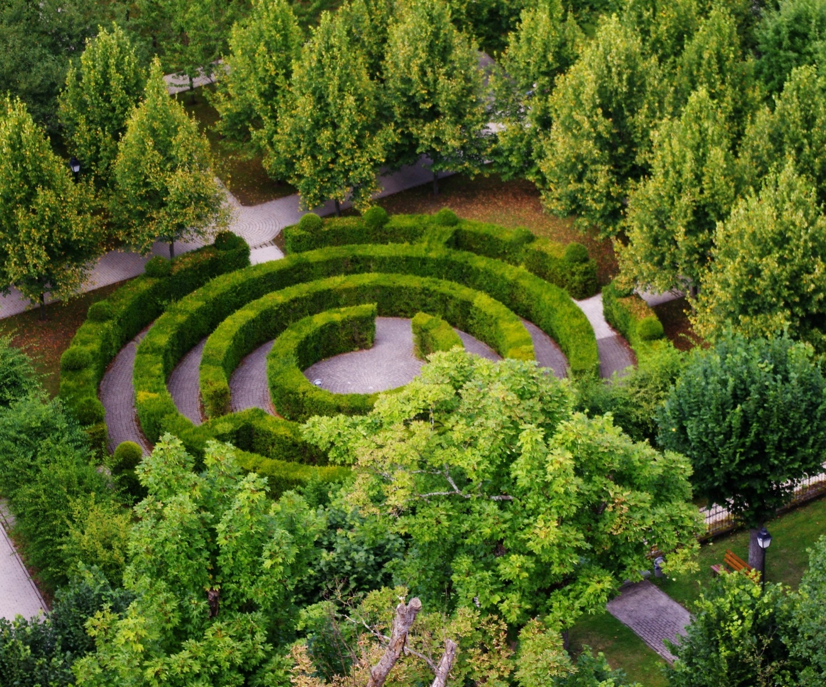
https://www.cofchrist.org/common/cms/resources/Documents/Labyrinth-Resource.pdf
This article is directly from the www.cofchrist.org website. Please follow the link for the complete online version. The text version is supplied for you below.

INTRODUCING THE LABYRINTH
What is the Labyrinth?
The Labyrinth is an ancient symbol patterned from the sacred geometry of the natural world (spiral and circle). Though it is used in Christianity to depict pilgrimage and journey into God, its symbolism and meaning transcend religious and non-religious boundaries. The path in is the path out. The Labyrinth is not a maze and is not intended to trick or confuse you. There is no “right” way to walk the Labyrinth, though typically you start at the entrance, follow the path to the center, and then follow the same path out. The beauty of this symbol is how it can
mean different things to different people. Diverse paths find expression on this unifying way. Allow the experience to be a metaphor for your life and discover what this ancient path means
for you today.

Why walk the Labyrinth? Persons may walk the Labyrinth for many reasons, including curiosity. You may begin walking and discover your reasons along the way. Here are some possible uses of the Labyrinth:
- Prayer and discernment
- Searching for meaning
- Self-reflection
- Processing grief
- Reducing stress
- Healing and wholeness
- Mindfulness meditation
- Mind-heart-body connection

Using the Labyrinth in Community of Christ: Connecting Symbols
and Concepts
Sacred Geometry The Labyrinth is inspired by the spiral, a symbol found throughout the natural world. The spiral is a significant symbol for Community of Christ, representing our understanding of the inward/outward journey toward God’s shalom.
Inward/Outward Journey “Understand that the road to transformation travels both inward and
outward. The road to transformation is the path of the disciple” (Doctrine and Covenants 161:3d).
Spirit and Mission (Contemplation and Action) “As a spiritual venture, boldly follow the initiatives into the heart of God’s vision for the church and creation. Then, in response to growing insight about God’s nature and will, continue to shape communities that live Christ’s love and mission.” —Stephen M. Veazey, words of counsel (2013)
Pilgrimage The Labyrinth is a symbol for pilgrimage. “The Christian journey is a pilgrimage toward shalom; a movement toward wholeness revealed to us in the way of Christ. Jesus’ life, ministry, death, and resurrection take us into the intimate center of God and impel us outward into mission; to embody wholeness and grace in a suffering world. Jesus is ‘the Way.’ Jesus is the Christian journey itself, a pilgrimage that culminates in the wayfarer’s arrival in God. The Temple symbolizes God’s summons to pilgrimage. The journey matters. We are a people on a pilgrimage into God and out into God’s world. That is the daily rhythm of discipleship into which we are invited.”
—Sharing in Community of Christ, 3rd ed., 21

Faith Journey
“Collectively and individually, you are loved with an everlasting love that delights in each
faithful step taken” (Doctrine and Covenants 163:10a).
“Listen carefully to your own journey as a people, for it is a sacred journey and it has taught
you many things you must know for the journey yet to come” (Doctrine and Covenants
162:2a).

Suggestions for Labyrinth Facilitators
1. See next page for a sample handout.
2. Consider adding candles or other materials around the perimeter and in the center (electric
candles if on canvas) to make this sacred walk more meaningful.
3. If indoors, you may want to walk the Labyrinth to music. Create a playlist (or find live musicians)
that will facilitate a slow, natural pace and a meditative walk. If outdoors, you can use music or let nature be its own soundtrack.
4. For 30–40 people to walk the Labyrinth, it may take 45–60 minutes. Plan for plenty of time.
5. If someone is physically unable to walk the Labyrinth, consider having images of the Labyrinth to pass out for people to use as finger Labyrinths, tracing the path deliberately with a finger or pencil. (See handout with Labyrinth image below.)
6. Depending on the context of your Labyrinth walk, you may want to invite people to journal about their experiences while others finish the walk.
7. The Labyrinth speaks to people in different ways. It is best to avoid over-explanation so people can encounter the Labyrinth in a way that feels right for them.
8. A few helpful introductory remarks:
a. The Labyrinth is NOT a maze. The path in is the
path out. You will not get lost if you follow the
path. Others will be coming and going at the same
time, so it is permissible to pass or make room for
someone who is coming from the opposite
direction. Find your natural pace and move freely
as you feel led.
b. The Labyrinth is a metaphor for your spiritual
journey. Allow everything that happens to you on
the way speak to you about where you are on
your journey with God.
RELEASE: The journey in—what distractions or resistances are you called to shed as
you journey deeper into God?
RECEIVE: The center—feel free to linger here. Rest into God’s presence. What is
God’s invitation for you?
RETURN: The journey out—what is God’s call in your life? Whom are you being
called to become?

Labyrinth: The Inward-Outward Path
What is the Labyrinth? The Labyrinth is an ancient symbol used to represent the Christian journey. The path in is the path out. The Labyrinth is not a maze and is not meant to confuse you. There is no “right” way to walk the Labyrinth, though typically you start at the entrance, follow the path to the center, and then follow the same path out. As you walk, allow everything to be a metaphor for your journey with God. It helps if you walk attentively and find your natural pace. When you finish walking the Labyrinth, take time to journal about your experience.

A Rhythm for Walking
RELEASE: The journey in—what distractions or resistances are you called to shed as
you journey deeper into God?
RECEIVE: The center—feel free to linger here. Rest into God’s presence. What is God’s
invitation for you?
RETURN: The journey out—what is God calling you to do in the world? Whom are you
being called to become?

“Thus says the Lord: Stand at the crossroads, and look, and ask for the ancient paths,
where the good way lies; and walk in it, and find rest for your souls” (Jeremiah 6:16
NRSV).
“Understand that the road to transformation travels both inward and outward. The road
to transformation is the path of the disciple” (Doctrine and Covenants 161:3d).
“Collectively and individually, you are loved with an everlasting love that delights in each
faithful step taken” (Doctrine and Covenants 163:10a).
“Listen carefully to your own journey as a people, for it is a sacred journey and it has
taught you many things you must know for the journey yet to come” Doctrine and
Covenants 162:2a).

