Loving God with Your Mind

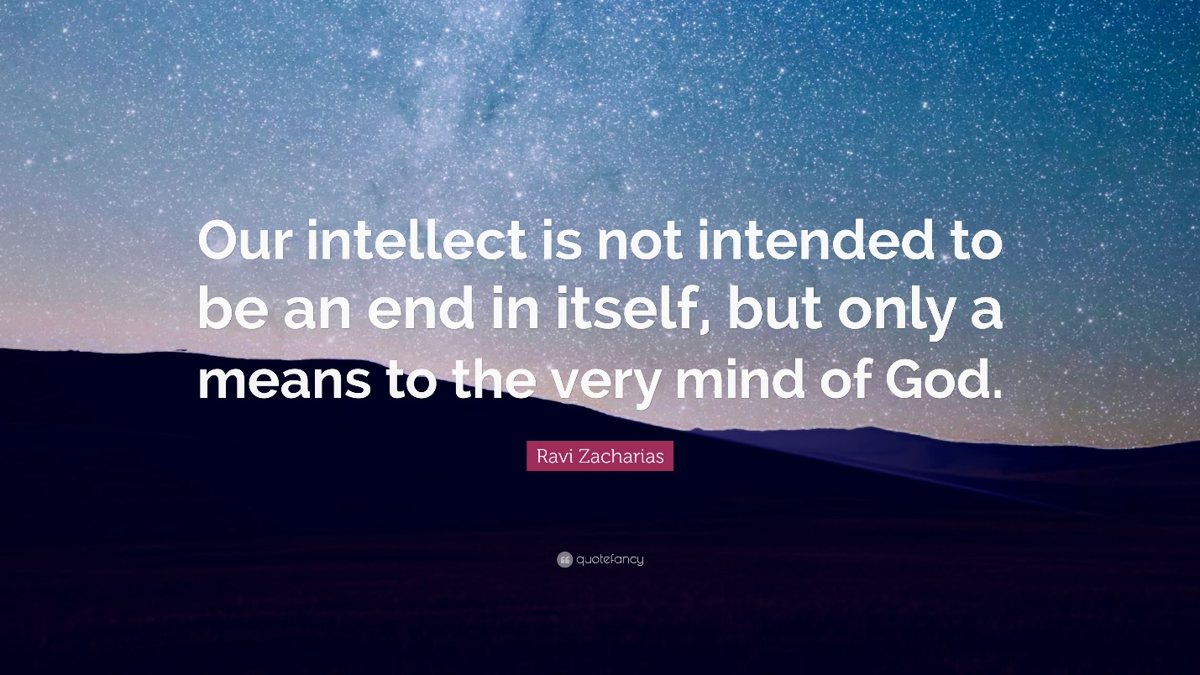

What is the Gospel , NT Wright - https://www.youtube.com/watch?v=ICHovRHJAYY

Why is biblical preaching important?, John Stott https://www.youtube.com/watch?v=1Q9DtlP8dGw

Time, Walter Brueggeman (a beautiful reflection of our worth, life and death, within the goodness of God) https://www.youtube.com/watch?v=VOXS2_fdgTE

