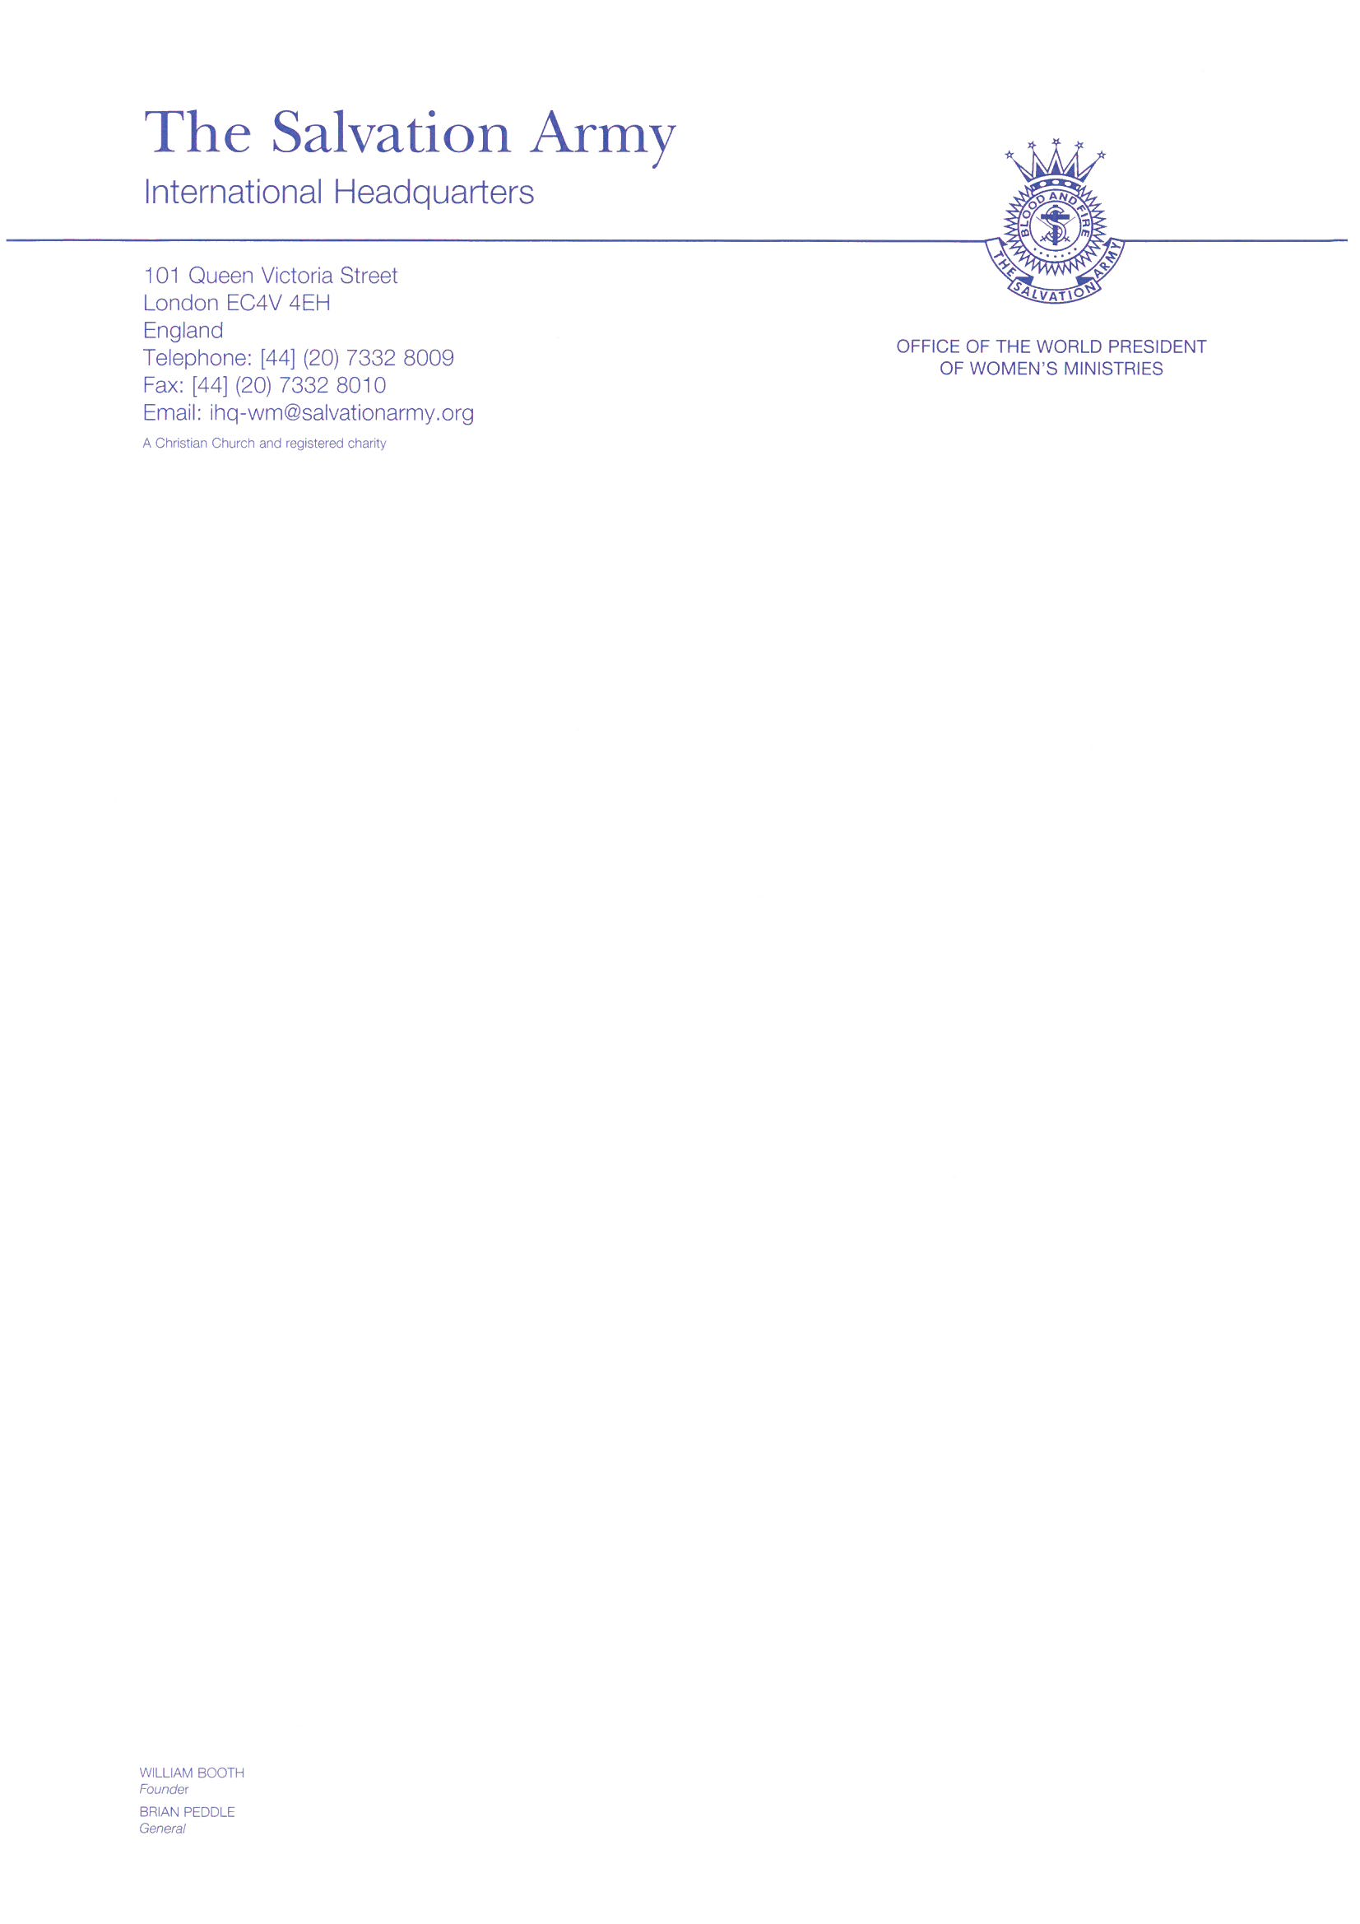

New Year 2022

Dear Women of God,

Greetings to you all in the strong name of Jesus!

We are celebrating a new year, 2022 is upon us! We take time to reflect on the past year and many of us will continue to experience emotions beyond our understanding. The Covid-19 pandemic continues to grip the world with force, and our various losses cause us to carry deep pain and an overwhelming feeling of helplessness.

Yet through it all God remains faithful. His promised presence continues to surround us. His love is deep and full and wide, reaching into the very depths of our world and our hearts. His grace is indescribable, incomparable, and amazing. God still has the whole world in his hands and if we take time to rest and reflect, we can see evidence of his miracles all around us.
So, as daughters of the King, we lift our hearts and heads to God. We lift our eyes to the Creator who saw us while we were still being formed. We lift our eyes to the Sustainer, who knows when a single sparrow falls, clothes the flowers in the field and anticipates our needs and worries. We life our eyes to our Saviour, who invites us to be a part of his Kingdom work here and now. His word equips us to see our world through his perspective and recast all our days in light of eternity. We remember who God is, and in him we find renewal and confidence. He is the Resurrection. He is the life. The best part? This is all available to us if we take hold and believe!

In Philippians 3:12-21, Paul shares that the future holds out hope, and we need to reach for it. We can reach out in hope because the future belongs to God, and we belong to Heaven, not earth! As women who serve Jesus faithfully, let us also be a forward-looking people. As we look upward to God for strength, courage, and hope, let us look forward to the new things that God is going to do in our lives and in the lives of others. The prospect of the new is what motivated Paul, and I trust it will motivate us today to aim for the highest when it comes to our mission and ministries. As we welcome in the New Year, I believe that God is calling us to a lifestyle of spiritual awakening. With a fresh faith and the help of the Holy Spirit, we can push through whatever obstacles stand in our way. We can penetrate the barriers Satan has built to bind us, breaking free and moving forward in faith and victory! Let us stop allowing our failures to cloud the glory of what God is doing in our lives and daily practice the presence of God, setting our hearts on Heaven.

Friends, I charge you to march forward into this new year with confidence, no matter what is ahead. Now is the time to make a difference in this world.

It’s time to love God more.
It’s time to love one another more.
It’s time to go the extra mile.
It’s time to reach the lost, least, and lowest.
It’s time to work harder for the Kingdom.
It’s time to worship the Lord.
Now is the time for us to be the Church.

We want the world to see Jesus in and through us, right now today! We pray that as we embrace others with love and compassion and as we fight the injustices that plague our world today, we influence others to seek the Lord. May God help us to be women of influence today.

I wish you a blessed and happy 2022! God is with us!

Yours in Christ,

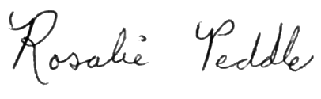

Commissioner Rosalie Peddle
World President of Women’s Ministries
