21 Day Holiness Challenge
Captain Bhreagh Rowe

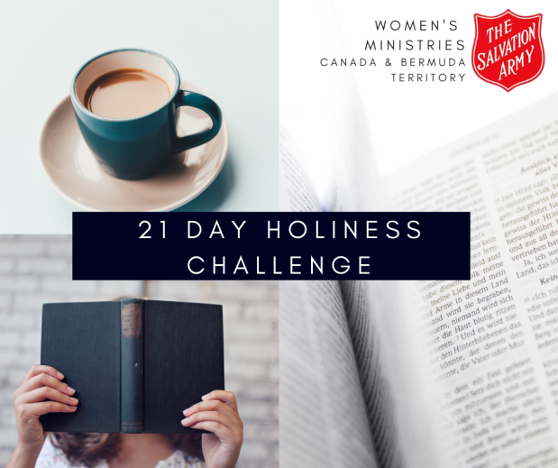
INSTRUCTIONS
For 21 days there is a picture and a write up to go along with it. The idea is to help women understand what holiness is, understand how to be holy and understand what holiness looks like in every aspect of their lives. Social media is a really easy way to connect and spread the good news to many people. All you have to do is decide when you want the challenge to start and then post the picture and copy and paste the write up for each day. Don’t forget to comment yourself and interact with anyone who is commenting as well.
Images will be available on www.salvationist.ca/women-s-ministries/annual-events/promotion-week/
Here are a few tips:
- Advertise what is coming in your corps and on Facebook (or other social media) to get people interested and excited about the challenge AND the theme of this year’s Women’s Ministries Promotion Week.
- You can start the challenge 21 days before the promotion week, right in the middle or after your promotion Sunday to keep the idea going.
- Try and post the same time everyday so people know when to expect the post. You can actually schedule your Facebook posts in advance so you do not have to worry about being on the same time every day. For more information check out these simple instructions: https://www.facebook.com/help/389849807718635
- Add or take away any information you feel necessary but also feel free to simply copy and paste.
- Interact with anyone who comments. Social media can be a great way to build deeper relationships with those in your corps and community.
- Don’t worry about the post too much, don’t pay attention to how many “likes” or comments you get. Just because people are not interacting does NOT mean people are not reading and learning.
- Have fun and remember social media is an excellent way to reach people!

Below is an idea for an “intro post” or something you can write up on Facebook to let people know what is coming and why:
The Salvation Army is a Holiness Movement and that simply means we want to be an Army of women (and men) who strive to be more and more like Jesus while sharing the gospel with others. How do we do this? In many ways, but one of the most influential ways to help others understand Jesus is by actually living like Him, being Holy because He is holy. Over these next 21 days we are going to learn a little more about what holiness really is and how we can all strive for a more holy life. Each day you will see a picture, a small write up and a “read, write, pray, do” section that helps you understand what the Bible says and how we can apply that to our lives. Join along, look for the post each day, invite your friends and discover what God requires of you.
WEEK ONE: “WHAT?”
DAY ONE: What is holiness?
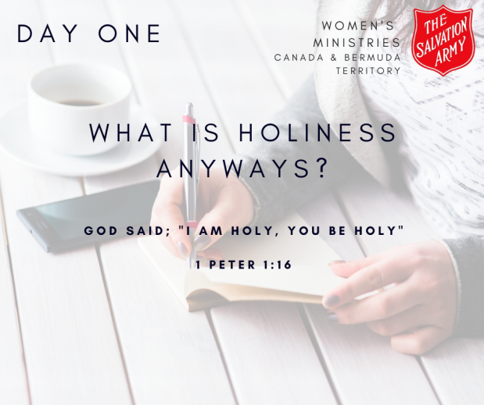
What is this thing called holiness and why does it matter?
In the simplest way, Holiness means to be “set apart”. God wants us to be Holy because He wants us to be different, unique, like fish swimming upstream when everyone else is floating down. Why? Because He wants us to make people stop and say “there’s something different about that girl, I want to know more!” God has this beautiful vision and plan for us – that we would dedicated our lives to Him and then craft our lives around our calling – to share the love of Jesus with everyone and turn them into disciples.
Holiness matters. Holiness is required. Holiness is hard. Holiness is a journey.
Come along with us over these next 21 days to learn more about Holiness and what that means for your life!
Read: 1 Peter 1:13-16
Write: What are 5 words that you would use to describe holiness?
Pray: “God, help me understand how you want me to be holy.”
Do: Invite someone to come along on the holiness challenge with you!
DAY TWO: Holiness as a lifestyle
My life is pretty ordinary, I pretty much do the same thing every day and sometimes that can be really mundane. If you’re a mom, those simple tasks of motherhood seem to never amount to anything. Maybe you work and feel like it’s a “wake, work, repeat” kind of scenario. How about those who maybe are older (and much wiser) and are feeling forgotten or like their glory days are over? Wherever you are at in your life know this – these simple mundane and sometimes annoying tasks of life can bring about holiness to the fullest extent.
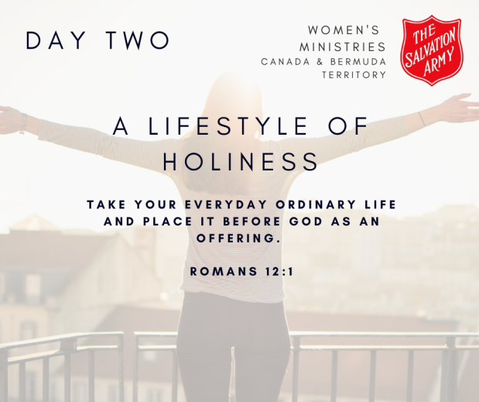
God asks us to take our ordinary lives – our cleaning, cooking, working, parenting, grocery shopping, laundry and falling asleep on the couch lives – and intertwine holiness all throughout our days. Hand those moments over to Him and watch how cooking a meal and cleaning the house turns into serving others, how loving on and caring for kids turns into teaching and discipling, how grocery shopping turns into evangelism and how falling asleep turns into sabbath. God asks us to surrender our lives to Him and then watch how those tasks we see as worthless turn into worthy acts of holiness.
Read: Romans 12
Write: What are some key “things” described in Romans 12 about holiness that you struggle with?
Pray: God, reveal to me which aspect of my life need a little more holiness.
Do: Write one goal for this 21-day challenge. “After 21 days I want to see growth in this area of my life ____________ by showing more ____________.”
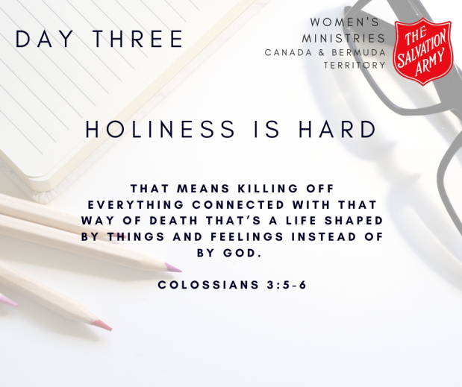
DAY THREE: Holiness is hard
Don’t be fooled by the pretty pictures with the bible and the scriptures and the simple definitions. Holiness is hard. Going against the flow, swimming upstream while everyone is drifting down is not easy. Sometimes, depending on where you are and who you surround yourself with, true Godly Holiness can be lonely and make you feel like a crazy person.
I wake up in the morning with the best intentions to be kind and loving to my husband, to be patient and caring to my children and to try and find those little moments throughout my day to share the love of Jesus with others. Usually by the time I get my kids out the door for school, my holiness has been tested. I’ve already yelled once at my husband and now I am to talk to someone about Jesus? No thanks, I just want to keep my head down and get the day done.
Nothing that comes with holiness is the natural way we do things. Holiness is hard. It’s a choice that we have to make about 50 times before the kids get out the door and another 50 before lunch. It’s hard but it’s worth it.
Read: Colossians 3:1-17
Write: Make a list of the “things” that stop you from perusing holiness every day. Maybe they are found in verses 8 or 9.
Pray: God, help me identify and work on those things I get entangled in each day.
Do: Pick one thing from the list you made and tell someone about your struggle. Accountability is the BEST thing we can do for ourselves.
DAY FOUR: Holiness is required
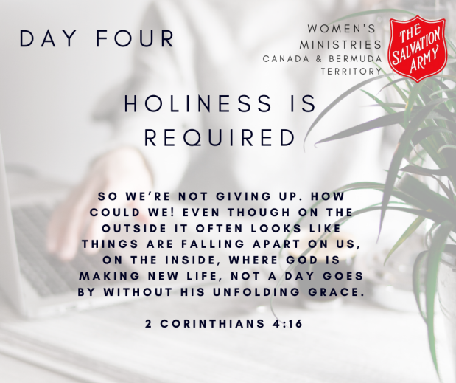
We have this amazing FREE gift of love, grace and eternal life. It really is free, Jesus died on the cross so we could have access to this gift, all we have to do is accept it. The gift is free but that doesn’t mean there are not some requirements. Holiness is one of them.
There are a few different ideas out there about holiness and when (or if) we can obtain it. In the Salvation Army there are two ideas from two different Officers; General Coutts believes holiness is a process, growing to be more like God every day and finally obtained in Heaven. Commissioner Brengle believes that holiness was obtainable here on Earth in a single moment – a second work of sanctification. Holiness was less about maturity and more about purity. Although there are two different thoughts both believed that achieving holiness (whether now or later) is a necessity.
The gift is free but the work is hard and we must do just that, put the work in.
Read: 2 Corinthians 4 (The Message version)
Write: What are some of the things God requires that you have difficulties with?
Pray: God, help me understand that the purpose of my life is to bring You glory and not to bring myself glory.
Do: Pick one thing on your list and make a commitment to do that thing every single day for the rest of the challenge.
DAY FIVE: Holiness is sacrifice
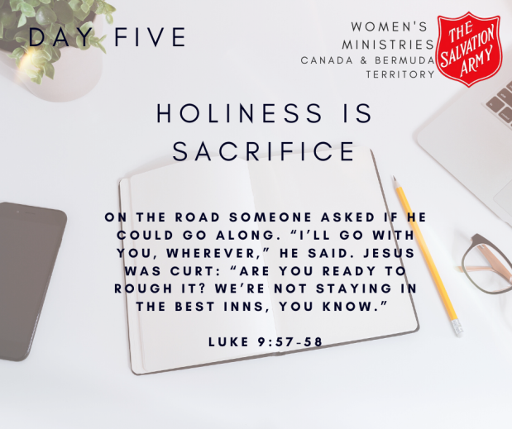
We talk a lot about the loving sacrifice Jesus made for us so that we would not have to pay the penalty for our sins. But sometimes we forget to talk about the sacrifices that we need to make while following Jesus. Ok, maybe we don’t actually forget, maybe we just decide to not talk about them or pretend like they don’t exist. Holiness is sacrifice because Holiness goes against every natural desire of our human bodies. “Are you ready to rough it?” may not have been Jesus’ exact words but those 5 short words pretty much sum up the Christian life. It’s not all skittles and rainbows, it’s not all happiness and perfection, its trials and hard climbs and tears and dusting yourself off and claiming Jesus and His holiness over and over again.
Are you ready to rough it?
Read: Luke 9:43-62
Write: Make a list of some of the things in your life that you find really hard to sacrifice.
Pray: God, show me the ways I can sacrifice more for you.
Do: Pick one thing on that list and figure out what you need to do to give it up. Maybe it’s a simple decision, maybe it’s replacing the habit with something else, maybe it’s simply praying that God will help take it away.
DAY SIX: Holiness vs. Happiness
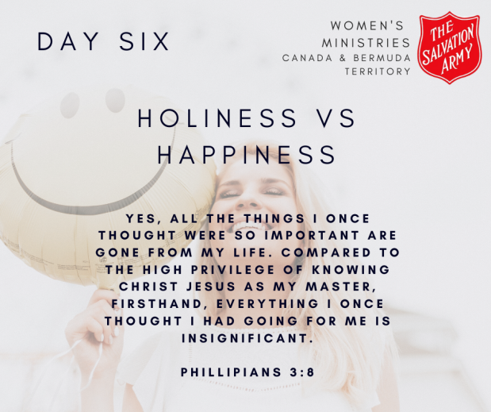
This is where people start to back off a little. “Wait, God doesn’t promise I will always be happy?” God wants a lot of you, He wants a lot from you, and He wants a lot for you, but happiness is not at the top of His list. Don’t run away scared. I’ll explain, I promise.
Sometimes we get confused with happiness and holiness. Happiness is almost always caused by something we like to do, something we like to get from people or something that makes us feel better about ourselves. Holiness doesn’t always bring the same feelings. Holiness is hard. Holiness makes us scared or question things. Holiness does not always make us happy.
Consider what Paul said in Philippians 3:8 Indeed, I count everything as loss because of the surpassing worth of knowing Christ Jesus my Lord. Those things that make us happy, those things are all about our life here on Earth. As Christians, we should be focused on eternity and what God wants us to do before we get there. Paul got it. He counted all those things of Earth as nothing compared to knowing and loving Jesus.
Jesus loves you, a lot! He died for you. He wants you to be happy but His route to happiness looks a whole lot different than ours.
Read: Philippians 3
Write: What are some of the things that make you really truly happy? Are they things that glorify God or yourself?
Pray: God, reveal to me the things in my life that bring glory to me and not to You.
Do: Do something today for someone else that you really don’t like doing.
DAY SEVEN: Holiness is Christ-Like
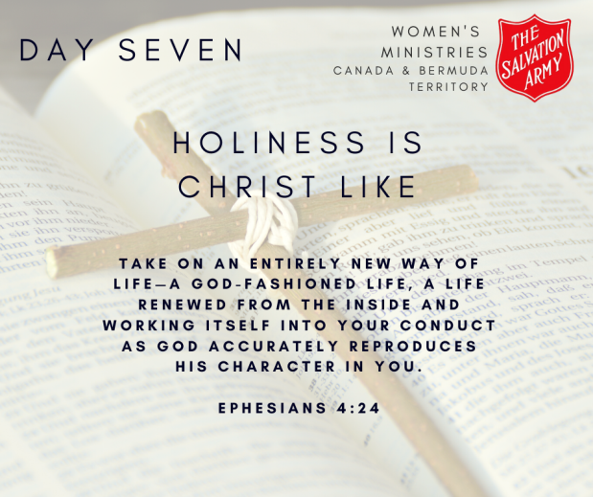
As we wrap up this first week of the Holiness Challenge, we finish with this simple truth – Holiness is being like Jesus. That’s why Holiness is hard, a lifestyle is required. That’s why Holiness will always be greater than happiness. That’s why Holiness is a challenge. Jesus was truly and properly God and truly and properly man which means He was just like you and me with all the opportunities for unholy things. Jesus made a choice, He followed God’s plan and He worked hard at showing others who God is and what His Kingdom was like. We are called to do the same thing but, unfortunately, are not perfect like Jesus.
There is good news though, grace. What would we do without grace? God wants our best. He wants us to strive towards holiness and although He doesn’t want it to become an excuse to not try, grace will always be present.
Holiness is Christ-like and we are called to be Christ-like.
Read: Ephesians 4:17:32
Write: What are some things you know about Jesus’ life; how did He live?
Pray: God, reveal to me the things in my life that need to look more like Jesus.
Do: Offer grace to someone today who may not deserve it because guess what, we don’t deserve it either!
WEEK TWO: “WHERE?”
DAY 8: Holiness at Home
Home is (hopefully) a safe place for you. It’s a place where you can kick off your shoes, change into your comfy pants and not worry about the make-up running or the 3 (or 4) days of unwashed hair. Home is where we can just be ourselves. Holiness needs to start at home. If we cannot pursue a lifestyle of holiness within the four walls of our homes then we will not be able to peruse holiness anywhere else.
Who are we when no one is watching? What are we when no one is watching? What are we watching when no one is watching? This is where all the “whys” of last week meet the hard truths of where and how.
OK, I admit it. I have a bit of a reality TV problem. You know those shows that do nothing for your mind and are pointless and fruitless and basically just make you feel like less of a crazy person? Yup, those reality shows are my jam. Now I am not saying that perusing holiness means never turning on the TV and watching who gets voted off the island, who the newest housewife is or if that guy is actually going to propose to her. But what I am saying is on that pursuit we make decisions like “is this really worth it?” Is what I am watching filling my mind with good or numbing me from reality? Should I be spending my time on this or something that actually fills my soul?
Holiness starts at home because home is where we can make the decisions to fill ourselves with God in order to take on the world OR filling ourselves with culture in order to blend into the world. Remember that “set apart” definition from last week? Yes, watch your Amazing Race or Survivor or Grey’s Anatomy but don’t let those things take up all the time that you could be feeding your soul.
Read: Psalm 139
Write: Write out what your daily routine looks like. What part of your day are you filling with mindless or useless things instead of holy things?
Pray: God, help me discover activities and practices within my home that help me grow closer to you.
Do: Before you watch TV or Netflix or go on your phone each morning, pick up your Bible or devotional book or prayer journal and give God those first and last moments of your days.

DAY 9: Holiness at Work
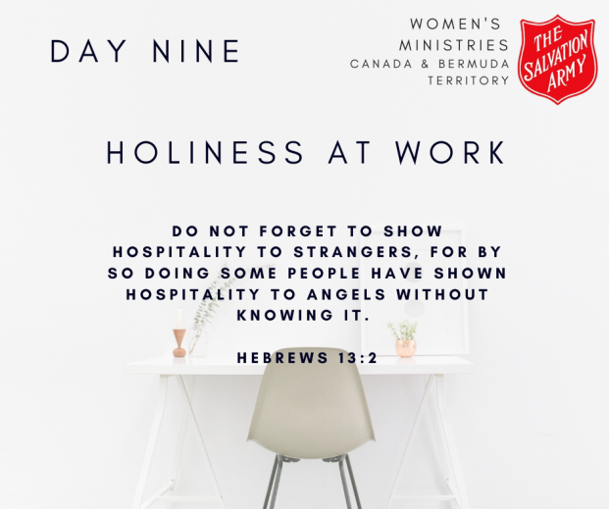
Work can look very different for all of us. Some of you may have a traditional “work out of the home” job, others may work from home or be a stay at home mom. Some of you may be in school, in between jobs, trying to discover your next step or have given many years of work and are happily (or unhappily) retired. No matter what our work situation is, it’s important to understand, for most of us, holiness at work is WAY more important than we think.
Before I was called into ministry and Officership I was a Registered Nurse and worked mostly in the ER (because I have always been slightly obsessed with George Clooney in the show ER but that’s another story for another day). I loved my work, I was pretty good at it, but it was hard. The atmosphere is fast and somewhat toxic and extremely difficult to practice holiness.
For some reason I still loved it but was often convicted because of my faith on how to be holy at work when I was more often than not surrounded by a lot of unholiness. I remember this one specific night shift that a young woman came in who was sexually abused. I had the privilege of walking through that tough night, the questions and the procedures with this beautiful, young and scared woman. Most of the time I just listened or sat in silence while holding her hand and, little did she know, I prayed for her that whole 12 hours. The chance never came for me to talk to her about Jesus (and I would have gotten in trouble) but as she left that morning she hugged me and told me my “vibe” was so good and peaceful and helpful that whole night. I told her I loved her, that God loved her and that she was HIS precious child – that’s what that vibe she spoke of was. She kind of looked at me funny, told me quickly that she used to go to church and maybe she should go back again and then turned around to leave.
I have no idea what happened to her. I never saw her again. But that moment, at the end of a long hard night when I was supposed to go home 45 mins ago, that moment of mentioning the name of God is what we are called to do as holy and set apart people. If our coworkers or the people we come in contact with at work don’t see something different about us then we have done something terribly wrong.
Read: Hebrews 13
Write: What are some opportunities you have at work to share Jesus?
Pray: God, forgive me for those moments I have passed up on and help others see something different about me.
Do: Write a list of 5 things you can do at work to share the love of God.
DAY 10: Holiness in the Neighbourhood
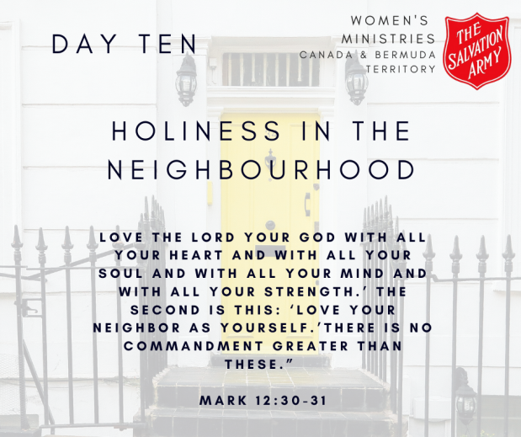
Do you know the names of your neighbours? I don’t! This is partly because I live in a large city where everyone keeps their heads down and goes about their own business, partly because my neighbours keep changing, but mostly because I am an awkward introvert who doesn’t like talking to people.
I believe that THE biggest mission field that we have is within our own neighbourhood. The people you pass by every day, your neighbours, the parents at your kid’s school, the cashier at the grocery store, that guy who walks his dog at the same time every day. These are the people we see every single day and most of us don’t even know their names. The message version of John 1:14 says that “the word became flesh and blood and moved into the neighbourhood” which means Jesus, the son of God, became man and moved into the world. If Jesus was walking on Earth today He would know the name of all of His neighbours, He would know the name of that “weird guy” that no one talks to, that sad person that everyone avoids, the homeless man asking for money at the red light and the young kids who are way too loud and annoying. He would know their names, their stories, their needs and would offer help.
Guess what? We are called to be like Jesus. We are called to move into our neighbourhoods and get to know those people and to not stop at that – to show them the love of God. If you are an awkward introvert like me, that scares you and makes you close the blinds and duck when you hear the doorbell. But remember last week when we talk about how holiness is hard? Here’s a great example. Holiness in your neighbour will look different for you than it will for me in my neighbourhood, but that’s ok – open your eyes, see the people you see every day and then watch how God reveals what He wants you to do in your neighbourhood.
Read: Mark 12:28-34
Write: Draw out your neighbourhood. Who are the closest 4 people to your home or some of the people you see every day. Do you know their names? If not, ask and then put that drawing on your fridge as a reminder to be holy in your neighbourhood.
Pray: God, let me see my neighbourhood like you see it.
Do: Have one conversation with a neighbour today and find out one new thing about them.

DAY 11: Holiness at play
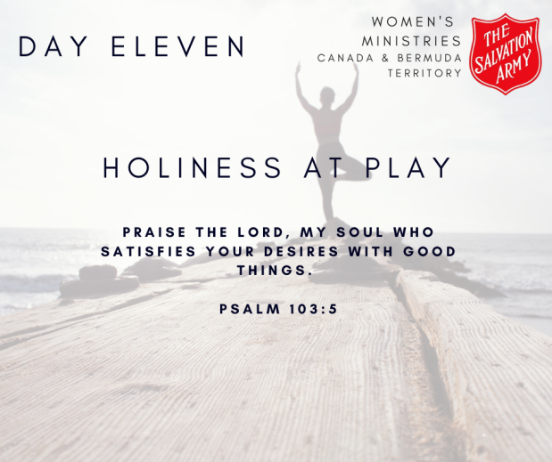
What do you like to do? Are you a crafter, a sports lover, is music or is movies your thing? Nature, reading or dancing? What do you like to do when you have a second to yourself? Me, I like anything that means I don’t have to interact with people and can just be quietly by myself with a good book and a cozy blanket. Play can look so different for each and every one of us and that’s ok. But just because we are “off duty”, relaxing or playing does not mean we can take a break from holiness. In fact, these are some of the most important times for us to practice holiness. We may be off duty of our jobs or ministry responsibilities, but we are never off duty as followers of Jesus.
One of the biggest lessons I have learned over the past few years is how what is around me really determines what is in me. Cluttered house = cluttered mind. Loud atmosphere = anxious soul. Negative people = negative spirit. Bad news = bad attitude. What I do during my “play” time is just as important to my heart, soul and mind as when I am on duty in life and ministry because what I surround myself with in my play ultimately comes out in my life.
Read: Psalm 103:1-5
Write: What are some things that fill me? What are those things producing in my life?
Pray: God, reveal to me those things in my life that may seem harmless but are really harmful.
Do: Think of one “play” activity that you can do that is relaxing but produces good fruit in your life.
DAY 12: Holiness in Parenting
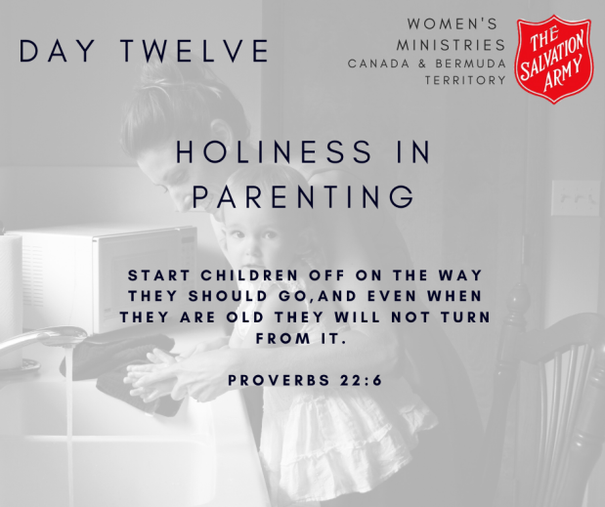
Even if you are not a parent, every single one of us has opportunities to speak into children, even if it’s just with a little patience. So, not a parent? Don’t skip over this day!
Holiness in parenting seems a little like an oxymoron to me. If there is anything in the world that makes me unholy it’s two tiny humans names Maverick & Asher. You feel me? As parents and adults, we have this huge responsibility to pass on what we have learned to the next generation and raise them up in the way they should go. I don’t think I need to remind you of this but those little children, they see, watch and hear every single thing we as parents and adults do. Everything.
What are we modelling to our young people? Do they see a bunch of adults who come to church on Sunday and then leave that aspect of their lives in the building? Do they see us practicing holiness in all aspects of our lives? Are we yelling in the car on the way to church offering no patience and grace and then singing about those same things 30 mins later? What are we showing our young people about living a life of holiness?
Holiness in parenting should be as essential as physical nourishment and emotional support. I bet you do not outsource the teaching of Holiness to your kids to someone else. If we cannot figure out how to teach the next generation then who will?
Read: Proverbs 22:1-6
Write: One Christian tradition that you have that you could pass down to the next generation in order to point them to Jesus.
Pray: God, teach me to pass down your love to the next generation.
Do: Find out one way you can serve the next generation in your church or community.
DAY 13: Holiness in Marriage
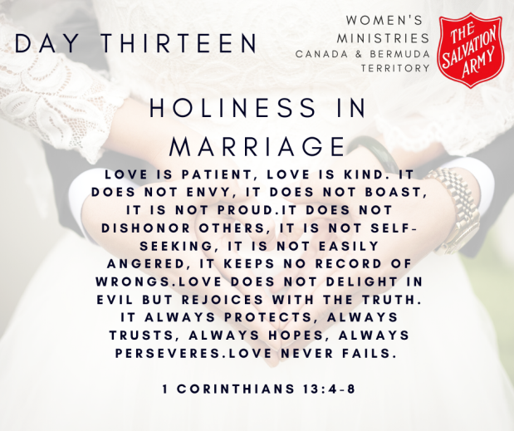
Marriage is hard. Whatever relationships you experience in your life are hard. It’s hard to be so close to people, to know a lot about others, for others to know a lot about you and see you at those very tough and vulnerable moments. God’s design for all of us is that we are image bearers, that we reflect Him in all that we do and therefore, He wants us to reflect Him in our relationships and marriages too. That means being patient, kind, not being envious or boastful, not proud, honoring others, not self-seeking or easily angered, keeps no record of wrongs, rejoices with truth, always protects, trust, hopes and perseveres. I mean, that’s quite a list right?
Holiness in our marriages and relationships means that they reflect God and His character. Did you know that the divorce rate within the church is the exact same as the divorce rate of people who do not attend church? Holiness in our marriages means our marriages are set apart (remember the definition last week), it means that people can see something different in our relationships (see that list above) and means Jesus Christ should be the foundation of our marriages.
When was the last time you prayed for your spouse, prayed with your spouse, worshipped together or taught one another?
Read: 1 Corinthians 13
Write: Take the word “love” out of the scripture and replace it with your name.
Pray: God, show me ways to love my spouse or others like you love me.
Do: Do something really caring and unexpected for a loved one today.
DAY 14: Holiness when no one is watching
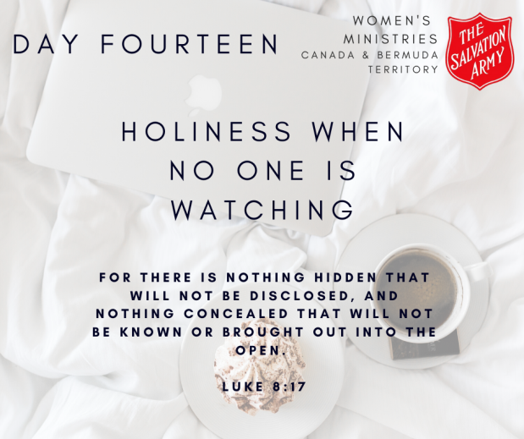
This one sums up nicely the past 6 days – we can try our best to live a life of holiness at home, work, play, in our neighbourhood, marriages and parenting but none of that is true and genuine unless we are able to practice holiness when no one is watching.
I remember this one time, many years ago, I was trying to stop saying the word “frig” (sorry mom) and replaced it with something (I honestly can’t remember the word). I kept correcting myself around this group of friends and explained what I was doing. One of them jokingly said “Jesus knows your heart”. We laughed and moved on but wouldn’t you know it, 7 years later I still remember him saying that. No, it wasn’t a ground-breaking thing to say, yes, I know Jesus knows my heart but how many times do we say something when we really mean something else? How many times do we claim a good relationship with God but really haven’t talked to Him in days? How many times do we share that quote on Facebook just for the likes or the attention? How many times do we speak poorly about someone in our heads or, my personal favorite, say we are going to pray for someone but really have no intention of following through?
Who are we when no one is watching?
Read: Luke 8:16-18
Write: What do you do when no one is watching or when you are by yourself? What are some things that you can replace those habits with that will honor God?
Pray: God, help me see who I truly am and how I can be more holy when no one is watching.
Do: Pick one of those things from your list in the “write” section and decide to make that change.
WEEK THREE “HOW?”
DAY 15: Holiness in waking
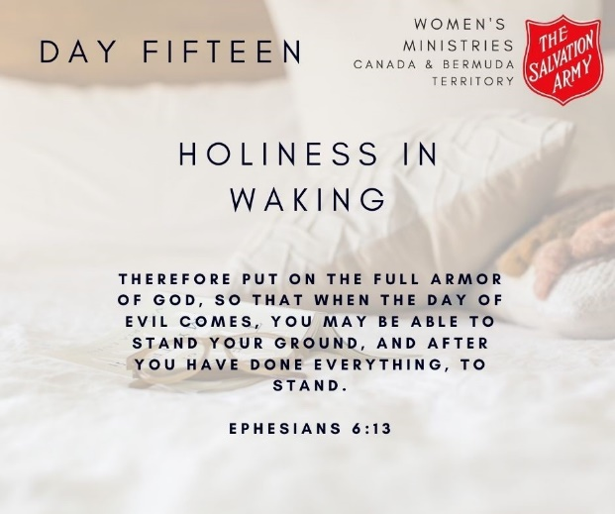
Are you an early riser? I am, but not because I want to be. I have kids and I need to be awake before them or my whole time becomes chaos. The first thing I do is read – usually scripture or a book or something that involves something about God. It took me an embarrassing amount of time to get a morning routine down but it works and it’s important to me.
Why? Because we are marked from our first waking moment as a child of God – an identity that is given to us by grace. That identity has to be the first thing we put on every morning or something else will take over. What is the first thing you reach for in the morning when you wake? Is it your phone to read the news, check your Facebook, emails or the weather, is it the remote to turn on the news? Are you putting your identity in Facebook likes, email responses and cultural truths or are you putting your identity in Christ and reaching for His word?
God is forming us into new people, it doesn’t happen in one big swoop of His magic wand but in the ordinary moments of everyday. How I spend this ordinary day in Christ is how I will spend my Christian life.
Read: Ephesians 6:10-20
Write: Write down all the pieces of armour and what they represent
Pray: God, help me wake up every morning and reach for you and your armour.
Do: For the remainder of this challenge, reach for God’s word first every morning.
DAY 16: Holiness in making the bed
My husband makes the bed every morning. Is it up to my standards? Probably not, but at least he does it, right? (Now if only I could get him to put his clothes IN the laundry basket and not beside…) It’s become a habit to him, a habit that may have been formed from me nagging too much but a habit just the same.
Think about your day and what you do during each moment and hour. Our days are made up of habits, good and bad. The make-up of 24 hours becomes who we are and what we do. If you are like me, most of your days look the same and become slightly mundane and boring but it’s in the repetitive and mundane that we begin to learn to love, to listen and to pay attention to God and those around us.
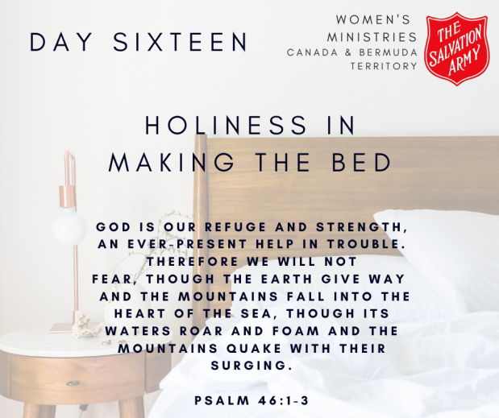
Whether it’s making your bed, cleaning your face, brushing your teeth, putting on a certain radio station in the car or going to a certain coffee shop, those mundane things that we do every single day are all opportunities to grow in holiness and closeness to God. A beautiful painting is not made by one big paint brush, but by hundreds and hundreds of tiny brush strokes. A beautiful and holy life is made the exact same way, simple habits and choices to focus everything we do on God.
Read: Psalm 46
Write: What are some of the things you do every single day that sometimes become mundane and boring?
Pray: God, reveal to me how I can grow in my holiness through the mundane moments of life.
Do: Practice stillness today, just like verse 10 tells us. In that mundane stillness you may just hear from God.
DAY 17: Holiness in losing my keys
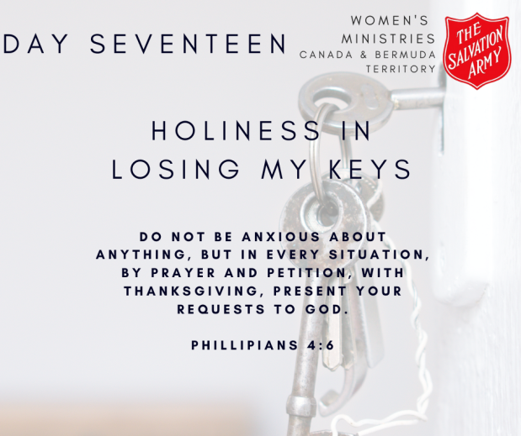
Scheduling is my love language. I schedule everything and work our lives around rhythms so that we all don’t lose our minds. We have certain things we do in order to set our days up right and then I go for the car keys and everything gets thrown out the window. I mean, more often than not they were left in the door all night because I am THAT person, but as soon as something gets thrown off of rhythms there goes my whole perspective, my plan and my cool. I get angry, I blame and I generally just lose my mind when something doesn’t go the way I planned it. And yet, here is where I find myself on an ordinary day and here, in my useless anger and irritation is where God meets me. These moments are an opportunity for formation, for sanctification, for holiness.
Those little moments, frustrations, slips and justifications that happen in the ordinary days of our lives is what forms us into a more holy and set apart people. Holiness doesn’t mean that you do not get frustrated when something goes wrong, but it does mean that if we do get frustrated, we quickly realize our misstep and bring ourselves back to God. God searches more earnestly for me then I do for my keys. And unlike my keys, He desperately wants to find you and make you whole. Let’s allow God to find us.
Read: Philippians 4:4-9
Write: What is the biggest thing you stress over in life?
Pray: God, remind me that I do not need to be stressed about anything, but I bring it all to you.
Do: Memorize or write down verse 6 and ask God to help you remember that verse in times of need.
DAY 18: Holiness in takeout
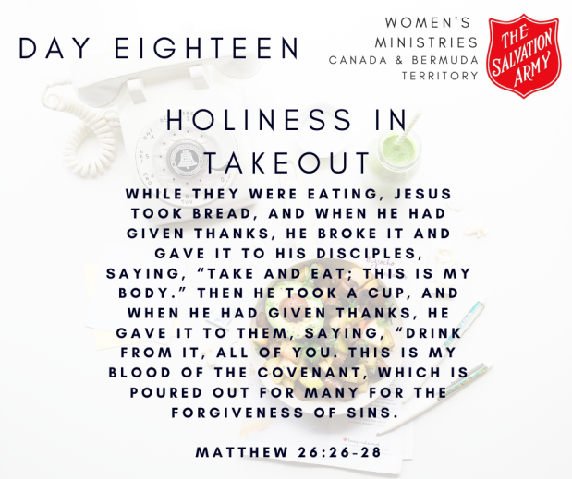
God is great, God is good, let us thank Him for our food. Amen.
I am a horrible cook. Just a month or so after we were married I decided to make my mom’s meatballs for super. I was so excited because it was one of my favourite meals. Everything was ready, I served my husband his plate and he sat down to eat before me. God bless him. He ate two or three meatballs before I had a taste and realized I doubled the vinegar for the sauce, and it tasted horrible. He was SO relived to be able to stop eating them and not have to pretend they were good. Needless to say, I order out when my husband is away.
As a Salvation Army, we do not practice some of the sacraments that many other churches do, specifically communion. It’s not that we disagree with it or think it’s wrong, it’s simply because of two reasons; 1) at its inception, The Salvation Army never intended to be a full-blown church so why would we do churchy things and 2) simply put – communion is not necessary for salvation. But here’s the kicker, we actually do practice communion every single time we sit down together for a horribly cooked meal, some take out or leftovers. Every single time we sit down to eat we can remember His body that was broken and His blood that was shed. Every single time we have a meal together we can practice this important part of holiness – acknowledging the sacrifice of Jesus, thanking Him for all He has done and taking those few minutes to connect with our family and God.
Jesus, we thank you for your sacrifice, for shedding your blood for my sins, for your broken body, for Your amazing love for us. We ask for forgiveness when we fall short of honoring this gift and pray that you will continue to guide us on – God is great, God is good, let us thank Him for our food.
Read: Matthew 26:17-30
Write: Write out a prayer that includes something from the scripture to say at the beginning of every meal.
Pray: God, remind me every time I eat to thank you for your broken body and bloodshed.
Do: Print off your prayer and place it somewhere close to your table to remind you to practice holiness at every meal.
Day 19: Holiness in fighting with my husband
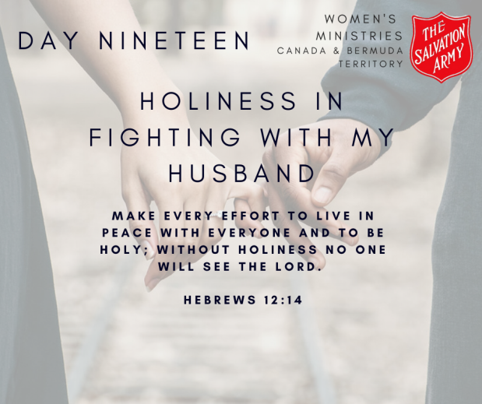
Where to start with this one? I believe I can say that my husband and I have a good marriage but that does not, I repeat DOES NOT mean we do not fight. Cause we fight! I am a pacifist who yells at her husband and takes the majority of my stresses and emotions out on him. Sometimes he just hugs me and takes it, sometimes he yells back, but all that to say – how do we practice holiness within the fight?
Holiness doesn’t mean I never fight with my husband, holiness just means I learn to fight fair and maybe, just maybe, we fight a whole lot less while practicing peace, shalom. We are a people who fight but God is pushing us towards being people who, through our ordinary moments, show His kingdom of peace. This takes a lot of faith. It takes a lot of faith to believe that the tiny and small decision to lay down my sword in the middle of our kitchen and stop the fighting will usher His peace, His shalom into our world. Holiness is sharpened in the everyday moments of decisions – a decision to yell and pick up my sword or a decision to practice love, joy and peace.
We still need to be “Jesus” to our spouse, even in the midst of a fight.
Read: Hebrews 12:14
Write: Write this verse down somewhere in your home so you can see it every single day and use it as a reminder to practice holiness in all things.
Pray: God, help me make every effort to keep the peace in every avenue of my life.
Do: Do or say something kind to someone who really rubs you the wrong way. Show God’s peace and love today.
Day 20: Holiness in sleeping
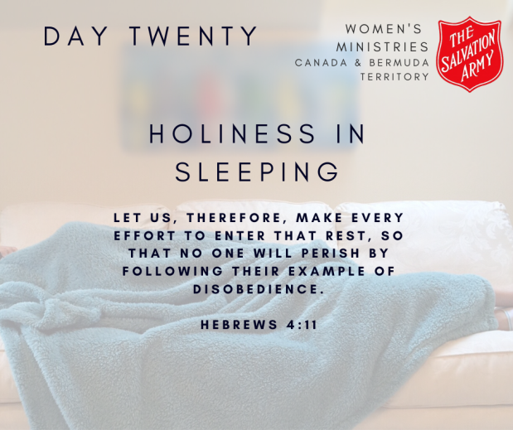
A lack of rest is an epidemic in our world today and I believe this is an epidemic that is rather unique to women. Men and women were created in the image of God but were also given unique and complementary gifts. One gift we as women have is the amazing ability to never ever have our brains turn off. Men, they have this amazing empty box in their brain that they can go to and think of absolutely nothing. Nothing. Doesn’t that sound wonderful. We as women would go into that box and then we would rearrange some things and get distracted by a dent in the wall or some dust and then we would make a list of all the things we need to do when we leave that nothing box. Tracking with me?
Rest is holiness. And I am not talking about a good nap or a nice manicure. I am talking about good deep soul rest. Soul rest is holiness and boy oh boy do we suck at this. We have limits. We are not super heroes. We cannot do all the things while having joy and peace. We need rest. We do not need to be connected at all times. We can turn our phones off, not check our emails for a day, not answer phone calls or check things off our list. We can say no. We do not owe any explanations to anyone. We can achieve deep soul rest and it won’t always be popular.
What if, as Christians we were known as people who were countercultural, who were well-rested, who embraced our limits with joy and who practiced sabbath at the truest form?
Sleeping is practicing holiness. If we neglect our souls and its care, absolutely nothing we have talked about for these last few weeks matters.
Read: Hebrews 4:1-11
Write: Write a list of all the things that fill you with joy and peace. Do one of those things during your sabbath this week.
Pray: God, help me rest my soul in you.
Do: Scratch one thing off your to do list, turn off your phone notifications (because you do not need to be instantly connected to anyone) and care for your soul today.
Day 21: Holiness Always
Biblically, there is no difference between radical or ordinary believers. We are all called to be willing to follow Christ in radical ways through our ordinary lives. Holiness is the way we radically alter our ordinary lives and live to serve God. Holiness is not a moment, a choice or a thing that we talk about within The Salvation Army. Holiness is who we are, it’s in our bones, it’s in our DNA, it’s completely opposite of what we want to do and it is to make up every aspect of our lives.
Over these past 3 weeks we have looked at what holiness is, why we need it and how we do it but ultimately none of that matters until we decide that our lives can and should be more.
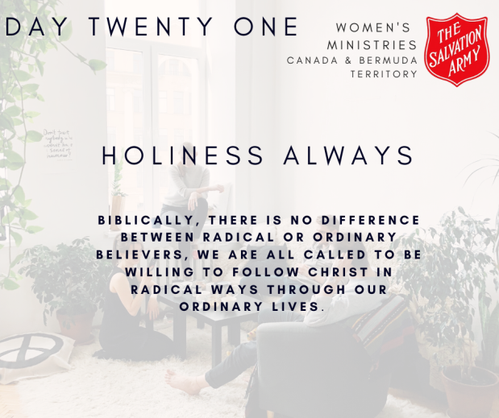
Jesus died so that we can be free, and his instructions are not confusing – ‘be holy for I am holy’. No, holiness does not mean perfection, holiness does not mean an easy life, holiness does not mean no screw ups or mistakes, holiness is not some sort of unobtainable standard we can never achieve – that’s why there is grace. But holiness is required, its commanded, its asked and begged of us and as Christians, it should be our desire.
One day, soon or not so soon, I will stand before God and He will (hopefully) say “well done my good and faithful servant”. He is not going to say that because I solved world hunger or I saved thousands of orphans or started a massive revival all across the world (although all of that would be so cool – but it would also mean I believed my salvation is based on works). He will say that because I made simple daily habits and decisions to chase after holiness in every aspect, in every moment and every day of my life – I chose to be faithful. Can you even imagine what our world would look like it we, as Jesus followers, actually chased after holiness in all the things of our lives? Dare I say holiness is what the world is clamouring for, they just don’t know it!
As we finish this challenge my prayer for you is that you will know this: there is room for you on this couch. Come sit next to us women who are trying to find our way through kids and jobs and aging parents and responsibilities and managing a home and knowing ourselves. Sit next to us without fear of judgement or condemnation. Sit next to us and know that we are cheering you on. Sit next to us and know that someday you too can pray Hannah’s prayer saying;
I’m bursting with God-news!
I’m walking on air.
I’m laughing at my rivals.
I’m dancing my salvation.
Nothing and no one is holy like God,
no rock mountain like our God.

