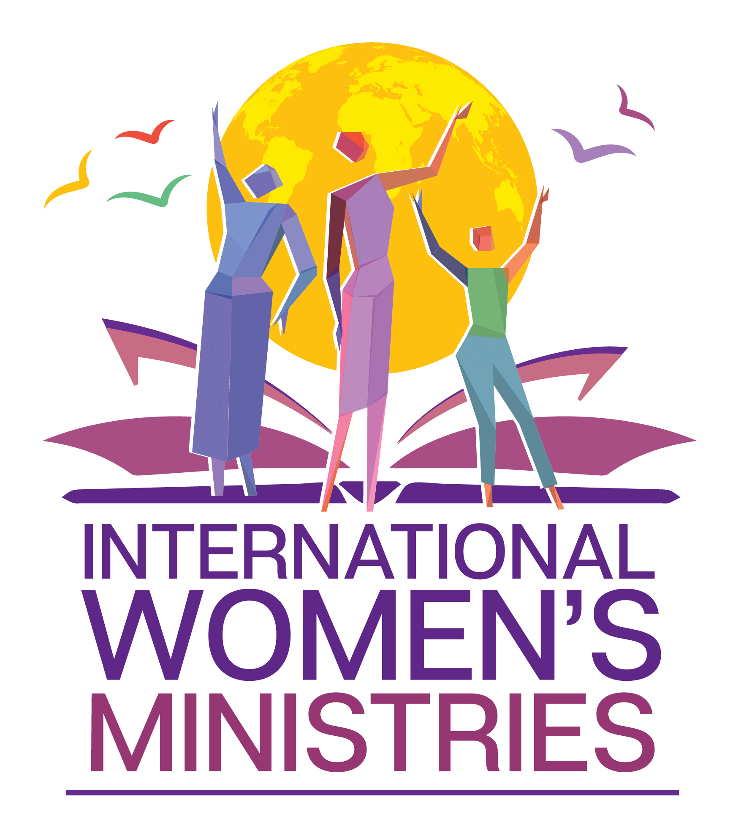
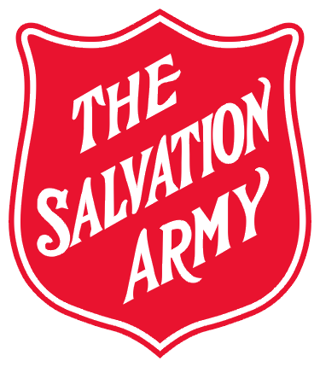

Canada & Bermuda
WOMEN’S MINISTRIES
Report Forms
2020

DHQ Full package
(MU Package included)

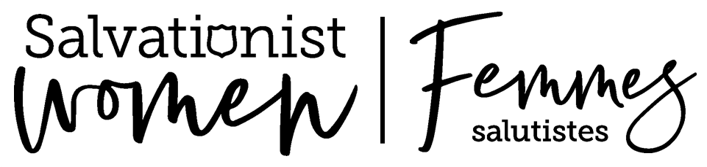

WOMEN’S MINISTRIES FORMS
INDEX

Ministry Unit Reports to DHQ | Date Due | Page
WM Forms 2020 |  | 4
WM Annual Online Survey (sent out by THQ) | January 22,2021
Ministry Unit Summary – WM Groups in Operation | January 22, 2021 | 5
WM Integrated Membership Roll | Due at Annual Corps Review | 6
WM Projects/Sponsorships/Offerings | January 22, 2021 | 7
WM Corps Promotional Week & Women’s Sunday | January 22, 2021 | 8
WM June Change Report (Jan. – June 2020)  *those changing appointments only | June 18, 2020 | 9-10
Ministry Unit WM Annual Corps Review Forms |  | 11
Growth History Overview | Due at Annual Corps Review | 12-13
Annual Corps Review & Strategic Plan Questions for WM | Due at Annual Corps Review | 13

Divisional Reports to THQ |  | 14
Divisional Summary – Groups in Operation | February 22, 2021 | 15
WM Corps Promotional Week & Women’s Sunday | February 22, 2021 | 16
Projects/Sponsorships/Offerings | February 22,2021 | 17
WM Camp / Retreat Report | Within 10 days following event | 18
WM Mom’s & Tot’s Camp Report | Within 10 days following event | 19
WM Celebrations/Rallies/Conferences/Seminars/Retreats | Within 10 days following event | 20
Territorial Project & WM Focus Week/Sunday Poster/Bulletin Ordering |  | 21

MINISTRY UNIT REPORTS

FOR

DHQ

(Includes MU package)

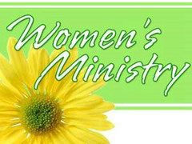

Canada & Bermuda
WOMEN’S MINISTRIES
Report Forms
(Ministry Unit Package)
2020

Note: All forms are downloadable from our THQ Women’s Ministries website under Administration

Women’s Ministries Group SUMMARY REPORT
Groups IN OPERATION for 2020

Due at DHQ January 22, 2021

MINISTRY UNIT: | DIVISION:

GROUP CATEGORY | FOCUS | NAME and DESCRIPTION  OF GROUP(s) | FREQUENCY
Home League | Traditional four-fold focus:  Worship, Fellowship, Education, Service
Spiritual Growth | Designed to deepen relationships with God and group members, such as:  Bible study, Prayer, Mentoring
Fellowship/Outreach/  Other | Providing opportunities for fellowship outreach through means such as: Ladies Night Out, Craft, Drama, Coffee/tea groups, Music etc.
Healthy Lifestyle | Activities designed to benefit body, mind and spirit, such as: Mental & Physical Health/Fitness, Basic life skills & Education e.g. self-esteem, cooking, Women’s Issues, Positive parenting
Pre-School | For mothers/caregivers and children, such as: Mom and Tots, Babysong, Playgroups, Play café etc.
Girls & Young Women  ages 12 - 17 | Focusing on developing strong spiritual values, self-esteem and social awareness. such as: Girl’s Night Out, God’s Girls, BRAVE
Total # of Women’s Ministries Groups:
 |  | Type of Events & Frequency
Special Events | MU events such as Corps Women’s Retreat, Fundraising Sales, Teas, Breakfasts, WM group catering for funerals, receptions etc.
OTHERS  Trade for Hope |  | Event held this year €  I’m interested in an event €

Corps Officer/  Ministry Unit Leader: |  |  | Date:

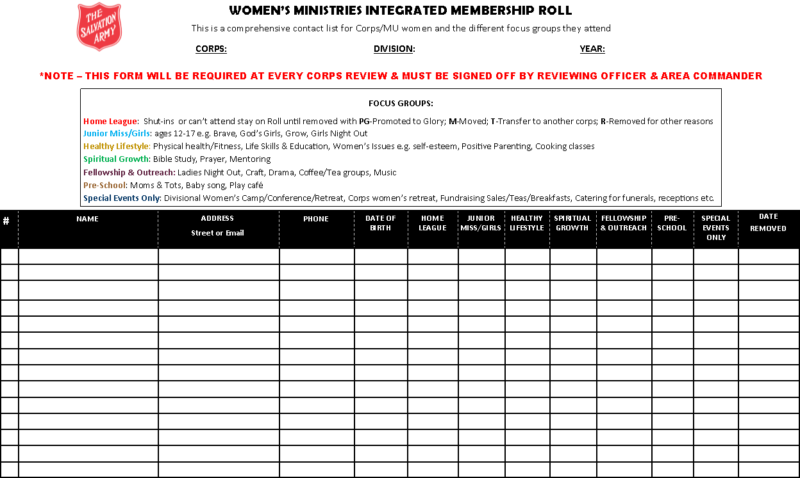

NOTE: This is only a picture of the form as it is legal size and is not fillable by corps in this format. Please download from THQ Women’s Ministries website under Administration drop down option.

Women’s Ministries PROJECTS Form
The Salvation Army Women’s Ministries Department
Canada & Bermuda

MINISTRY UNIT: DIVISION: YEAR: 2020

Territorial Project – Mozambique (2020 & 2021)
(World Services 300106/Women’s Ministries1222/Account 51001)

Amount Raised: $______________ Date Internal Transfer sent to RAC: _______________

Divisional Project

Amount Raised: $______________ Date Internal Transfer sent to RAC: _______________

Project Description: _______________________________________________________________________

Special/Missionary Offering
(World Services 300106/Specified Donations 1220/Account 51001)

Amount Raised: $_____________ Project Description: _________________________________________

What types of fundraising activities did your ladies engage in to raise funds for the above projects?

__________________________________________________________________________________________________________________________________________________________________________________________________

Corps Officer/Ministry Unit Leader: ______________________________ Date: _______________

Process for submitting Project money:

1. Send all Project monies to RAC through an Internal Request to Charge form before mid- January indicating funds raised from the previous year.
For example, funds raised in 2020 will be sent to RAC on or before January 15, 2021.

2. Copy DDWM (DHQ) and CAN-Women@can.salvationarmy.org (THQ) on all submissions.

3. This form due at DHQ January 22, 2021

Women’s Ministries corps
promotional Week
& Women’s Sunday

- Annual form due at DHQ - January 22,2021

THIS EVENT IS TO BE HELD WHENEVER IT FITS INTO THE LOCAL CORPS CALENDAR TO
RECOGNIZE AND CELEBRATE YOUR WOMEN.

Resources are available on the Women’s Ministries Webpage including:
IHQ Bible Studies and the THQ resource package

Ministry Unit: |  | Year: | 2020
Guest Speaker(s): |  | Date held:

Narrative Report (Include special features, highlights, spiritual commitments, photos, etc.)
Corps Officer/Ministry Unit Leader |  | Date

CANADA & BERMUDA TERRITORY

WOMEN’S MINISTRIES
JUNE CHANGE REPORT 2020
(Report reflecting first six months of the year)

(Due date at DHQ – June 18, 2020)

MINISTRY UNIT: __________________________ Date forwarded to DHQ: ________________

Please review the checklist below to be sure all your statistics are recorded in WM SAMIS and arrange to have entered at the end of June:

- MEMBERSHIP (e.g. Who are the ladies that attend your events? Please update your Women’s Ministry Integrated Membership Roll (see p.4 of MU Forms package) for follow up

- Complete WM Group Summary Report (see p. 3 of MU Forms package) and submit with your June report

- Attendances for each month including Spiritual Results (e.g. # of Seekers, Soldiers, Adherents, Families made through WM)

*Remember that Statistics tell a Story and the more accurate they are, the better we will understand your valuable ministry to the women of your community!

PLEASE LEAVE A COPY OF THIS REPORT IN YOUR FAREWELL BRIEF TO HELP THE INCOMING OFFICER

Women’s Ministries
June Change Report 2020

(Due at DHQ June 18, 2020 for those that are changing appointment)

MINISTRY UNIT: | DIVISION:

Tell us about what you have done in the first 6 months of 2020 in your Women’s Ministries
Photos? (please attach)
Any new initiatives tried or Ideas to explore you would like to share with the incoming officer in the area of WM?
Primary issues that women and girls are facing in your community? | Share an initiative that has had a positive impact in addressing these issues
Please share with us stories of transformation through WM - How have lives been impacted?
e.g. Did women come to know the Lord for the first time or become more involved in your church through WM?

Is your WM raising awareness about and providing practical assistance in Anti-Human Trafficking?
If yes, how? Are you aware of the resources available to you?

Corps Officer/Ministry Unit Leader: |  | Date:

ANNUAL CORPS MINISTRY REVIEW

Women’s Ministries Section



Corps – Annual Ministry Review Form – Growth History Overview (Samis sample)
Corps: | Growth History – Overview | Division:

Official Salvation Army Rolls | 2007 | 2016 | 2017 |  | Senior Average Attendances  (BY # Meetings) | 2007 | 2016 | 2017
Senior Soldiers |  |  |  |  | Senior – Primary Worship Service
Senior Recruits |  |  |  |  | Senior – Secondary Worship Service
Junior Soldiers |  |  |  |  | Alpha
Adherents |  |  |  |  | Discipleship Groups *
Total IHQ Official Membership |  |  |  |  | Healing & Wholeness (Recovery Ministries)
Friends |  |  |  |  | Men’s Ministries
TOTAL Canada & Bermuda Membership |  |  |  |  | Seniors Ministries
Membership Registers | 2007 | 2016 | 2017 |  | Youth Average Attendances  (BY # MEETINGS) | 2007 | 2016 | 2017
Cradle Roll Register members |  |  |  |  | Sunday School
Sunday School Register Members |  |  |  |  | Weekday Sunday School
CCM Members |  |  |  |  | Children’s Outreach/Fellowship **
Healing & Wholeness Ministry  # Trained Facilitators |  |  |  |  | CROSSzone & CROSStraining (Corps Cadets)
 |  |  |  |  | Junior Action
Seniors Ministries Members |  |  |  |  | Pioneers & Kid’s Club
Men’s Ministries Members |  |  |  |  | Youth Outreach/Fellowship/ Youth Discipleship ***
Women’s Ministries Members
# Home League Members
# All other WM Group Reg Att.
# Outer Circle Members
# Life Members
Local Officers Commissioned
All Other Ministries Leaders
Seekers | 2007 | 2016 | 2017 |  | Women’s Ministries Average Attendance & stats (By # Meetings) | 2007 | 2016 | 2017
Salvation – Adult (Senior Corps) |  |  |  |  | Home League Attendance
Salvation – Children & Youth |  |  |  |  | All Other Women’s Ministries Attendance
Other - Adult (Seniors Corps) |  |  |  |  | Junior Miss Attendance (Teen girl Groups)
Other - Children & Youth |  |  |  |  | Rallies / Camps / Conferences Attendance
Volunteers | 2007 | 2016 | 2017 |  | # Families linked Corps through Women’s Ministries
Total Number of Volunteers |  |  |  |  | # Soldiers made through Women’s Ministries
Total Volunteer Hours |  |  |  |  | # Adherents made through Women’s Ministries
# Youth linked to Corps through Women’s
Ministries
 |  |  |  |  | # Seekers – first time
 |  |  |  |  | # Seekers – other
 |  |  |  |  | Corps Income/Expenditure (Calendar Year) | 2007 | 2016 | 2017
 |  |  |  |  | Actual Cartridge Income
 |  |  |  |  | Thrift Store Grants
 |  |  |  |  | Red Shield
 |  |  |  |  | DHQ/THQ Grants
 |  |  |  |  | Total Income
 |  |  |  |  | Total Expenditure
* Includes Prayer and Bible Study and Cell Groups
** Includes Junior Youth Group
*** Includes Senior Youth Group

(The above form must be printed from SAMIS)

************************************************************************************************************************

ANNUAL WOMEN’S MINISTRIES REVIEW
(sample taken from Corps Annual Review Documents-Section 2)

Tell us about your ministry to Women:

- In what ways are corps women Sharing the love of Jesus in your community? How are you measuring the impact of this sharing?

- In what ways are corps women Meeting human needs in your community? How are those needs determined?

- How are the transforming efforts of corps women in Sharing the Love of Jesus and Meeting Human need, being recognized by those outside of the corps (people/organizations in your community)?

GOALS – Action Plan

- In the coming year what efforts could start/continue/cease in order to Share the love of Jesus and Meet human need more effectively through women’s ministries?

- Describe how you are planning to make a difference in your community in the coming year, through ministering to women.

DIVISIONAL REPORTS

FOR

THQ

Note:

- WM June Change report forms, when completed, are to be retained at DHQ with a copy kept on file locally for future reference. Please ensure the outgoing officer arranges for June stats to be entered by the end of the month.

- All Divisional Summary WM report forms are to be forwarded to THQ,
CAN-Women@can.salvationarmy.org no later than February 22, 2021.

DIVISIONAL SUMMARY REPORT
wm Groups IN OPERATION for 2020

Due at THQ February 22, 2021

DIVISION: | DATE:

TYPES OF GROUPS IN OPERATION
*Record the number of ‘like’ groups in the Division
(e.g. Home League-22; Spiritual growth-8; Pre-school-3, etc.)
(It is important that this page match with the Divisional WM SAMIS Reports which shows
the numbers of groups in each ministry unit/division)

GROUP CATEGORY | FOCUS | NAME and DESCRIPTION  OF GROUP(s) | FREQUENCY
Home League | Traditional four-fold focus:  Worship, Fellowship, Education, Service
Spiritual Growth | Designed to deepen relationships with God and group members, such as:  Bible study, Prayer, Mentoring
Fellowship/Outreach/  Other | Providing opportunities for fellowship outreach through means such as: Ladies Night Out, Craft, Drama, Coffee/tea groups, Music etc.
Healthy Lifestyle | Activities designed to benefit body, mind and spirit, such as: Mental & Physical Health/Fitness, Basic life skills & Education e.g. self-esteem, cooking, Women’s Issues, Positive parenting
Pre-School | For mothers/caregivers and children, such as: Mom and Tots, Babysong, Playgroups, Play café etc
Girls & Young Women  ages 12 - 17  (Junior Miss) | Focusing on developing strong spiritual values, self-esteem and social awareness. such as: Girl’s Night Out, God’s Girls, BRAVE
Total # of Women’s Ministries Groups in division:
 |  | Type of Events & Frequency
Special Events (DHQ) | Divisional events such as Women’s Retreat, Training Conferences, Rallies etc.
Special Events (MU) | MU events such as Corps Women’s Retreat, Fundraising Sales, Teas, Breakfasts, WM group catering for funerals, receptions etc.
Total Special Events | (DHQ + Ministry Units)
OTHERS  Trade for Hope |  | # Events held in division this year: _____  # MU’s interested in future event: _____

DHQ sUMMARY REPORT Form

Women’s Ministries corps
promotional Week
& wOMEN’S sUNDAY

Due at THQ Feb 22, 2021

Division: __________________________ |  | Year:

Number of Corps in the Division that held Promo Week ______________

Was the current WM Promo material made available to all Corps? ______________

Narrative Report (Include special features, highlights, spiritual commitments, photos, etc.)

Divisional Director of Women’s Ministries |  | Date

Divisional Secretary for Women’s Ministries |  | Date

Women’s Ministries PROJECTS
Divisional Summary Report Form
The Salvation Army Women’s Ministries Department
Canada & Bermuda

DIVISION: YEAR: 2020

Territorial Project – Mozambique (2020 & 2021)
(World Services 300106/Women’s Ministries1222/Account 51001)

Total Amount Raised: $______________ All funds sent to RAC? (y or n) _______________

Divisional Project

Total Amount Raised: $______________ All funds sent to RAC? (y or n) _______________

Project Description: ______________________________________________________________

Special/Missionary Offering
(World Services 300106/Specified Donations 1220/Account 51001)

Total Amount Raised: $_____________ Project Description: ___________________________________

What types of fundraising activities did your ladies engage in to raise funds for the above projects?

This form due at THQ, CAN-Women@can.salvationarmy.org no later than February 22, 2021.

Divisional Director of Women’s Ministries |  | Date

Divisional Secretary for Women’s Ministries |  | Date

WOMEN'S MINISTRIES CAMP/RETREAT/CONFERENCE

DUE AT T.H.Q. – Immediately following event

(Please use a SEPARATE FORM for each event held)

Division: ________________________ |  |  | Year: ______________
Dates: _________________________ |  |  | Guest Speaker(s): ________________________
Seekers | 1st. Time: ___________  Other: ______________ |  | Attendance: __________

For what project(s) was money raised? | $__________________________

Narrative Report (Include special features, highlights, brochures, photos, etc.)

________________________________________________________________________________________________
Divisional Director of Women's Ministries Date:

________________________________________________________________________________________________
Divisional Secretary for Women's Ministries Date:
MOM’S AND TOT’S CAMP

DUE AT T.H.Q. – Immediately following event

(Please use a SEPARATE FORM for each camp held)

Division: ________________________ |  |  | Year: _____________
Dates: __________________________ |  |  | Guest Speaker (if applicable):  ____________________________________________________________
Seekers | 1st. Time: ___________  Other: _____________ |  | Attendance:  Adults: _______________  Children: _______________  Total: ________________

Narrative Report (Include special features, highlights, brochures, photos, etc.)

Divisional Director of Women’s Ministries |  | Date

Divisional Secretary for Women’s Ministries |  | Date

DIVISIONAL SPECIAL EVENTS
REPORT FORM

E.G WOMEN'S CELEBRATION, RALLY,
LEADERSHIP TRAINING/SEMINAR etc.

DUE AT T.H.Q. – Immediately following event

(If more than 1 event – please use a separate form for each event)

Division: ________________________ |  |  | Year: _________________
Date: __________________________ |  |  | Guest Speaker(s): ________________________
Seekers | 1st Time: _____________  Other: _______________ |  | Attendance: ____________________________

Was a Special / Mission Offering taken? Yes _______ No_______
For what Missions Project was money raised?

Narrative Report (Include special features, highlights, brochures, photos etc.)

Divisional Director of Women’s Ministries |  | Date

Divisional Secretary for Women’s Ministries |  | Date

WOMEN’S MINISTRIES
TERRITORIAL PROJECT & PROMOTIONAL WEEK
POSTERS & BULLETINS

PROCESS for ordering Posters and Bulletins

One copy of the Territorial Project and WM Promotional Week posters will be sent to each corps from DHQ. French posters will be included for the Quebec division. (French and Spanish available also to other divisions upon request.)

Additional posters and bulletins are available for local download and printing.

Please check out the Women’s Ministries webpage for downloadable files – Promotional Resources or https://salvationist.ca/women-s-ministries

The files are also available through the Supplies and Purchasing on-line ordering website to download the file at no cost. salvationarmy.ca/store

If you wish to order these supplies, you may place your order with the Supplies and Purchasing order desk or on-line ordering. Please refer to the site for prices.

