WOMEN’S MINISTRIES

SAMIS FORMS

SAMIS Glossary
(terms and definitions for Women’s Ministries)

FOR CORPS/MINISTRY UNITS:

Home League - as defined by International Guidelines for Women’s Ministries (may be called by another title –
WM Fellowship, Ladies Group etc )
This will now include all Home League ladies who are no longer able to attend regular meetings due to age or health
but still want to feel a part of the groups (those who used to go on the Outer Circle Roll) – these names will now stay on the Home League Roll (contact may be kept by phone calls, newsletters, birthday/anniversary cards, special visits, etc.)

Outer Circle - This is now changed to include those ladies who have moved to locations where there are no Salvation Army Corps close enough for them to attend…(contact should be kept up through the nearest corps by phone calls, newsletters, birthday/anniversary cards, special visits, etc.)

Home League Life Members - this membership is being phased out - no new members to this group are being
made - therefore the numbers recorded cannot increase only decrease as ladies pass away.

Junior Miss - as defined by Young Women’s Ministries - for girls ages 12-20 years. Focusing on developing strong spiritual values, self-esteem and social awareness ex: Girls Night Out, God’s Girls, Young Women Alive ,etc.)

Spiritual Growth Groups - Groups whose focus is to deepen spiritual relationship with God and with others –
ex: WOW, Prayer Cells, Bible Study, Mentoring, Discipling groups, Missionary groups, etc.

Pre-School Groups - groups for mothers/caregivers and young children - ex: Baby Song, Moms & Tots, MOPS, Parenting classes, Play Groups, Kid and Music, Play Gym, Kids-Z-Own, etc.

Healthy Life-Styles Groups - groups that focus on developing and promoting a healthy life style - to benefit body, mind and spirit - ex: aerobics/exercise, health/fitness, walking, weight-watching /diet, Basic Life Skills, Self-esteem, Support Groups, etc.

Fellowship/Outreach/OTHER Groups - groups focusing on fellowship and outreach. ex: Ladies Night Out, Craft groups. Take-A- Break, Coffee Club, Book Club, Scrapbooking, Drama, etc

Special Events (IN COrps / Ministry Unit) - Women’s Ministries events that are not held on a regular basis (or events that the WM are primarily responsible for) - designed to cross over into Corps activities and reach out to the entire Corps family and/or community. ex: Breakfasts/ Brunches, Mother & Daughter Banquet, Rallies, Dinners, Bake & Craft Sales, Catering, Funeral Teas, etc.

Territorial Project - a project for overseas mission and ministry set by the Territorial Women’s Ministries Department each year - all Women’s Ministries groups are asked to raise monies and send these to THQ -Women’s Ministries Department.

Divisional Project - a project determined and set by individual Divisional Women’s Ministries Leadership to raise funds for special projects/needs within the division- ex: camp needs, sound equipment, etc.

Special Projects / Missionary Offerings - monies raised for special designated projects (small projects list - sent out yearly from THQ - usually for special overseas needs.) or for a specific missionary need determined by the Divisional Women’s Ministries Leadership or the individual ministry unit.

Seeker - 1st time - someone who comes to a salvation experience for the first time in a Women’s Ministries event/ meeting

Seeker - Other - someone who comes forward in a Women’s Ministries event / meeting for prayer, re-commitment, holiness, special needs, etc.

SAMIS Glossary
(CON’T)

Seeker - 1st time Junior- someone under age 14 who comes to a salvation experience for the first time in a Women’s Ministries event/ meeting

Seeker - Other Junior- someone under age 14 who comes forward in a Women’s Ministries event/meeting
for prayer, re-commitment, holiness, special needs, etc.

Families linked to Corps through Women’s Ministries - this refers to a family unit (or individual adult) who starts coming to the Corps for other events such as Sunday Worship or Bible Study or Youth event, whose first contact was with a Women’s Ministries group.

Soldiers made through Women’s Ministries - this refers to a woman who has come to the Corps through one of the Women’s Ministries groups and has come to the point where she is publicly enrolled a Senior Soldier in The Salvation Army.

Adherents made through Women’s Ministries - this refers to a woman who has come to the Corps through one of the Women’s Ministries groups and has come to the point where she makes a confession of faith in Christ and is publicly enrolled as an Adherent in The Salvation Army.

Young People linked to Corps through Women’s Ministries - this refers to a child or young person under 18 years who comes as a direct result of the mother/ caregiver belonging to a Women’s Ministries Group and starts attending another Corps activity such as Sunday School or Kid’s club or Youth Group.

MEMBERS - Only Home League and Junior Miss groups have an official Membership (with an enrolment ceremony and membership card and pin)

REGULAR ATTENDEES - all other Women’s Ministries groups will have a list of names / phone list / mail list / contact list of women associated with each of their groups instead of an attendance register - regular attendees are those ladies who come on a regular/consistent basis to that specific group.

GROUPS - refers to the number of groups functioning under that category ( ex: a Corps/ unit might have a Baby Song group, a MOPS group and a parenting class - the number of groups under PRE-SCHOOL GROUPS would be 3)

Note: The following WM SAMIS Statistic Collection form is a sample of what might be used to aid in the collection of weekly/ monthly stats at the Corps level. This form can be copied and given to the persons who lead the various WM Groups and they can fill in the statistic figures for each meeting of their groups and then give the form back to the CO or to person responsible for entering the corps statistics each month into the computer. Or it can be posted each month on the bulletin board where each group in the corps records their statistics…. It is available on the www.MinistryHelps.ca
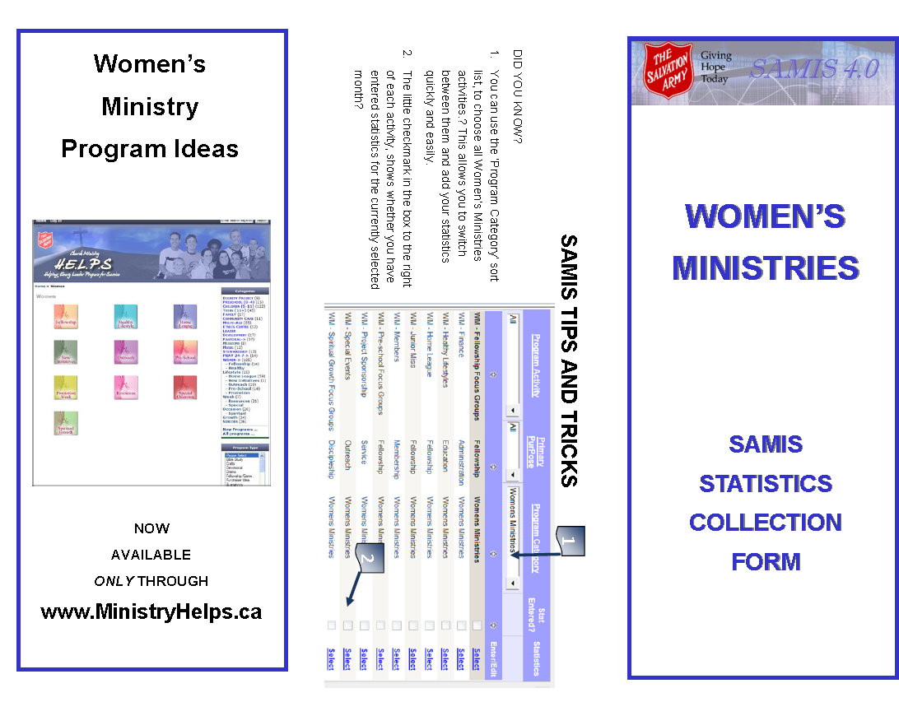
web site.



