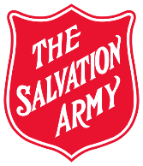
Women’s Ministries PROJECTS
DHQ
The Salvation Army Women’s Ministries Department
Canada & Bermuda

DIVISION: YEAR: 2021

Love Without Borders – Territorial Project – Mozambique (2021)
(World Services 300106/Women’s Ministries1222/Account 51001)

Amount Raised: $______________ Date Internal Transfer sent to the THQ Finance Department: _______________

What types of fundraising activities did your ladies engage in to raise funds for the above projects?

__________________________________________________________________________________________________________________________________________________________________________________________________

This form due at THQ, CAN-Women@salvationarmy.ca no later than February 21, 2022.

Divisional Director of Women’s Ministries |  | Date

Divisional Secretary for Women’s Ministries/  Divisional Coordinator for Women’s Ministries |  | Date

