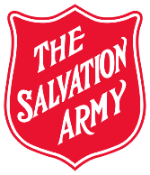
Women’s Ministries PROJECTS Form
MU
The Salvation Army Women’s Ministries Department
Canada & Bermuda

MINISTRY UNIT: DIVISION: YEAR: 2021

Love Without Borders – Territorial Project – Mozambique (2021)

Amount Raised: $______________ Date Internal Transfer sent to the Divisional Finance Department: _______________

What types of fundraising activities did your ladies engage in to raise funds for the above projects?

__________________________________________________________________________________________________________________________________________________________________________________________________

Corps Officer/Ministry Unit Leader: ______________________________ Date: _______________

Process for submitting Project money:

1. Send all Project monies to the Divisional Finance Department through an Internal Request to Charge form by January 14, 2022.

2. Copy DDWM/DSWM/DCWM (DHQ) on all submissions.

3. This form due at DHQ January 21, 2022.

