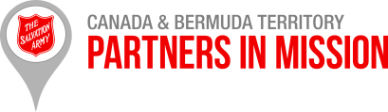
January 2021

Dear Friends,
Thank you for your generous support of the 2020 Partners in Mission Self-Denial campaign, especially in light of COVID-19. We look forward to your continued support as we launch the 2021 campaign. The Canada and Bermuda Territorial goal has once again been set at $2.3 million.
We are excited that the promotional materials for the 2021 campaign will focus on a variety of ministries in the Zambia Territory where our own Colonels Ian and Wendy Swan are the Territorial Leaders. Once again, a series of videos have been developed for use in your ministry unit along with many other practical resources. Please encourage your local leaders to use the materials with their various groups.
We continue to be intentional with our promotional materials to ensure that Salvationists across the Canada and Bermuda Territory understand the value and process of the Partners in Mission Self-Denial Campaign. As a reminder, please note that although we highlight specific territories, the Partners in Mission funds raised are distributed through International Headquarters to territories based on need. Also, I would like to take this opportunity to remind you that all territories/commands participate in the Partners in Mission Self-Denial campaign. Every Salvationist in the world is called upon to support the international work of The Salvation Army.
As in the past, the territorial finance department will automatically withdraw the funds collected on an annual basis from your bank account based on what is reported in the financial records of your ministry unit. The transfer will be the balance of funds raised from September 2020 to July 31, 2021. No cheques or request to make payment are necessary to transfer the funds.
Thank you for partnering with us to support the international ministry of The Salvation Army.
Together we can make a difference and reach the World for God!

With sincere thanks,

Lt-Colonel Brenda Murray
Director of International Development
Partners in Mission Campaign
Salvationist.ca/PIM

